Remote Monitoring/Control Software
HEM (HyperElectronicsMappers)
User’s Manual
Models: DP-9099
DP-9050
DP-9010

Before attempting to operate this product,
please read these instructions carefully and save this manual for future use.
HEM-M53500E
LIMITATION OF LIABILITY

- THIS PUBLICATION IS PROVIDED “AS IS” WITHOUT WARRANTY OF ANY KIND, EITHER EXPRESS OR IMPLIED, INCLUDING BUT NOT LIMITED TO, THE IMPLIED WARRANTIES OF MERCHANTIBILITY, FITNESS FOR ANY PARTICULAR PURPOSE, OR NON-INFRINGEMENT OF THE THIRD PARTY’S RIGHT.

- YOU CAN RECOVER FROM THE COMPANY AND ITS SUPPLIERS ONLY DIRECT DAMAGES UP TO THE AMOUNT YOU PAID FOR THE SOFTWARE. YOU CANNOT RECOVER ANY OTHER DAMAGES, INCLUDING CONSEQUENTIAL, LOST PROFITS, SPECIAL, INDIRECT OR INCIDENTAL DAMAGES.

- THIS PUBLICATION COULD INCLUDE TECHNICAL INACCUACIES OR TYPOGRAPHICAL ERRORS. CHANGES ARE ADDED TO THE INFORMATION HEREIN, AT ANY TIME, FOR THE IMPROVEMENTS OF THIS PUBLICATION AND/OR THE CORRESPONDING PRODUCT(S).

PRECAUTIONS

- PRODUCT KEYS: The software requires a key to install it. You are responsible for the use of keys assigned to you. You should not share the keys with third parties.

- You may make one backup copy of the software. You may use it only to reinstall the software.

- Please make a note of your settings and save them. This will help when you are required to change the system configuration, or when unexpected failure or trouble occurs.

- Distributing, copying, disassembling, reverse compiling, reverse engineering, and also exporting in violation of export laws of the software provided with this product, is expressly prohibited.

Table of Contents
1. Product Overview………………….……………………….……...  - Features…………………..…….…………..…………………...  - Release Note……………..…….…………..…………………….  2. Installations…….…….……………………………………….……  3. HEM Editing Mode…………………………….……..……….…...  3.1 Configure (DVR) Device List……….…………………………  3.2 File Operations………………………………….………………  3.3 Object Operations……………………………….………………  3.4 Options………………………………………….………………  4. HEM Running Mode..……..………………………………….…...  4.1 Device Operations…………….……………….………………  Appendix A – Specifications  Appendix B – Predefined Action Buttons | 4  4  5  6  10  11  14  15  19  24  29  31  32

1. Product Overview

The HEM (HyperElectronicsMappers) for Remote Monitoring, Control, & Management Station, DP-9099/9050/9010, is designed to be installed in a PC for use within a surveillance system. To achieve the highest user-friendliness, this series of software are all based on industry-leading Electronics Map infrastructure - HyperElectronicsMappers. With state-of-the-art Electronics Maps, unlimited levels of maps which support versatile dynamic map objects, including camera, alarm input, alarm output, etc., can be custom-made by the installers or users based on different surveillance requirements.

1.1 Features

Monitor/control all front-end (DVR) devices in PC stations

Remote monitoring, control, and management for virtually unlimited number of front-end surveillance devices such as DVRs

Bi-directional audio capabilities

Remote video, audio, and alarm input monitoring

Remote alarm output control

Remote PTZ control

Remote GPS/POS function

Remote software upgrade and setup for (DVR) devices

Remote alarm notification

Backup/playback video/audio in PC stations

Remote playback of recorded video/audio in front-end devices such as DVRs

Backup live/recorded video/audio of front-end devices and FTP server in local HDD

Play video/audio stored in local HDD

Print/snapshot live or recorded video

User-friendly Hyper Electronics Maps

Open system architecture

Custom-made electronics maps for different surveillance requirements

Unlimited levels of maps with hyper-links

Support versatile dynamic map objects, such as camera, alarm input, alarm output, action button, front-end (DVR) device, and map

Simultaneous monitoring/control of different front-end (DVR) devices in a single map

Virtually unlimited number of objects in a map

Ease of use

Multi-lingual support

Single device view same as the split window display in Internet Explorer or via hyper electronics map

Multiple device view via hyper electronics map

Single mouse click to view any hyper electronics map

Remote alarm notification to display user-defined hyper electronics map

Sequential display for user-defined hyper electronics maps and cameras

System provided default/sample bitmaps and icons for each object

The bitmaps and icons for each object can be tailored by the users

Auto-run for user-defined entry map

Password protection can be enabled/disabled by the user

Safety and Security

Protection key to access front-end (DVR) devices

Password to access front-end (DVR) devices

Multi-level password to enter HEM

1.2 Release Note

V5.10

Support audio broadcast

Support digital watermark

V4.07

Support H.264 and MPEG-4

Support Windows® Vista

V4.0

Miscellaneous backup function

Support POS search function

V3.0

Multi-lingual support

Support POS function

V2.8

Support DVR models DM/DH-1604 and GPS function

V2.3

PTZ function modified for DVR software V3.24 or above

New examples (Example 6, 7, and 8) which have better look-&-feel

V2.1

SEQ mode for HEM maps and camera objects

Alarm notification to call up HEM map and trigger action

Video display and iconization for camera objects

Multiple level of password protection

Programmable control port and data port for virtual server access to the DVRs

Remote software upgrade for (DVR) devices

Default.hem for DP-9010

2. Installations

System Requirements

It is recommended to install the HEM software using a PC that meets the following system requirements. If you use a PC that does not meet the following system requirements, it may cause problems such as slow imaging or the HEM software unable to operate.

- PC
IBM PC/AT compatible.

- CPU
Intel® Pentium® 4, 1.6 GHz or above.

- OS
MicroSoft® Windows® XP, Windows® 2000 with SP4, or Windows® Vista.

- Monitor
1024 x 768 or above.

- Memory (DRAM)
512MB or above, at least 1024MB recommended. The more complicated the HEM maps, the more memory required.

- Network Interface
Ethernet, 10/100 Base-T for LAN, or the other interfaces which can be connected to the internet.

- DirectX
MicroSoft® DirectX® 9.0 or above.

- Others
Windows XP KB319740 Package if Windows XP SP2 is installed.

Before running HEM software in your PC, please make sure the followings:

1. DirectX® End-User Runtime 9.0 or above has been installed in your PC successfully. If not, please logon to http://www.microsoft.com to get the free download of it.

2. Windows XP KB319740 Package has been installed in your PC successfully if the PC is running Windows XP SP2. If not, please logon to http://www.microsoft.com/downloads/details.aspx?FamilyId=9B5EDFC8-A4BB-4080-9063-6518166E2DAB&amp;amp;displaylang=en to get the free download of it, or install it from the corresponding directory in the CD. (This package is a bug fix for Windows XP SP2.)

3. Please go to Start->Setup->Control, select Display->Settings, and set the Screen Resolution to at least 1024x768 and Color to 32-bit.

4. To have better look-&-feel for the dialogs in your PC, please go to Start->Setup->Control, and select Display->Visual Style->Windows XP Style.

Installations

Please note that the PC user must have system administrator password for the PC; otherwise, the process will fail, and an error dialog will be shown.

To install the HEM software in your PC, please insert the HEM CD in the CD-ROM/DVD-ROM drive, and then double-click on Setup.exe in the CD directory. Please follow the instructions on the screen to install the software and all the required components step by step. Please note that the Product Key (4 X 6 digits) is shown on the HEM CD, the external box, or the file in the CD. Besides, the Protection Key must be the same as those of all the (DVR) devices to be accessed by this PC. Please refer to the Protection Key in the System Setup of the (DVR) devices. If the Protection Keys of the (DVR) devices are not the same, please make sure to set them to the same value which is appropriate to you.

Note 1: Different PCs cannot share the same Product Key for HEM of formal release, except DP-9010.

Note 2: The Protection Key for remote access is checked for DVR software version 2.10 or above. For earlier versions, the Protection Key is not checked for remote access.

The software will be installed in the default directory “Program Files\Hyper Electronics Mappers” or the directory entered by the user. After installation, the following files/directories will be generated:

- HEM.exe
HEM executable file.

- Setup.dll
Information file for this HEM.

- device_list
Device list for this HEM. The contents will be updated when the device list is modified.

- DEFAULT.hem
Default entry HEM map file for HEM-9010. If the users don’t want to build their own HEM maps, they can just configure the (DVR) device list, and use this file as the entry HEM map to have 1/4/9/16 split window display..

- Default
Directory for all the default HEM map files, icons, and background image files.

- System
Directory for the system information and settings for the connected (DVR) devices. The contents will be updated when the HEM is running. Please DO NOT save any user’s file in this directory.

- Example
The directory for some useful examples, including some HEM map files, background image files, and icons. Please note that the filename for the entry HEM map of each example is in capital letters.

- Example1
This example contains some HEM maps with some Camera objects, Device objects, and Link objects. The background image is a 2-D map. Iconized camera objects are added for updated version of HEM. Please note that one of the HEM maps (as shown below) contains 3 non-top-level maps, each with 16 Camera objects, 16 Alarm Input objects, 4 Alarm Output objects, and 1 Device object. So, it contains a total of 48 Camera objects, 48 Alarm Input objects, 12 Alarm Output objects, 3 Device objects, and some Link (to top-level map) objects.

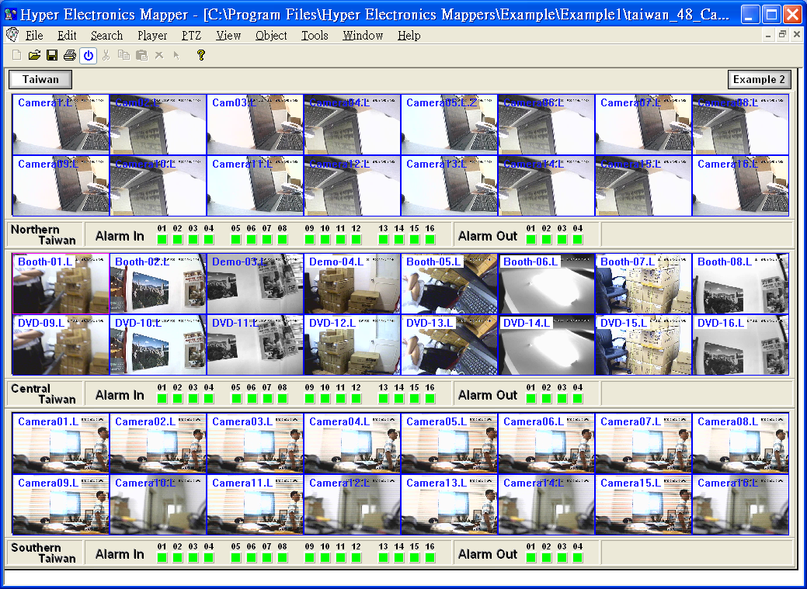

- Example2
This example contains some HEM maps with some Camera objects, Alarm Input objects - Door & Window, Alarm Output objects - light, and Link objects. The Link to non-top-level map can be moved around in HEM Running Mode by clicking in it (but outside of the video window) and then move the mouse cursor. The background image is a 2-D map.

- Example3
This example shows a structured diagram and contains some HEM maps with some iconized Camera objects, Alarm Input objects, Action objects, and Link (to top-level map) objects.

- Example4
This example contains some HEM maps with some Alarm Input objects, Action objects, and Link objects.

- Example5
This example contains some HEM maps with some Camera objects, Device objects, and Link objects. SEQ mode display is added for updated version of HEM. The available HEM maps are listed in the left side of each HEM map for ease of access.

- Example6 / Example7 / Example8
New examples with better look-&-feel.

3. HEM Editing Mode

HEM map is an innovative idea and the kernel of the whole HEM application software. HEM Editing Mode allows the users to build their own HEM maps. For each map, the users can set the background image file which may be an electronics map or a 2D/3D diagram scanned or drawn by the users. Besides, different types of map objects, including Camera, Alarm input, Alarm output, etc., can be inserted in the maps based on different application requirements. After building your own maps, you may monitor and control the (DVR) devices by opening & running those maps for dynamic display. By building your own HEM maps, you may have the dynamic display screens and the user operations all tailored for your specific applications.

If the users don’t want to bother to build their own HEM maps, it’s still OK. The users can just configure the (DVR) device list, use DEFAULT.hem as the entry map, and have standard 1/4/9/16 split window display.

Note: If the HEM maps are built by the installer, the installer may need to set some files as “Read Only” to avoid those files to be modified by the end users.

To open HEM: First click on your "Start" button. Once the menu appears, put your mouse on the word "Programs". From here, look through the list of programs to find your version of Hyper Electronics Mappers (HEM), and click on it - this will start the Hyper Electronics Mappers (HEM) program.

Once the HEM program opens, you will see the screen as shown below.

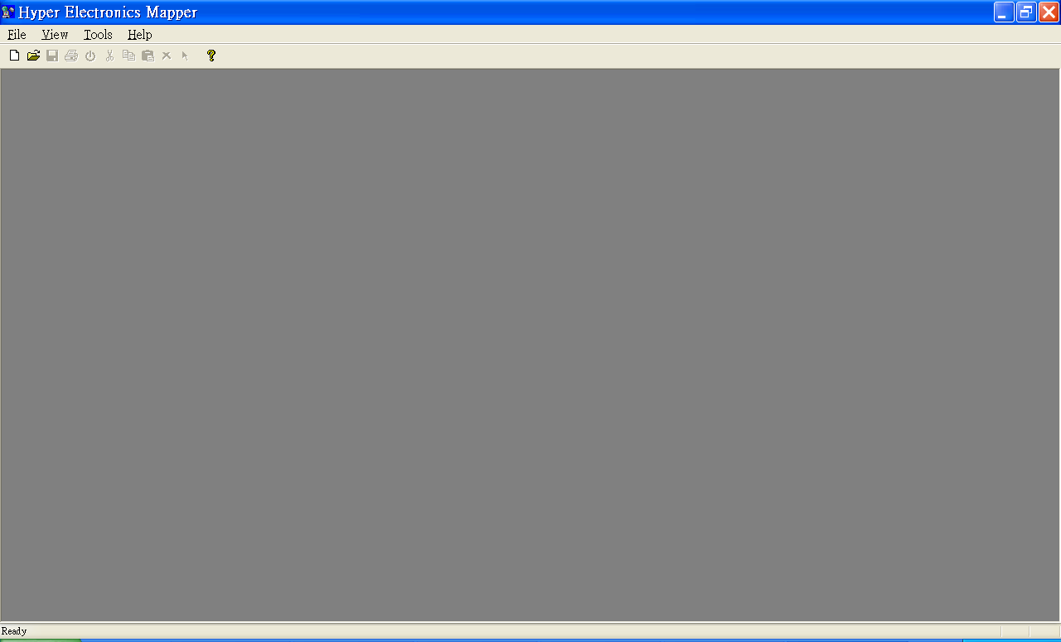

3.1 Configure (DVR) Device List

Since each object in the HEM maps corresponds to one of the objects of the (DVR) devices, the user needs to configure the (DVR) device list first.

Note: DP-9010 users may just modify the device properties, and then run the HEM map DEFAULT.hem. Please refer to Chapter 4 for the operations in Running Mode.

In HEM program, click on Tools menu, and then select Device->Config, the Device List Dialog for this HEM station will be shown as below.

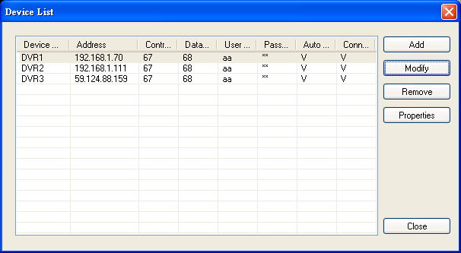

Please note that the DVR devices for all the examples are already built in the device list. If the PC is connected to some DVRs, the user may modify the IP address, Port Number, Username & Password, and then run the HEM maps (Please refer to Chapter 4 – HEM Running Mode) in the Examples to get a better understanding of HEM.

Following is a brief description for each item:

- Device Name – any meaningful name for the (DVR) device. The Device Name is used later for the configurations of all the (DVR) device related objects.

- Address – IP address or URL domain name for the (DVR) device. It should be the same as the IP address (for Static IP) or URL (for PPPoE) in Network Setup for the (DVR) device. Please consult your network administrator, esp. if virtual server is used in your network.

- Control Port – the control port for the (DVR) device. The default value is 67. The user may need to change it if virtual server is used or its setting in the DVR has been changed.

- Data Port – the data port for the (DVR) device. The default value is 68. The user may need to change it if virtual server is used or its setting in the DVR has been changed.

- Video Stream – “Record” – same as recording stream, or “Extra” – extra network stream if dual streaming is supported for the (DVR) device. The default value is “Record”.

- User Name – the login user name for the (DVR) device. It must be in the list in Password Setup for the (DVR) device. Please note that different levels of users have different available operations in HEM. Please refer to Password Setup in the manual for the DVR for the available operations of each level.

- Password – the corresponding password for the login user name for the (DVR) device.

- Auto Connection – whether the user wants to connect automatically to this (DVR) device when the HEM program is in running mode (even if the currently opened HEM maps contain no objects corresponding to this device).

- Connected – whether this PC is connected with the (DVR) device now (only for information in HEM Running Mode).

The operations are as below:

- Add
Add a (DVR) device to the device list. Click on the Add button, and the Device Dialog will be shown as below.

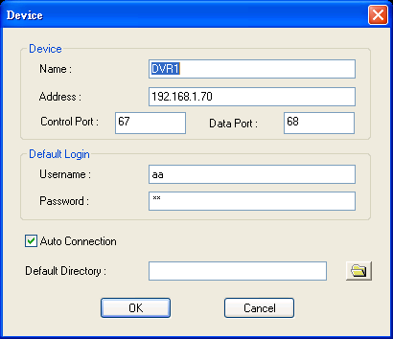

The items are as described above. The Default Directory is used to open/save the properties for this device. Please enter those items, and click on OK button to save those settings, or Cancel button to exit without saving.

- Modify
Modify the above-mentioned items of the selected (DVR) device in the device list. Select a (DVR) device in the device list, and then click on Modify button, and the Device Dialog will be shown as above with all the contents filled in.

- Remove
Select a (DVR) device in the device list, and then click on Remove button to remove the selected device from the device list.

- Properties
Select a (DVR) device in the list, and then click on Properties button to modify the properties of the selected device. The Device Properties Dialog is shown as below. All the items in the Tabs are used to setup the (DVR) device remotely after connection, and will be discussed in HEM Running Mode later.

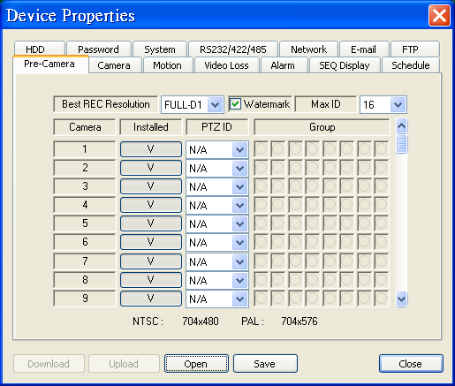
3.2 File Operations

In HEM program, click on File menu, and then select New to new an HEM map or Open to open an existing HEM map. Once the HEM program opens or news an HEM map, you will see the screen similar to the one (Example1/TAIWAN.hem) shown below.

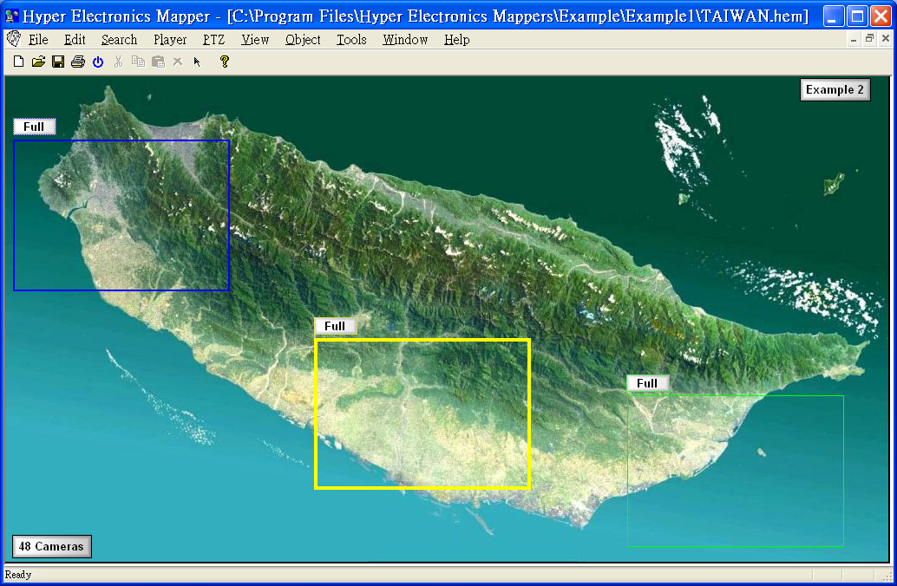

After you finish the editing, you may click on File menu, and then select Close to close the file, Save to save the file, Save As to save the updated contents to a different file, or Print to print the file.

System map files

There are some default system map files under the subdirectory Default of the HEM program. Please do not delete them or move them to another directory. The descriptions are as below:

- 1Win.hem, 4Win.hem, 9Win.hem, 16Win.hem, 25Win.hem, 36Win.hem, 49Win.hem, 64Win.hem – default split-window display map files for all the (DVR) devices and multi-split-window map files. These HEM maps are all top-level maps. After the users are very familiar with the HEM application, they may modify the contents to suit their needs. However, it would be better to make a backup copy before modification.

- Player.hem, PTZ.hem – default player panel HEM map file & PTZ panel HEM map file. These HEM maps are all non-top-level maps, and therefore can be shown in another map.

3.3 Object Operations

There are six types of map objects in the HEM program, including Camera, Alarm input, Alarm output, Device, Action, and Link. The descriptions are as below: (Please note that only Link to non-top-level HEM map can be moved around in HEM map in HEM Running Mode. Please refer to the Examples to get a better understanding of all the objects.)

- Camera
Corresponding to the camera connected to the (DVR) device. In Running Mode, if the object is not iconized, the video of the camera will be shown in the defined rectangle, and the audio, if exists and is enabled and the camera is focus camera, will be output to the HEM station. If the object is iconized, the (motion) status of the camera will be shown with the selected image files (motion triggered or not). Please note that there can be at most 32 “not iconized camera” objects of the same (DVR) device in one HEM map.

- Alarm input
Corresponding to the alarm input connected to the (DVR) device. In Running Mode, the status of the alarm input will be shown with the selected image files (triggered or not).

- Alarm output
Corresponding to the alarm output connected to the (DVR) device. In Running Mode, the status of the alarm output will be shown with the selected image files (triggered or not), and the user can click on the displayed image icon to control the corresponding alarm output from normal to triggered, or from triggered back to normal.

- (DVR) Device
Corresponding to the (DVR) device. In Running Mode, the user can call up the split window display of the (DVR) device when it’s selected.

- Action
Corresponding to the predefined Action buttons, including PTZ Up, PTZ Down, Freeze, Play, Stop, etc. Please refer to Appendix B for the predefined Action buttons. In Running Mode, the user can trigger the action by clicking on the displayed image icon.

- Link (to another HEM map)
Corresponding to Link to HEM map. In Running Mode, the contents of a non-top-level HEM map linked will be displayed and can be moved around in its parent map. For a top-level map link (and only link allowed), the user can switch to its map display by clicking on its displayed icon. (This is similar to the Hyper-link in web page.) That is to say, the user can use non-top-level HEM map as grouping purpose, and top-level map as (hyper) link purpose.

Add An Object

In HEM program, click on Object menu, and then select Camera, Alarm input, Alarm output, Device, Action, or Link, for the type of objects to be added to the HEM map. The selected object type will be checked.

After the desired object type is selected, click and drag the cursor in the client area to add an object to the HEM map. The object is shown as a rectangle with the selected border width and color. You may repeat this procedure to add as many objects as you want.

Object Properties

To select and highlight an object in the HEM map, click on Object menu, and then select “Select object“. Now, you may click on any object in the map to select and highlight it.

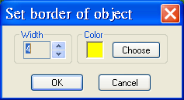
Once an object is selected, you may click on Object menu, and then select Border to change its border width and color, or select Properties to change its properties other than border. The dialogs are as shown.

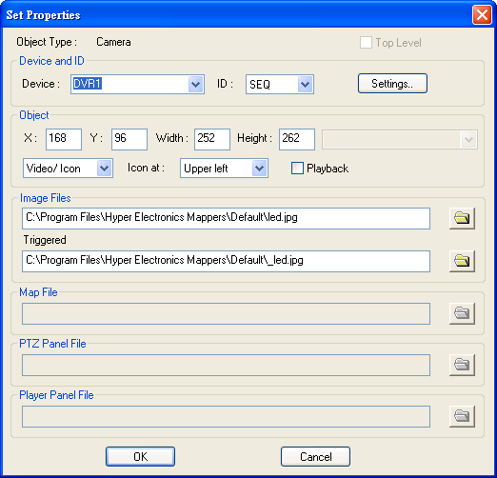
The detailed properties of each object type are described as below:

- Object type
The type of this object.

- Top level
Top level or not. This is only used for HEM map file. Please note that non-top-level HEM maps, EX. Player.hem or PTZ.hem, are very useful to group objects together to show/move in another HEM map.

- Device
The device name (EX. DVR1) for this object. Please refer to Section 3.1 to configure the device list for this station. “Auto” means that the object is dynamically linked to the selected device in Running Mode.

- ID
The ID for this object, EX. the ID for camera 1 is 1 and the ID for alarm input 1 is also 1. For Camera object, the ID can be set as SEQ to make this object capable of SEQ mode display in Running Mode. If so, the user can click on Settings button to call up the SEQ Mode Settings dialog as shown below.
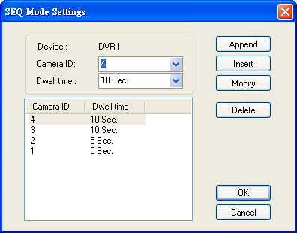
- SEQ Mode Settings
Please select the Camera ID and Dwell Time (5~240 seconds), and then click on Append button to append the settings to the list below, Insert button to insert the settings right before the highlighted item in the list, Modify button to modify the settings of the highlighted item, or Delete button to delete the highlighted item. Please click on OK button to exit and save the settings, or Cancel button to cancel.

- X
The X-coordinate of this object in the map.

- Y
The Y-coordinate of this object in the map.

- Width
The width of this object in the map, or that of the HEM map file.

- Height
The height of this object in the map, or that of the HEM map file.

- Video/Icon
(Video, Icon, Video/Icon, Icon/Video). This is only used for Camera object. “Video” means to display the camera video in Running Mode, “Icon” means to display the motion status bitmaps of the camera in Running Mode, “Video/Icon” and “Icon/Video” mean that the user can switch between Video and Icon in Running Mode, with the type before “/” used as default.

- Icon at
(Upper left, Upper right, Lower left, Lower right) – the corner in the rectangle the icon will be displayed in Running Mode.

- Playback
Playback or not. This is only used for Camera object for live/playback mode of the camera in Running Mode.

- Action Type
One of the predefined Action buttons. This is used for object type of Action. The predefined Action buttons are divided into several groups. Please refer to Appendix B for their descriptions.

- Toggle – information only
Toggle or not, used for object type of Action. For non-toggle type of Action button, the Action button will always return to non-triggered state after the mouse button is released. For toggle type, the Action button will keep at the same state after the mouse button is released.

- Image File
The default image (.BMP or .JPG) file of this object to be shown in the map. If no object is selected, this image file is to be shown as the background image of this HEM map.

- Image File - Triggered
The image (.BMP or .JPG) file of this object to be shown in the map while it’s triggered. This is used for object type of Camera (Icon), Alarm input, Alarm output, Action, and Link (to top-level map).

- Map File
The HEM map file of this object if it’s a Link (to HEM map).

- PTZ Panel File
The PTZ panel file to be called up for this HEM map in Running Mode. Please note that the PTZ panel file can be changed to a different file for each HEM map.

- Player Panel File
The Player panel file to be called up for this HEM map in Running Mode. Please note that the Player panel file can be changed to a different file for each HEM map.

Edit Menu

The user may click on Edit menu to Cut/Copy the selected object, Paste the cut/copied object, or Delete the selected object.

Context Menu

The user may also use the Context Menu by right clicking on the client area of the map. If there is an object under the cursor, the Context Menu for that object will be shown, if there is no object under the cursor, the Context Menu for this HEM map file will be shown. Please refer to the above-mentioned for the menu items in the Context menu.

3.4 Options

Click on Tools menu, and then select Options, the Options Dialog will be shown as below. After all the settings are done, please click on OK button to exit and save the settings, Apply button to save the settings without exit, or Cancel button to cancel.

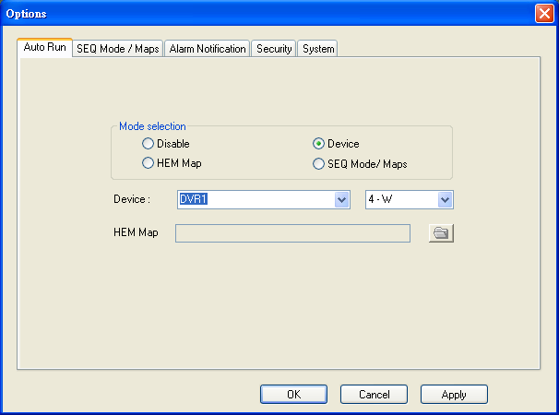

Auto Run

The user may select Disable to disable Auto Run, or Device, HEM Map, or SEQ Mode / Maps to enable Auto Run. If enabled, one of the HEM maps or the devices, or SEQ Mode will be Auto Run every time the program starts. This is to be used as the entry point for the user. If it’s a device, please select the device and its split-window display to be shown after Auto Run. If it’s an HEM map, please select the top-level HEM map file to be shown after Auto Run. Non-top-level HEM map should not be selected for auto run. If SEQ Mode / Maps is selected, please do the SEQ Mode / Maps settings as described below.

SEQ Mode / Maps

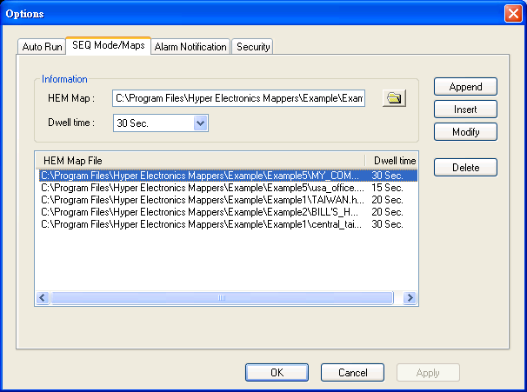

SEQ Mode / Maps is used to display the selected HEM maps in the HEM Map File list at preset dwell time sequentially in Running Mode.

Please select the top-level HEM Map and Dwell Time (5~240 seconds), and then click on Append button to append the settings to the list below, Insert button to insert the settings right before the highlighted item in the list, Modify button to modify the settings of the highlighted item, or Delete button to delete the highlighted item.

Alarm Notification

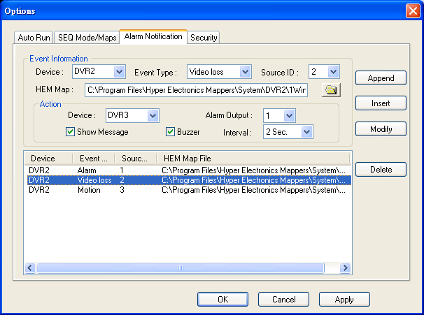

Alarm Notification is used to define how HEM responds to the alarms reported from the front-end (DVR) devices in Running Mode.

Please do the settings in Event Information, and then click on Append button to append the settings to the list below, Insert button to insert the settings right before the highlighted item in the list, Modify button to modify the settings of the highlighted item, or Delete button to delete the highlighted item.

Following is a brief description for each item:

- Device, Event Type, Source ID – to define the source of the alarm to call up the HEM Map and Action described below.

- HEM Map – to define the top-level HEM Map to be called up when the defined alarm is detected.

- Action -> Device, Alarm Output – to define which Alarm Output of which Device will be triggered when the defined alarm is detected.

- Action -> Show Message, Buzzer – to display the alarm message on the screen of the HEM or not, and to activate the internal Buzzer of the PC or not, when the defined alarm is detected.

- Action -> Interval – to define the interval for the Buzzer to keep being triggered after the defined alarm is detected.

Security

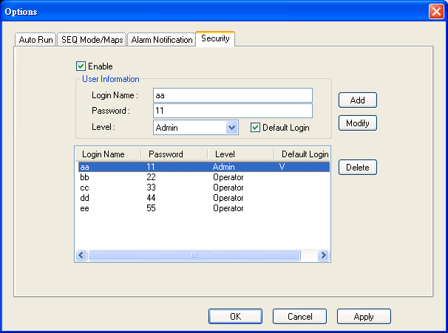

The system allows virtually unlimited number of user accounts. There are two password levels in the system, including Administrator (highest) and Operator (lowest). The Operator can only operate in Running Mode, but cannot change the configurations. The Administrator can do everything in Editing Mode and Running Mode.

The user (administrator) may enable password protection for the HEM program. If the password protection is enabled, the Login Dialog for the HEM program will be shown every time the HEM program starts. Please enter the Login Name, Password, Level, and Default Login, and then click on Add button to add the settings to the list below, Modify button to modify the settings of the highlighted item in the list, or Delete button to delete the highlighted item.

If Default Login is checked for the login name/password, this login name/password will be the default one each time the login dialog is shown, so the user doesn’t bother to enter the login name/password to login the system.

System

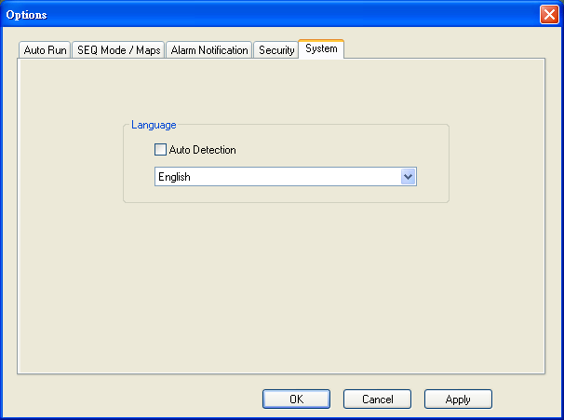

The system will automatically detect the language of the Windows system. If the user wants to use a different language, please disable “Auto Detection”, and select the desired language.

4. HEM Running Mode

The HEM application software can access the (DVR) devices remotely if the PC and the (DVR) devices are connected via network, either internet or intranet.

Before Running

Before accessing the (DVR) devices through HEM application software, please make sure the followings:

1. The (DVR) devices are connected to the network and the configurations are all setup correctly. (If the system resources - DRAM, CPU speed, etc. - in the PC are limited, or the network bandwidth is low, please set the record resolution of the DVRs to Half-D1 or CIF.)

2. DirectX® End-User Runtime 9.0 or above has been installed in your PC successfully. If not, please logon to http://www.microsoft.com to get the free download of it.

3. Windows XP KB319740 Package has been installed in your PC successfully if the PC is running Windows XP SP2. If not, please logon to http://www.microsoft.com/downloads/details.aspx?FamilyId=9B5EDFC8-A4BB-4080-9063-6518166E2DAB&amp;amp;displaylang=en to get the free download of it, or install it from the corresponding directory in the CD. (This package is a bug fix for Windows XP SP2.)

4. Port 67 (control port) or port 68 (data port) for the (DVR) devices is not blocked out by your router or ISP (Internet Service Provider).

5. Please go to Start->Setup->Control, select Display->Settings, and set the Screen Resolution to at least 1024x768 and Color to 32-bit.

6. To have better look-&-feel for the HEM program in your PC, please go to Start->Setup->Control, and select Display->Visual Style->Windows XP Style.

Run

To run HEM map: Just run the HEM program if Auto Run for top-level HEM map or (DVR) device, or SEQ Mode / Map is set. Or click on File menu, and then select Run if the top-level HEM map has been opened already. The screen will be shown similar to the one (Example2/BILL’S HOME.hem) below.

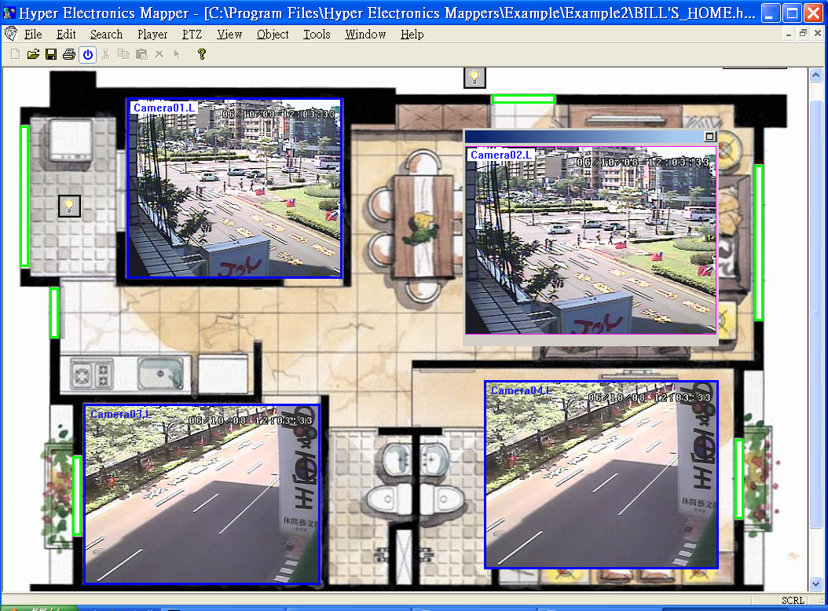

Once the HEM is in Running Mode, the corresponding menu will all be enabled. (Please note that “.L” following the camera title stands for Live display, “.P” for Playback, and the camera title with white background has detected motion.)

Note: DP-9010 users may use the HEM map DEFAULT.hem as the entry map. Please click on the DVR icon to switch to its split-window display.

File Operations

The File Operations are the same as in Editing Mode. If the HEM map is in Running Mode, you may click on File menu, and then select Run to stop running and return to Editing Mode, and vice versa. Please note that the oldest HEM map files may be automatically closed if the HEM program consumes too much system memory.

Search Operations

There are different search operations, including Time, Event, and PC Video. Those operations are the same as in the Remote Access described in the manual come with the DVR, and are also described below:

- Search By Time
Click on Search menu, and then select Time to call up Search-by-time Dialog. Please select the time (Year, Month, Date, Hour, and Minute) and recorded video/audio type (Alarm, Motion, Video Loss, and Normal) to search for playback. Click on Search button to start the search of the recorded video/audio. (If it failed, the result will be shown on the title of the dialog.) Now, you may use the player operations to play the recorded video/audio. Please note that there must be at least one camera in playback mode for the search to succeed. Besides, the cameras of different (DVR) devices can be selected for search by time.

- Search By Event
Click on Search menu, and then select Event to call up Search-by-event Dialog. The event logs will be shown on the screen. Please select the (DVR) device, event type and source ID to search for the event logs. Click on Refresh, Up, or Down to update the event logs. Click on the desired event log to highlight and select it. Click on the OK button to search the recorded video/audio for the highlighted event log. Now, you may use the player operations to play the recorded video/audio.

- Search PC Video
Click on Search menu, and then select PC Video to call up Search-PC-video Dialog. Please select the file, and then click on Open. Now, you may use the player operations to play the recorded video/audio in the file.

- POS Search
Click on Search menu, and then select POS to call up POS-Search Dialog. Please select the DVR, camera, key word, and start/end time, and click on “Search”, then the matched POS data will be shown. Please select the desired POS data, and click on “Backup” or “Play” to backup or play the recorded video/audio corresponding to the POS data.

Player Operations

The Player Operations are the same as in the Remote Access described in the manual come with the DVR. Those operations include Fast Backward, Fast Forward, Single Step, Play, Pause, Stop, and Copy. Please note that the Copy function can be used to archive both live and playback streams. The user may use the menu, the toolbar, or call up Player Panel for player operations. Please check/uncheck the cameras to be archived when the Copy Dialog is shown, and then click on OK or Apply button. If the user click on Apply button and select & highlight one of the cameras, the current copying status for that camera will be shown in the dialog.

PTZ Operations

The PTZ Operations are the same as in the Remote Access described in the manual come with the DVR. The user may use the menu or call up PTZ Panel for PTZ operations.

View Operations

- Toolbar
Show/hide the Toolbar above the client area.

- Status Bar
Show/hide the Status Bar below the client area.

- Player Panel
Show/hide the Player Panel in this HEM map. Please note that the Player panel file is specified in the object properties for this HEM map, and can be changed to a different file for each HEM map. The operations of the default Player Panel are similar to those of the Remote Access described in the manual come with the DVR. The user can click on the Player Panel (but outside of any object in it) (to call up the Context menu) to move it.

- PTZ Panel
Show/hide the PTZ Panel in this HEM map. Please note that the PTZ panel file is specified in the object properties for this HEM map, and can be changed to a different file for each HEM map. The operations of the default PTZ Panel are similar to those of the Remote Access described in the manual come with the DVR. The user can click on the PTZ Panel (but outside of any object in it) (to call up the Context menu) to move it.

- 1-W, 4-W, 9-W, 16-W
Switch to 1-W, 4-W, 9-W, or 16-W split window display of the selected Device object. The default split-window display map files in the directory Default will be used. The advanced users may edit those default maps to suit their own requirements. However, it would be better to make a backup copy before modification.

- Playback, Freeze, Audio In / Out / Broadcast
These View Operations are similar to the Remote Access described in the manual come with the DVR except that the operations for Playback/Freeze apply to the whole HEM map. Please refer to Appendix B for the detailed descriptions.

- SEQ Mode / Cameras
Switch all the camera objects (in this HEM map) with SEQ settings to SEQ mode, or back from SEQ mode.

- SEQ Mode / Maps
Switch the HEM program to SEQ mode for HEM maps, or back from SEQ mode.

- GPS Display
Display the GPS information (if any) for all the connected DVRs in this HEM map.

- POS Display
Display the POS information (if any) for all the connected DVRs in this HEM map.

- Display Control
Display this HEM map at Original Map Size, to Fit Window, or to Fit Width/Height.

Object Operations

The enabled Object Operations are similar to the Remote Access described in the manual come with the DVR, and the operation applies to the selected object. The detailed operations for each object are described below:

- Camera
If the object is not iconized, the video of the camera will be shown in the rectangle, and the audio, if exists and is enabled and the camera is focus camera, will be output to the HEM station. If the object is iconized, the motion status of the camera will be shown with the selected image files.

If not iconized, left-click the mouse to select it, or right-click the mouse to call up the dialog to change its ID or live/playback status. The user may also set its Playback mode, (un)Freeze the video, Print the video, Snapshot the video, display GPS information, configure GPS, display POS information, or configure POS by selecting Object->Playback/Freeze/Print/Snapshot/GPS Display/GPS Config/POS Display/POS Config. If iconized, left-click the mouse to change the ID of the previously selected camera object to the ID of this iconized camera object.

For Dual mode (Video/Icon or Icon/Video) camera object, the user may double click the mouse to switch its display mode back and forth. For camera object with SEQ settings, the user may switch the camera object to SEQ mode, or back from SEQ mode by selecting Object->SEQ Mode.

- Alarm input
The status of the alarm input will be shown with the selected image files. It’s always iconized, and no operation in Running Mode.

- Alarm output
The status of the alarm output will be shown with the selected image files. It’s always iconized, and the user can left-click on it to control the corresponding alarm output from normal to triggered, or from triggered back to normal.

- (DVR) Device
Always iconized. The user can left-click on it to select it. While it’s selected, the user can click on View menu, and then select 1-W, 4-W, 9-W, or 16-W to switch to the split-window display of the (DVR) device. The user may also click on the device, and then select 1-W, 4-W, 9-W, or 16-W to switch to the split-window display of the (DVR) device.

- Action
Always iconized. The user can left-click on it to trigger the corresponding action. Please refer to Appendix B for the predefined action buttons and their descriptions.

- Link (to another HEM map)
If it’s a (hyper) Link to a top-level HEM map, it will always be iconized, and the user can left-click on it to switch to its map display. Please note that the oldest HEM map files may be automatically closed if the HEM program consumes too much system memory. If it’s a Link to a non-top-level HEM map, it will always be not iconized, and the user can click on it (but outside of any object in it) (to call up the Context menu) to move it.

Backup Operations

Click on Tools menu, and then select Backup to call up Backup Dialog. Please select the DVR, cameras, event type, destination directory, execution time, and data range, and then click on “Apply” or “OK” to backup, or “Cancel” to cancel. Please note that Execution of “Now” or “Once” is one-time backup, while “Daily” is daily backup.

4.1 Device Operations

In HEM program, click on Tools menu, and then select Device. The operations are as below:

- Connect
Connect to the (DVR) devices in the device list. (The dialog as shown below) The user may select one (or none) of the split-window displays to be invoked and run at connection.

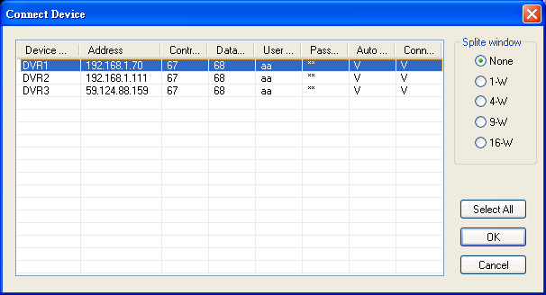

- Disconnect
Disconnect from the connected devices. (The dialog similar as shown above)

- Config
Please refer to Section 3.1 for the dialogs and operations to configure the devices. All the items in the Device Properties are used to setup the (DVR) device remotely after connection. Please refer to the Remote Access described in the manual come with the DVR. Please also refer to the setup of the DVR in the manual come with the DVR for the detailed descriptions. Besides, the user can download/upload the configurations from/to the connected (DVR) device, or open/save the configurations from/to the designated directory.

- Software Upgrade
Upgrade the (DVR) devices in the connected device list. (The dialog as shown below) The user may select one (or all) of the devices to be software upgraded, select the upgrade file in the PC, and then click on Start button to start the software upgrade process. The Upgrade status will be updated according to the progress. When the upgrade file is uploading, the user may click on Stop/Close button to stop the upgrade process.

After the software in the DVR is upgraded, the DVR will restart immediately and the HEM program will be disconnected from the DVR. Please (re-run the HEM program to) connect to the DVR(s) again.

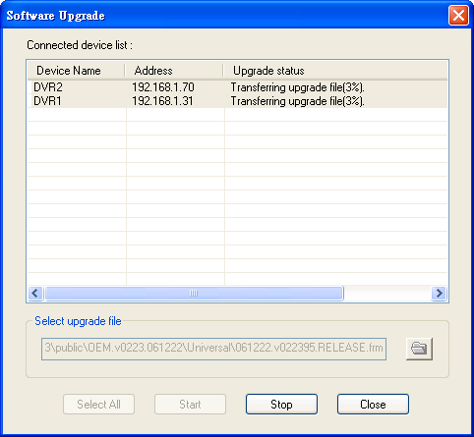

Appendix A – Specifications

Features\Models | DP9000 | DP9001 | DP9010 | DP9050 | DP9099
Monitoring & Control
Max. # of front-end devices | 4 | 4 | 10 | 50 | Unlimited
Bi-directional audio | Yes | Yes | Yes | Yes | Yes
Remote video, audio, alarm input, and alarm output monitoring | Yes | Yes | Yes | Yes | Yes
Remote alarm output control | Yes | Yes | Yes | Yes | Yes
Remote PTZ control | Yes | Yes | Yes | Yes | Yes
Remote upgrade | Yes | Yes | Yes | Yes | Yes
Remote configuration | Yes | Yes | Yes | Yes | Yes
Remote alarm notification | Yes | Yes | Yes | Yes | Yes
Remote playback | Yes | Yes | Yes | Yes | Yes
Playback search | Date/time, Camera, Alarm, Motion, and POS
Backup video/audio in local HDD | Yes | Yes | Yes | Yes | Yes
Play video/audio in local HDD | Yes | Yes | Yes | Yes | Yes
Print out / snapshot | Yes | Yes | Yes | Yes | Yes
Display GPS information | Yes | Yes | Yes | Yes | Yes
Display POS information | Yes | Yes | Yes | Yes | Yes
Hyper electronics map | -- | Yes | Yes | Yes | Yes
Display
Multi-lingual | Yes | Yes | Yes | Yes | Yes
Single device view | Yes | Yes | Yes | Yes | Yes
Split windows | Yes | Yes | Yes | Yes | Yes
Multiple device view | -- | -- | Yes | Yes | Yes
25/36/49/64 split windows | -- | -- | Yes | Yes | Yes
Security
Authentication key | -- | Yes | Yes | Yes | Yes
Password protection | Yes | Yes | Yes | Yes | Yes
Ports used | 67, 68, 80 | 67, 68 | 67, 68 | 67, 68 | 67, 68

Appendix B – Predefined Action Buttons

The predefined Action buttons are divided into several groups as described below:

- Generic buttons

. (Blank) – No action at all, used to display the specified image file at the predefined location.
. Audio In – toggle type, same as View->Audio In, used to enable/mute the audio input (Mic. In & Line In) from the PC. If enabled, the audio input from the PC will be sent to the connected (DVR) device containing the focus object.
. Audio Out – toggle type, same as View->Audio Out, used to enable/mute the audio output from the camera for the focus window.
. Audio Broadcast – toggle type, same as View->Audio Broadcast, used to enable/disable audio broadcasting from the PC to all the connected DVRs.
. Freeze – non-toggle type, same as View->Freeze, used to freeze/unfreeze the video for all the cameras.
. Mode – non-toggle type, same as View->Playback, used to change the mode, live or playback, for all the cameras.
. SEQ – toggle type, same as View->SEQ Mode / Cameras, used to switch to/from the SEQ mode of all the camera objects with SEQ settings in the HEM map.
. GPS Display – toggle type, same as Object->GPS Display, used to display the GPS information (if any) for the DVR for the focus camera.
. POS Display – toggle type, same as Object->POS Display, used to display the POS information (if any) for the DVR for the focus camera.
. Snapshot – non-toggle type, same as Object->Snapshot, used to snapshot the video for the focus camera.

- Player buttons

. Copy – non-toggle type, same as Player->Copy, Copy button in Player Panel, used to call up Copy dialog.
. Fast Backward – toggle type, same as Player->Fast Backward, Fast Backward button in Player Panel.
. Fast Forward – toggle type, same as Player->Fast Forward, Fast Forward button in Player Panel.
. Pause – toggle type, same as Player->Pause, Pause button in Player Panel.
. Play – toggle type, same as Player->Play, Play button in Player Panel.
. Play/Pause – toggle type, Play/Pause button in Player Panel.
. Step Forward – toggle type, same as Player->Single Step, Step Forward button in Player Panel.
. Stop – toggle type, same as Player->Stop, Stop button in Player Panel.

- PTZ buttons – non-toggle type

. PTZ Up / PTZ Down – to tilt the focus camera up/down if it’s a PTZ camera.
. PTZ Left / PTZ Right – to pan the focus camera left/right if it’s a PTZ camera.
. PTZ Focus + / - – to set the focus of the focus camera far/near if it’s a PTZ camera.
. PTZ Iris + / - – to increase/decrease the iris of the focus camera if it’s a PTZ camera.
. PTZ Zoom + / - – to zoom in/out the focus camera if it’s a PTZ camera.
. PTZ Goto/Set Preset – same as PTZ->Goto preset/Set preset, to goto/set the preset position of the focus camera if it’s a PTZ camera.
. PTZ AutoPAN.Run / AutoPAN.Stop – same as PTZ->Auto PAN->Run/Stop, to run/stop the AutoPAN mode of the focus camera if it’s a PTZ camera.
. PTZ AutoPAN.Set Start Position / AutoPAN.Set End Position – same as PTZ->Set start/Set end, to set the Start/End position of the AutoPAN mode of the focus camera if it’s a PTZ camera.
. PTZ SEQ.Run / SEQ.Stop – same as PTZ->SEQ->Run/Stop, to run/stop the SEQ mode of the focus camera if it’s a PTZ camera.

- Dialog-Call buttons – non-toggle type

. Device Config – same as Tools->Device->Config, used to call up Device List dialog.
. Software Upgrade – same as Tools->Device->Software Upgrade, used to call up Software Upgrade dialog.
. PTZ Panel – same as View->PTZ Panel, used to call up PTZ Panel (default as PTZ.hem).
. Search By Event – same as Search->Event, used to call up Search-by-event dialog.
. Search By Time – same as Search->Time, used to call up Search-by-time dialog.
. Search PC Video – same as Search->PC video, used to call up Search-PC-video dialog.
. POS Search – same as Search->POS, used to call up POS-Search dialog.
. GPS Config – same as Object->GPS Config, used to call up GPS Configuration dialog.
. POS Config – same as Object->POS Config, used to call up POS Configuration dialog.
. Backup – same as Tools->Backup, used to call up Backup dialog.

