High Speed 4 Port Web Server Products Series

User Manual &
Installation Guide

Version: 1.0
Date: July 28, 2026

Table of Contents
Table of Contents 2
Documentary history 3
1. Product Overview 4
What is ASiP Web Server? 4
Product Features 4
Application Architecture 4
2. Physical Connections 6
Product Perspective Graph 6
3. Installation 7
Before you start 7
Network connectivity check 8
Connect your CCTV Camera 9
Connect Web Server to network 9
Connect Power Supply 10
Start your first time network monitoring 11
How to visit the built-in web 12
About the User Interface of Web Server 13
How to check the firmware version 14
How to change the configurations 15
User Management 18
Log 19
Network 20
Video (by Channel) 22
PTZ Camera 23
Event 24
4. Product Specifications 29
Models 29
Specifications: 29
5. Appendix 31
Dictation 31

Documentary history
Structured/Layout
2004/6/16 4 Port Web Server
2004/7/1 Specifications Fix
2004/7/7 Revise How to visit the built-in web
2004/7/7 Revise Network
2004/7/7 Revise Event

1. Product Overview

What is ASiP Web Server?
ASiP Web Server is designed for intranet & internet. Users can view image or change configurations via built-in web server. The two-layer user-validation prevents any illegal user to monitor or change configuration once user validation is enabled

Product Features
High Speed  4-Port Web Server | CPU: 32 Bits RISC Processor. 16Mb Flash, 128Mb SDRAM  Linux OS  TCP/IP network remote Video transmission system  High performance JPEG/MJPEG compression  Built-in Web sever  Built-in DHCP Client  Built-in Motion Detection  3external composite video input(DI x 2, DO x 1)  Frame Rate Control  Administrator / User level password protection  Snapshots  On-line firmware upgrade  Frame Rate: 1 channel input:  NTSC:30 frame/sec(320x240)  PAL:25 frame/sec(352x288)  4 channel input: 22 frame/sec/channel  (NTSC:320x240/PAL:352x288)

Application Architecture
VSS-201: High Performance 4-Port Web Server
The following picture represents a standard application architecture for ASiP’s 4-Port Web Server.
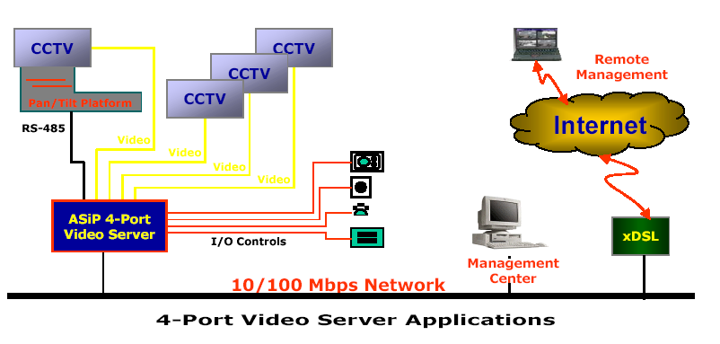

2. Physical Connections
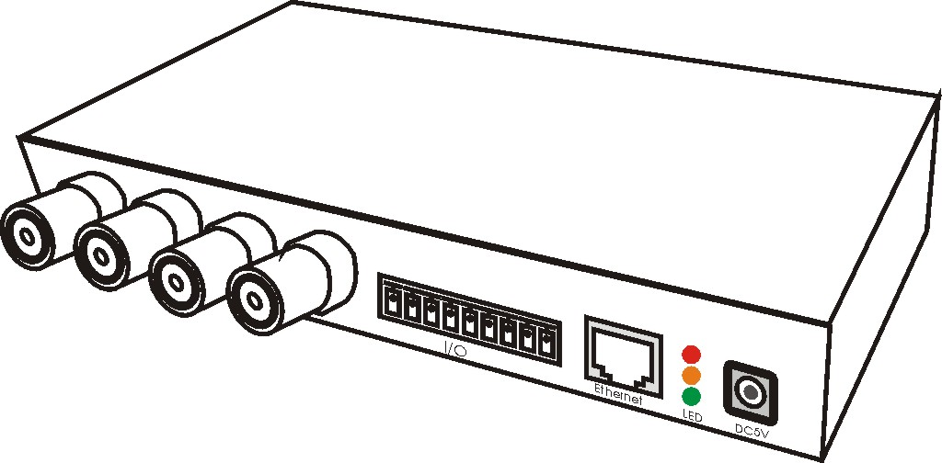

Product Perspective Graph
Front Panel Connections


VINx: Video Input (1 ~4)
Pin Assignment:
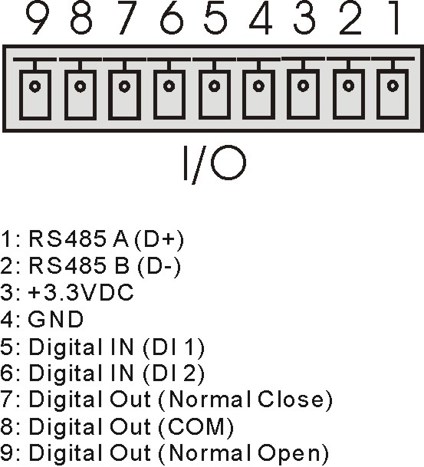
Ethernet: UTP Cable
Power: DV 5V

3. Installation

Before you start
Before you proceed to the installation steps of the ASiP Web Server. Please check the content of the package. Which must include all the components lists below.
ASiP Web Server
Power Adapter
User manual & installation guide
Quick installation reference card
If any part is lost, please contact nearest supplier to change.
Please check the hardware/software requirements of the Web Server monitoring workstation. You may download or update your system to the newer version to make the monitoring components work.
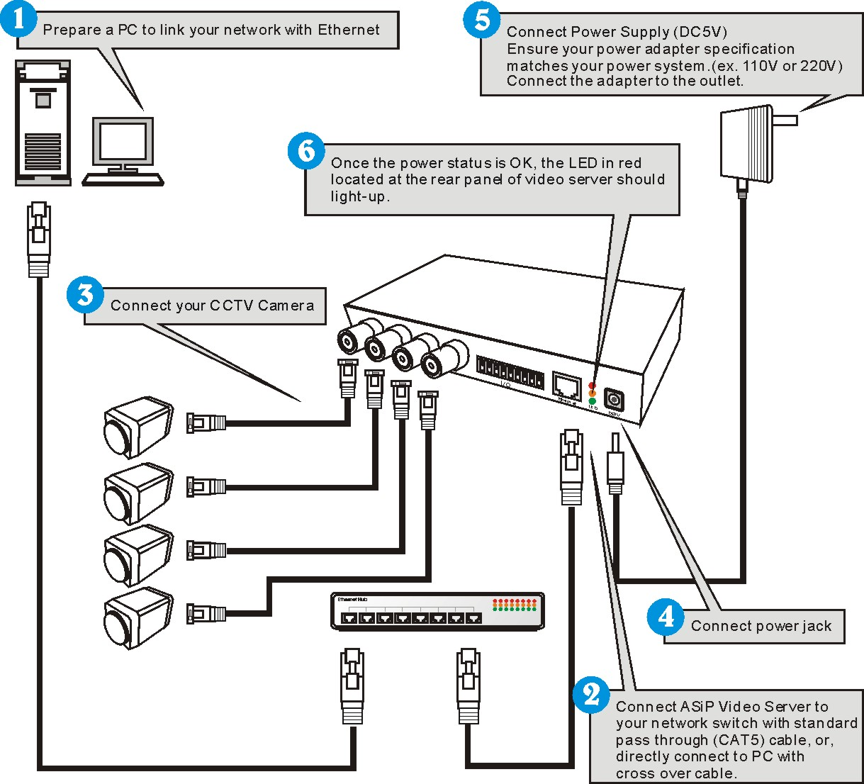

Network connectivity check
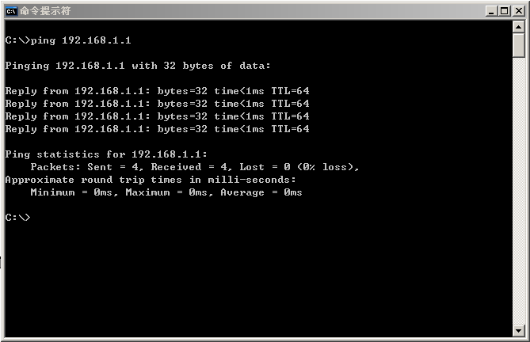
Please check your network connectivity before you start install the product. Confirm the link status of your LAN is OK. You may try use the following way to check the network.
Assuming you are under Microsoft Windows 2000 desktop, Click on Start button, Programs, Accessories, Command Prompt，Then there will be a blank window appear to wait command input. Please key in the following command to test the network status.

C:\>ping 192.168.1.1 [Enter]

*Note: the target IP address given above may be correct in common scenarios, if your network is not configured by IP segment 192.168.1.x, please change the IP Address to a valid address in your local network. Any difficulties please contact your network administrator for assistance.
If your network status is OK, the result of above command should like following

Pinging 192.168.1.1 with 32 bytes of data:
Reply from 192.168.1.1 bytes=32 time=10ms TTL=64
…
If you have confirmed your network connectivity is OK, Please proceed to next part of installation guide, otherwise, contact your network administrator to recover the problem.

Connect your CCTV Camera
Locate the Video Input connector (Marked in VinX) at the front panel of the Web Server and plug all the CCTV cameras to the connector by using a video signal transmission cable, finally, lock the BNC connector correctly.

Connect Web Server to network
Connect Web Server to your hub/switch by using a normal RJ45 cable, plug the RJ45 cable into the Ethernet connector locate at the rear panel of the Web Server, another side connect to your hub/switch.

Connect Power Supply
Connect the Web Server and power source with the adapter provided, plug the power adapter into the DC5V Connector. Once the power status is OK, the LED in red located at the rear panel of Web Server should light-up.

Start your first time network monitoring
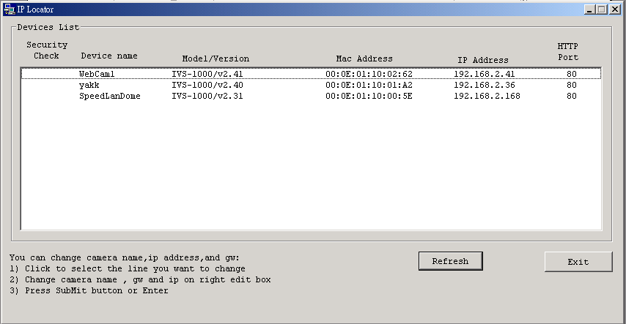
Run the “IPLocator30” utility, the newly connected Web Server will be listed in the application window. Please remember its’ IP address.
Open an Internet Explorer Window input the following address into the address textbox:

http://[Web Server IP Address provided by IPLocator]

After you press on the enter key, the main working interface and video picked by the camera should appear after a short period. The installation steps are completed. You may now start your first network monitoring experience. You may change the video channel by click on channel switch located at the left bottom of the screen.

Note: when you first time enter the working interface, the browser may ask whether to install a COMWebSurv component, which is used to communicate with our Web Server product, PLEASE CHOOSE YES to install, otherwise the monitoring function may not work.

How to visit the built-in web
Launch your Internet Explorer (I.E. 6.0 or above) first, then type the Web Server’s url. (i.e. http://192.168.1.100). The user validation is disabled as default, no login is necessary. The user is same as the system administrator (Default : root/pass).
For the first time user visits the Web Server, the ActiveX (ATLWebSurvCOM) will be downloaded to the [Downloaded Program File]. Be sure to click the button [Yes] as below.
Notes: Call your system administrator if you have not enough privilege to download the ActiveX. (i.e. Users should be the administrator to download the ActiveX for Windows 2000/XP operation system)
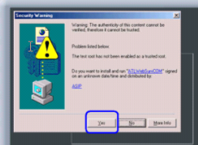

You can find the ActiveX ATLWebSurvCOM will be downloaded to the [Downloaded Program File] folder. The above dialog will pop automatically once new ActiveX is available(i.e. after firmware upgrade)
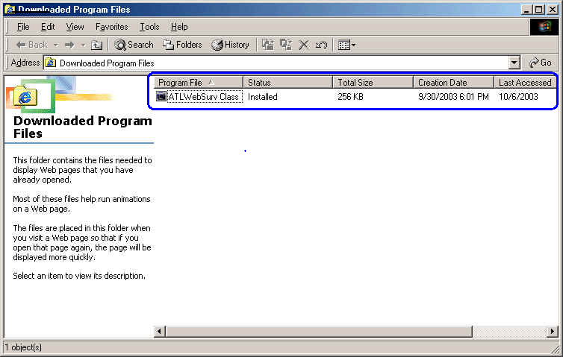

About the User Interface of Web Server
The upper window is for company logo display(i.e. This is a generic version. The company logo leaves blank). The left side of the window is the control panel. It is used for PTZ control, Dome preset point recall and image resolution change. The right window is for image display. (Please switch to full screen mode when the resolution is set to VGA mode) 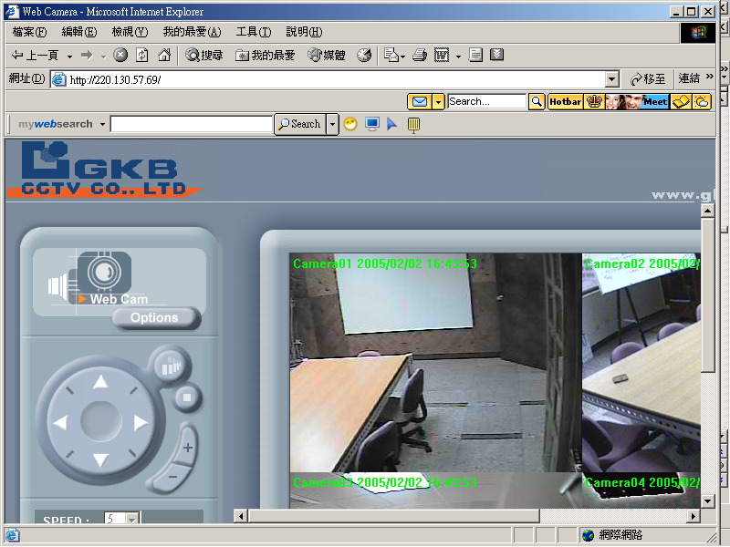

How to check the firmware version
Click the Web Server icon and you will read the firmware version
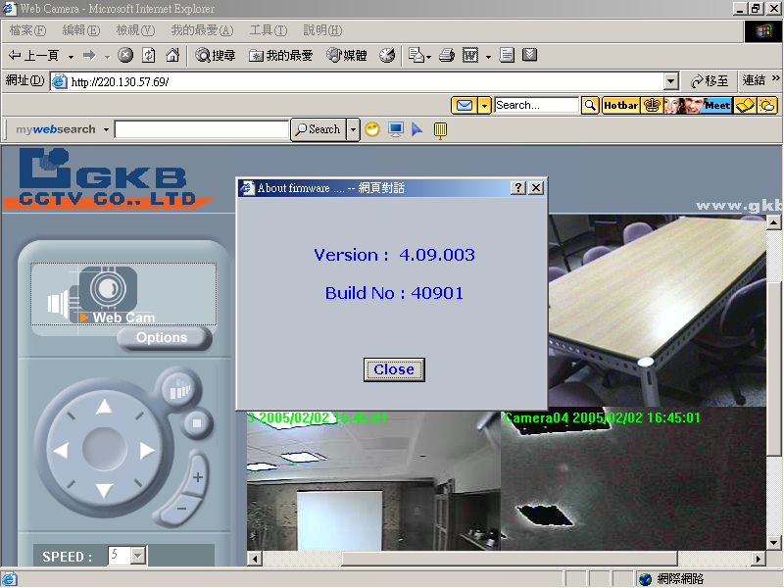

How to change the configurations
The system administrator :root is the one who has the privilege to change system configuration if user validation is enabled. The following window will appear when you click [Options] icon in the control panel (left side of the window). The follow is the description & field definition.
[System]:
Server Info: Server Model and Firmware Version
Device Name: the name of hardware device.
Video Mode: Video Mode (NTSC or PAL)
Time Zone: Time Zone Setting
Display Option
Show Camera Name: Show Camera Name on Display
Show Date Time: Show Date Time on display
Traffic Control: Bandwidth Setting
Others
Load default configuration: Load the factory default.
Reboot: Reboot the hardware remotely.
Firmware Upgrade : Upload & upgrade the Web Server firmware.
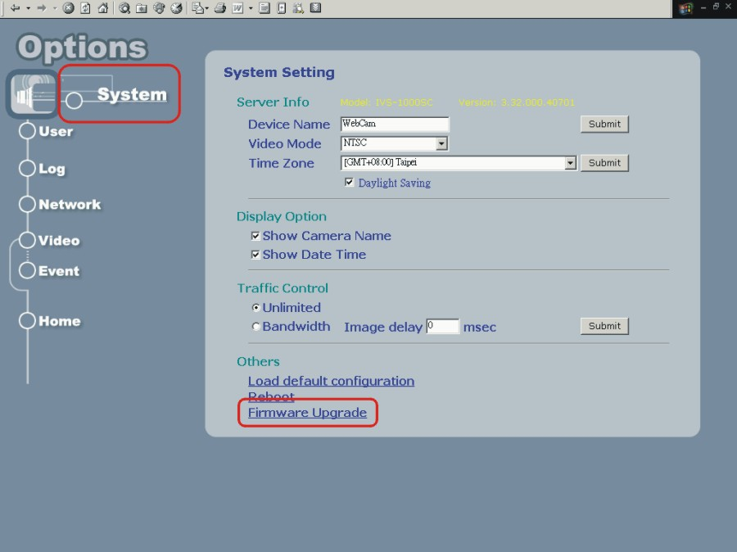

[Firmware Upgrade]: Please follow the standard procedure to upgrade firmware.
Step 0: Stop all unnecessary running application in your PC.
Step 1: Uncheck the [Browse..] and [Upload] motion images in the Motion Detection Setting and reboot the hardware. Note: You have to make all event setting to be disable, before you do this step.
Step 2: Set Image Quality to normal & Resolution to 352x288 or 320x240(or below)
Step 3: Reboot your Device
Step 4: Upload the firmware: Be sure to upload the correct firmware. Wrong firmware may cause your Web Server malfunction. It may take a few minutes to upload the firmware to memory depending on the network environment. Since too many unknown situation may occur in the Internet, we strongly recommend you to upgrade firmware in Intranet.
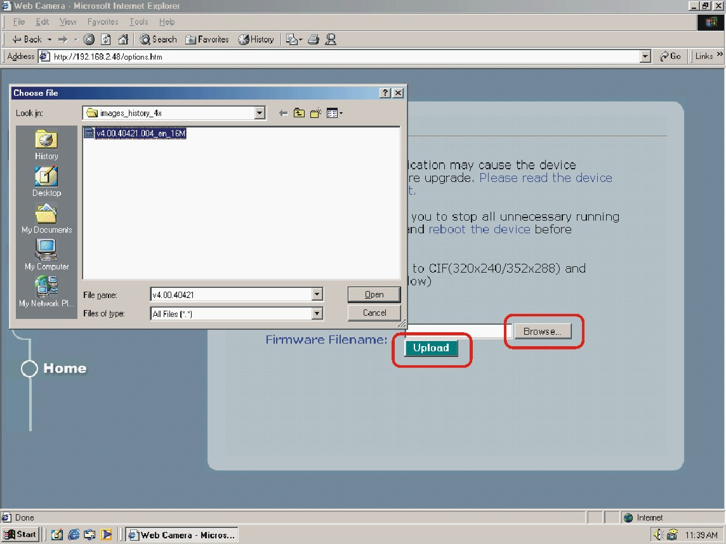

Step 5: Write firmware into Flash. It takes about 2 minutes to write firmware for the whole process. Please click [OK] button when the complete dialog pops up and the Web Server will reboot automatically. DO NOT reboot the device manually.
Note: Any interrupt during writing process will cause the Web Server malfunction.
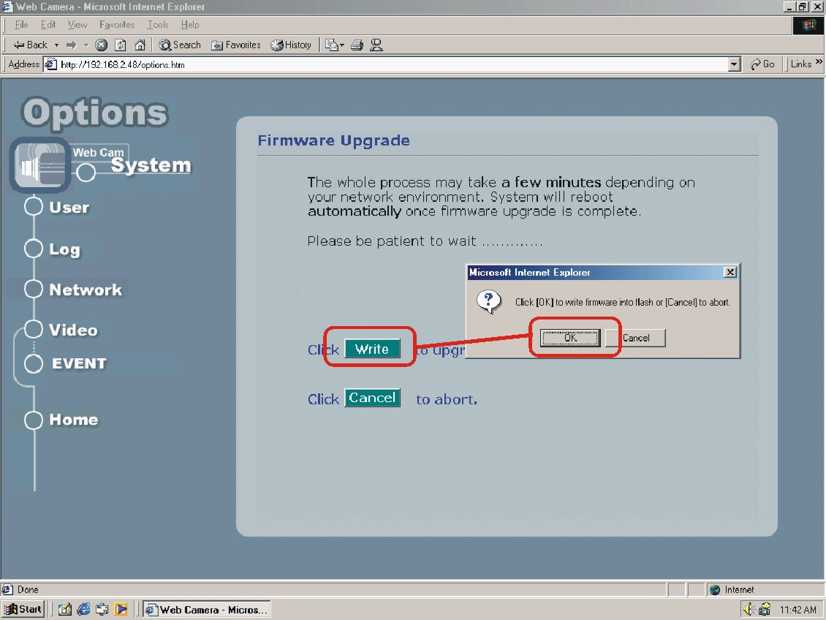

User Management
The administrator(root) has the privilege to manage users if User Validation is enabled. Here are the configurations available & field definition.
[User]:
User validation
Yes : Enable user check
No : Disable user check
Add/Modify User: To create new user or modify existing user password
Username : user name
Password: user password
Confirm : user password confirmation
Delete user: To delete existing user
Current User List: The users in the Web Server
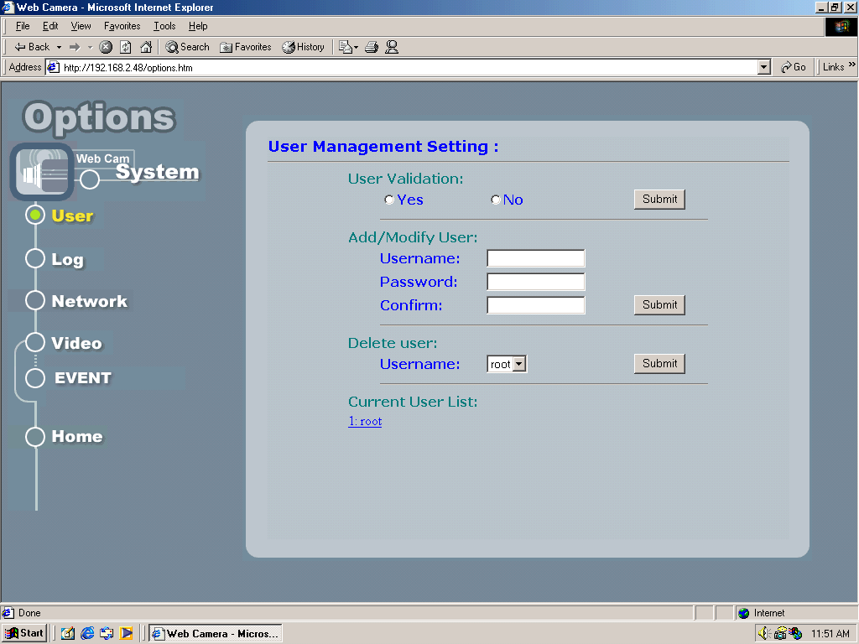

Log
The system log will be listed in the window when you click [Log] icon.
Operation: The operation which user operates
Value: The value to change
Client IP: The IP address of client PC
Client MAC: The mac address of client PC
Date time: date-time which operation occurs
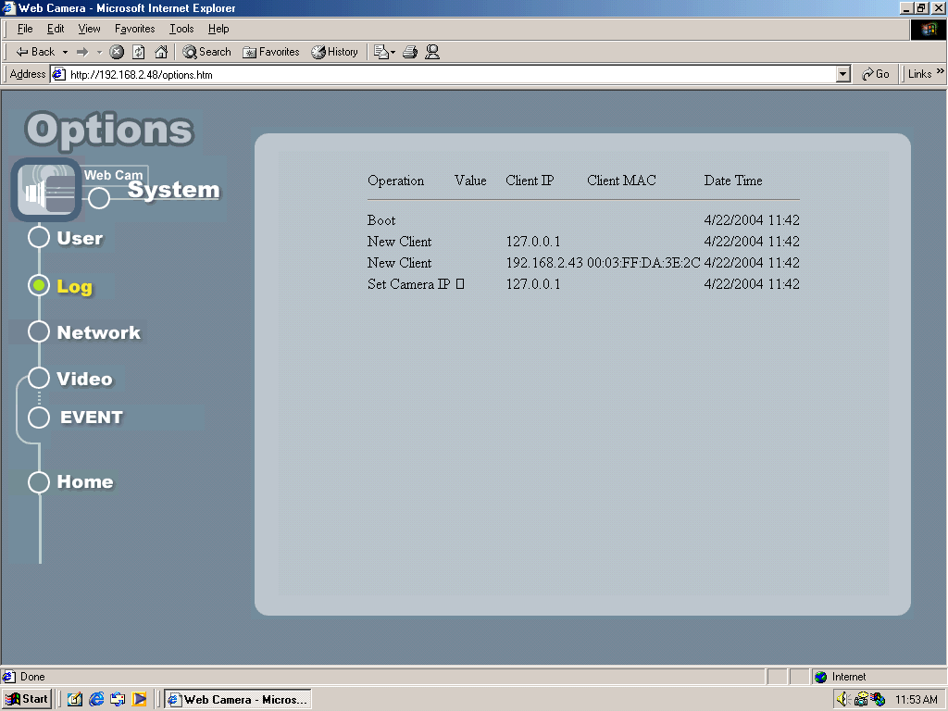

Network
Allows administrator(root) to change network setting when you click [Network] icon.
IP Setting: Please consult you networking manager for the following values
Manual: To set network setting manually.
DHCP: To let Web Server get network setting from DHCP server automatically.
IP Address: IP address of Web Server
Subnet mask: Subnet mask of Web Server
Default Gateway: Default gateway of Web Server
DNS 1/2/3: DNS Server IP if necessary
Http Port: Change the http port of built-in web server (default 80).
(i.e. range 80, 1025 ~ 65535)

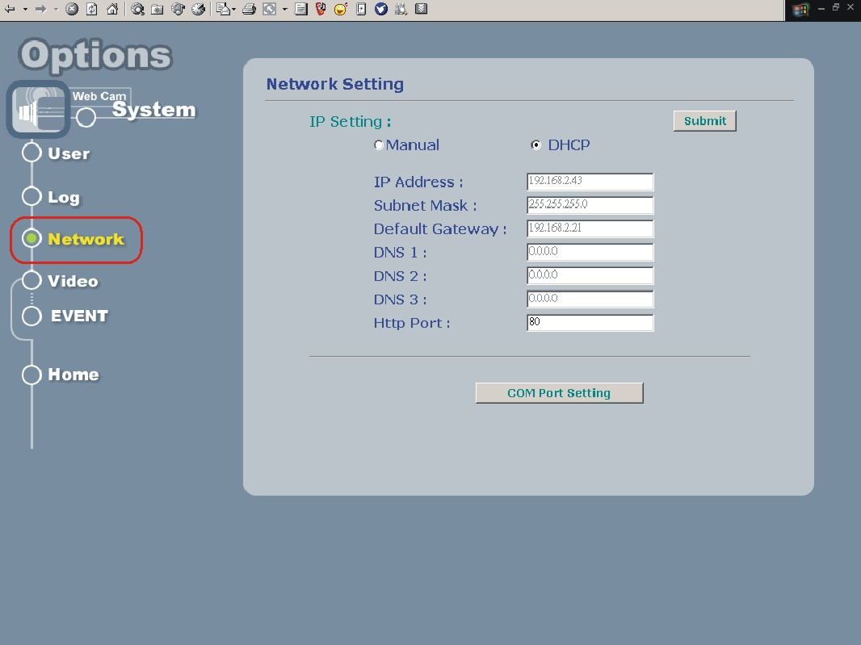

COM Port Setting:
COM Port: COM1 only
COM Port Mode: RS232/RS485
Baud Rate: 300 ~115200
Parity: None/Odd/Even
Data Bits: 5/6/7/8
Stop Bits: 1/2
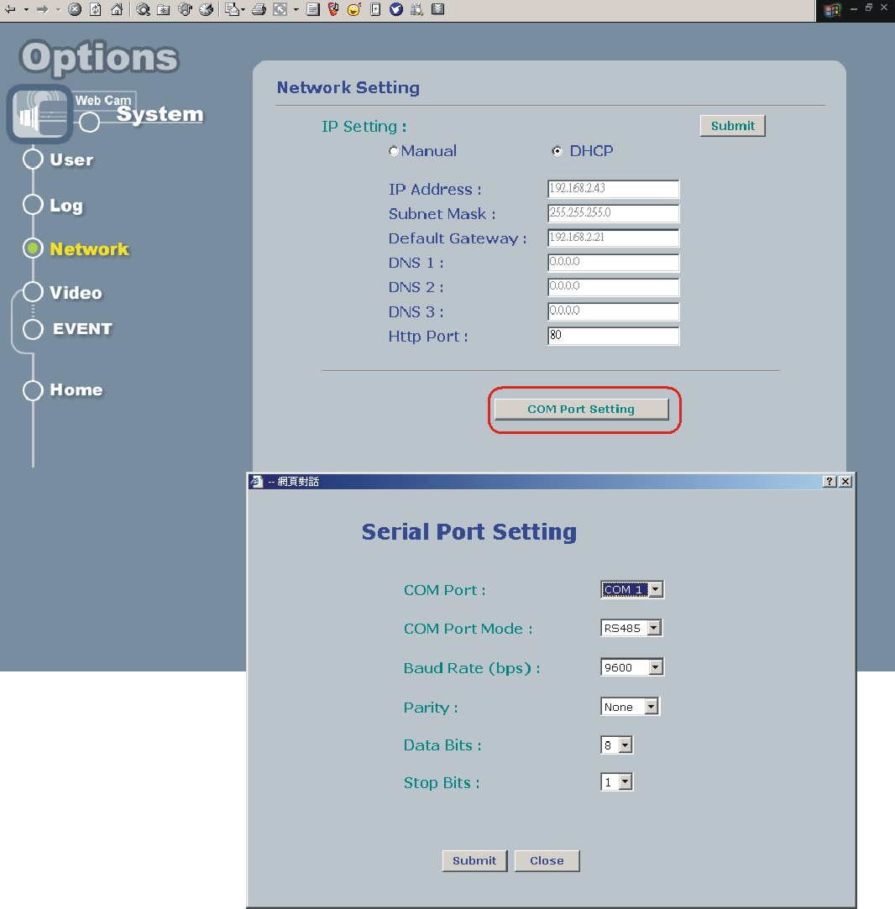

Video (by Channel)
Allows administrator(root) to change Image Setting, Traffic Control or Motion Detection.
Image Setting
Quality: Image Quality (Low/Normal/Good/Fine/Excellent)
Images Size: 160x120/176x144/320x240/352x288/640x480/704x576
Rotation: Nomal/180 degree (Upside down)
Advanced: Image preference adjustment
Brightness: Adjust image brightness
Contrast: Adjust image contrast
Hue: Adjust image hue
Saturation: Adjust image saturation
Traffic Control
Unlimited: To send out image at full speed. (up to 30 frames per second)
Frame per second: Delay to send image every x second(mini-second)

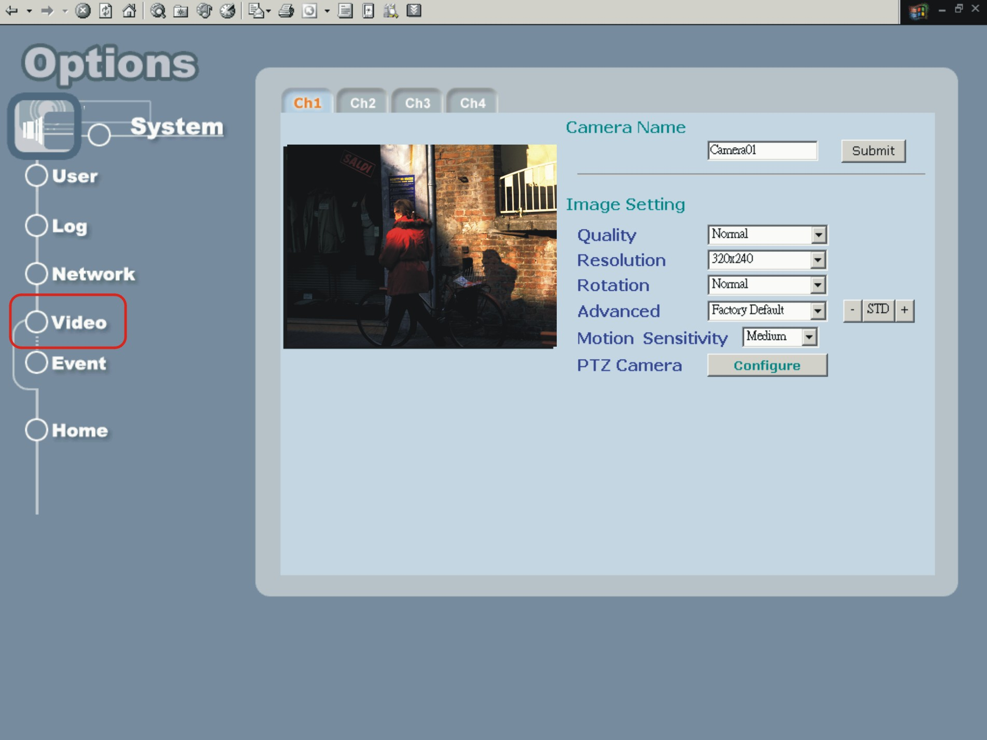

PTZ Camera
Allows administrator(root) to configure PTZ Dome. Please select the right model for your dome to make it work properly.
Dome Setting:
Dome Model: Dome model list which Web Server supports
Dome ID: ID for RS-485
Preset: The preset position of Dome camera
Location: The preset location name of Dome camera
Speed: Dome speed for Pan/Tilt/Zoom operation
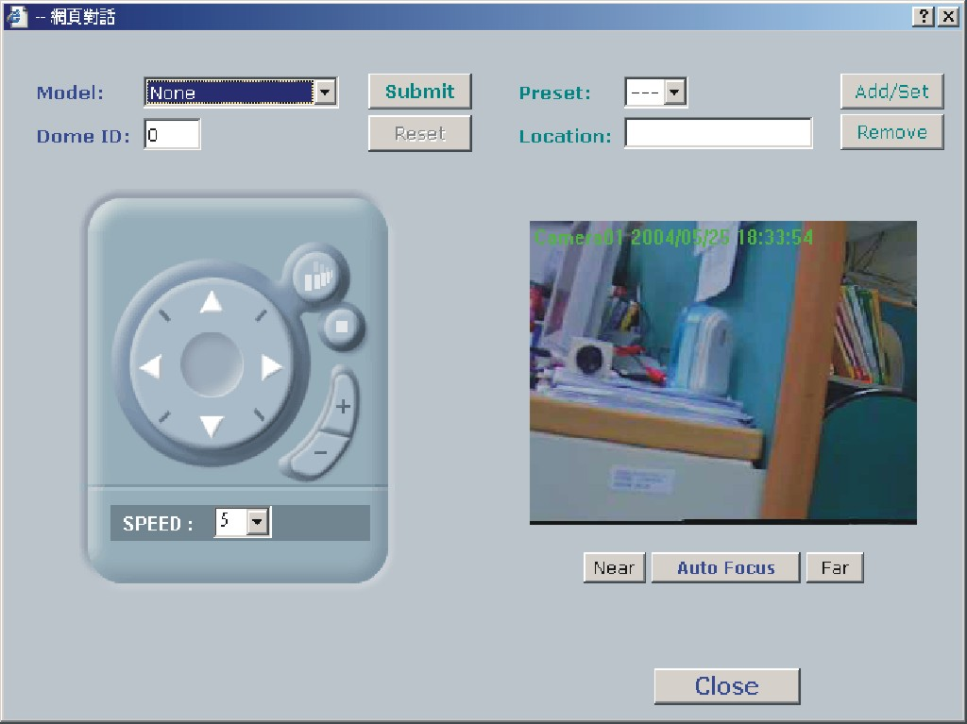
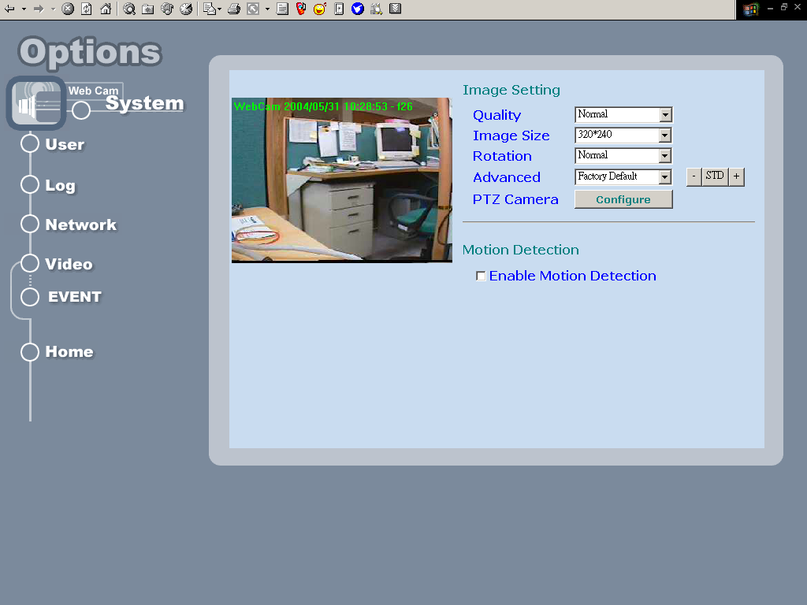

Event
This Option contains three major functions: Server Configuration, GPIO Configuration and Event Configuration
Server Configuration: User can setup Ftp and Mail services that provides the actions in 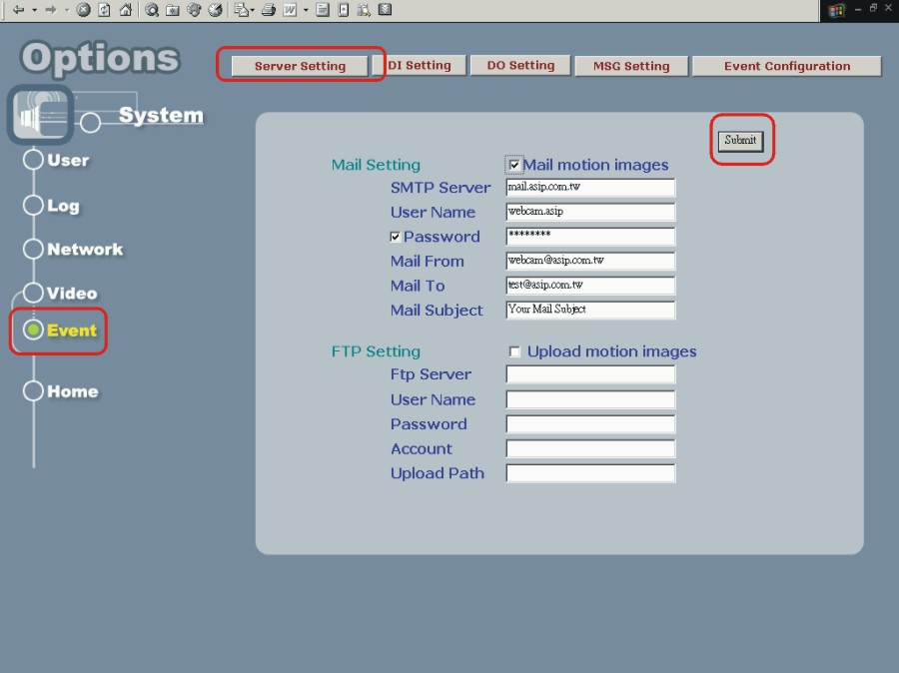

See figure below:

Allows administrator(root) to configure the mail & ftp setting once motion detected
Mail Setting: if check on Mail motion images, Device will send motion images
Mail Server: Name or IP of Mail server
Username: Username
Password: User password (Password will be validated if checked)
Mail From: Mail sender
Mail To: Mail receiver
Mail Subject: Mail subject
FTP Setting: if check on Mail motion images, Web DVR will upload motion images FTP Server: FTP Server
Username: Username
Password: User password
Upload Path: Images upload path

GPIO Configuration : Allow user to define types of digital input and their status.
See Figure below:
DI Configuration:
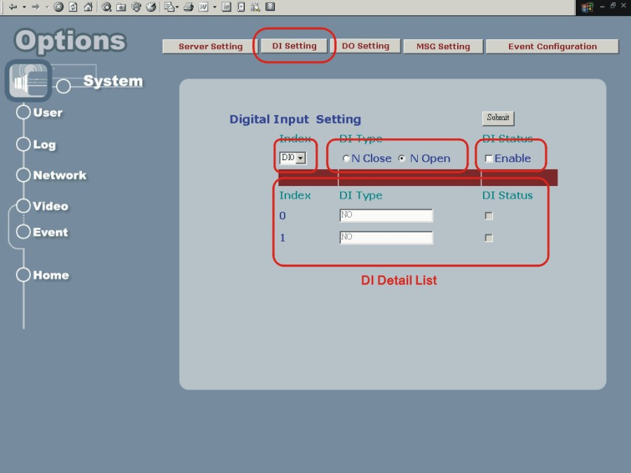
Index: the Index of digital input (range from 0-1)
DI Type: define type of digital input to : [Normal Open] or [Normal Close]
DI Status: Disable the DI or Enable it.

DO Configuration:
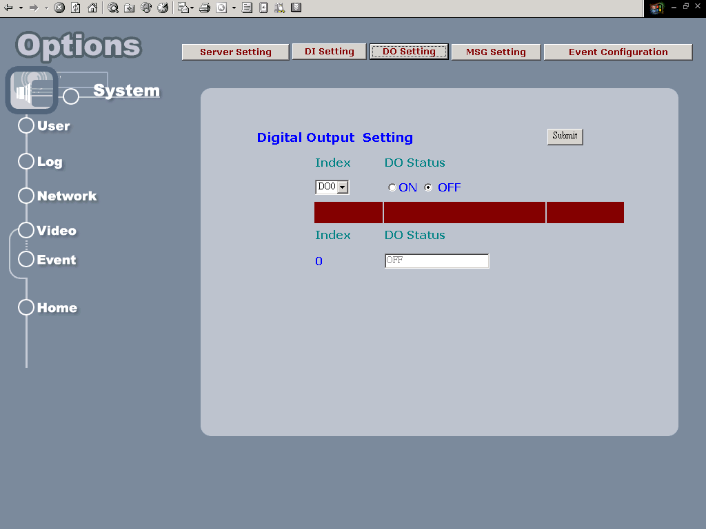
Index: the Index of digital output
DO Type: define type of digital input to : [Normal Open] or [Normal Close]
DO Status: Disable the DO or Enable it.

MSG Setting:
Alert Message function provides user the ability to send message to a remote server. Device manager can assign ip address , port number and message for remote server. Thus, Remote server can collect related alert messages via network when events are triggered.
[IP Adderss]: Server’s IP adderss.
[Port Num]: Http port Number.
[Message]: Message string.
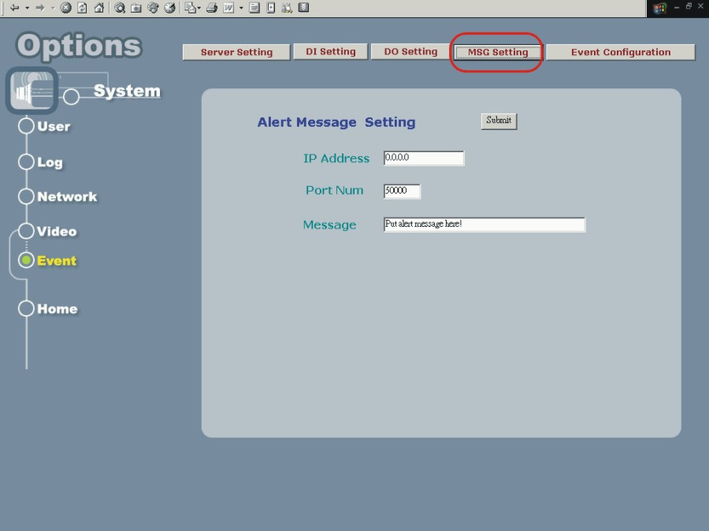

Event Configuration: User can select Event Index to locate Event (range from 0-2) and also decide to enable or disable this event. Three parts of event setting will be discussed below: [Trigger condition], [Delay time], and [Trigger Action]
[Source]: The [Input Type] contains DI0, DI1 and Motion Detection
[Eanble]: Select to Enable the Input Type that you selected.
[Delay time]: Duration that ignores same event trigger. Range from (1-30) sec
[Action]: Including FTP, MAIL, DO and MSG.
After System accepts trigger condition, related actions can be launched. FTP and MAIL will send image to remote area, thus; [Camera] is necessary for user to specify. DO is related to its index to specify which digital output (Only 0 is enable). MSG can send a string to remote server via TCP protocol which will be released soon.
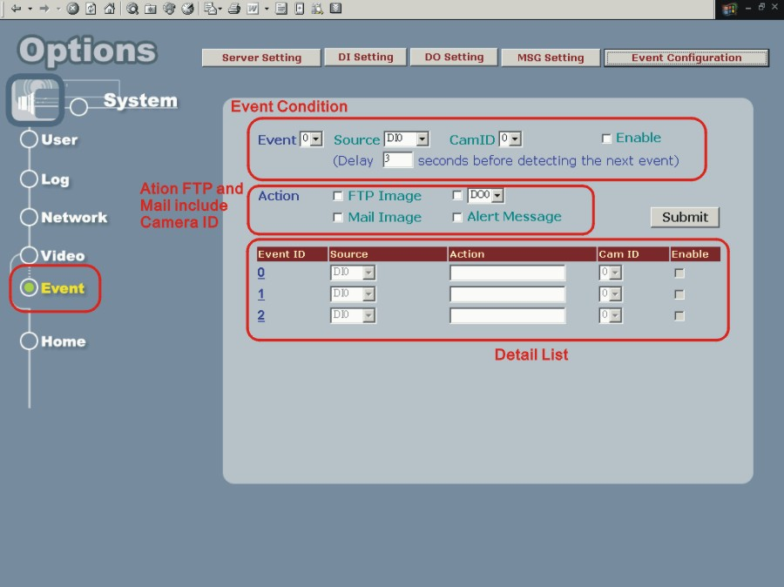

4. Product Specifications

Models
VSS-201: High Performance 4-Port Web Server

Specifications:
Items | Specifications
Model | VSS-201
Power
Supply | 5VDC, 2A
Consumption | ~10 Watts
Networking
Connectivity | 10/100 Ethernet
Protocols | SMTP, FTP, DHCP, HTTP
Internet | Built-In HTTP Web Server, DHCP Client
Event Controls
Trigger By | Motion Detect, DI
Alarm Notifications | FTP/Mail motion image, DO, Message
Video Input
Signal | Composite 1.0 Vpp at 75 BNC
Standard | NTSC/PAL Auto Detection
Video Output | N/A
Images
Compression | JPEG/MJPEG
Flow Control | Frame-Rate Controls
Format | NTSC:640x480/320x240/160x120  PAL: 704x576/352x288/176x144
Frame Rate | Single Channel  30 fps @ 320x240  25 fps @ 352x288
Frame Rate | 4-Channel:  22 fps @ 320x240  20 fps @ 352x288
Image adjustments | Brightness / Saturation / Contrast / Hue
Security Controls
Access Control | Administrator / User Level Password Protection
Configuration | Http Port configurable
Log | Historical Access Log Management
Serial Controls | RS-485
GPIO
Input | 2(opto-isolated)
Output | 1(Relay)
Firmware Upgrade | On-Line Firmware Upgrade
Operating Environment
Temperature | 5ºC~50ºC(45ºF~125ºF)
Humidity | 20% ~ 80%
LED Indications | Power, Network, Link, Network Transmission
Dimension | 202mm(W) x 35mm(H) x 110mm(L)
Remote Viewing | Windows 98/2000/XP IE6.0 or above

5. Appendix

Dictation

TCP/IP:
Transport Control Protocol/Internet Protocol, the protocol used to transmit data between hosts in Internet, which provides data verification and error protection

Web:
World Wide Web service is used on Internet widely, It’s provides interactive rich content by using a web browser

Firmware:
A program built in hardware, which is used to control the hardware, provides software level functions

MJPEG:
Motion JPEG compression algorithm, use to compress digital video

MPEG:
International standard video compression algorithm

DHCP:
Dynamic host configuration protocol, used on IP network perform IP address, gateway, DNS server assignment, etc for client computers

DNS:
Domain Name Server/Service is used to translate domain name in to IP address

LAN:
Local area network

WAN:
Wide area network, normally Internet

FTP:
File transportation protocol, used to transmit files between server and client

POP:
Post office Protocol provides Email storage and receive service

SMTP:
Simple mail transportation protocol, provides Email delivery and relay service

Hub:
Physical layer network inter-link device, which simply connect ports together and broadcasting the data packet to all the port.

Switch:
Data link layer network inter-link device, which provides end-to-end data packet forwarding,

Router:
Network layer device, which connect networks and provides the function named “Routing” to find the best way to transport data from source to destination

CGI:
Common gateway interface, a kind of program, running on a web server to provides dynamic data process function and interacts with users’ action

ActiveX:
Concept and standard gave by Microsoft, which separates program into functioning pieces named ActiveX Control. These control can be embed into users’ program to give their specific function.

