ASiP Inc.

WebSurv 2.0
User Manual

Version 2.0

INDEX
Part 1, Overview 3
Part 2, Software installation and system requirements 3
Part 3, Operation Procedure Guide 4
3.1 Introduction to Manager & Viewer 4
3.2 Operation procedures guide for WebSurv 2.0 Manager 6
3.3 Operation procedures guide for WebSurv 2.0 Viewer 16
3.4 Operation procedures guide for WebSurv 2.0 Playback 21
3.5 Operation procedures guide for WebSurv 2.0 Record 25

Part 1, Overview
ASiP series network video server is next generation digital network video surveillance system. It’s based on international standard communication protocol & computer network technologies used most advanced Motion-JPEG compression algorithm. Can provide high quality video both on LAN and Network environment with bandwidth limitation. (Such as ISDN, PSTN, etc.) In this infrastructure, user will no need to lay special video & control cable, just simply connect the device to the existing Ethernet interlink devices will make the system work.

WebSurv 2.0 software based on this system provides central management functions, which including

  - Video servers & network camera central management
  - Remote real-time monitoring
  - Remote user, permission management
  - Remote video server & camera management
  - Monitoring 1~16 channel video at the same time
  - Support network sharing devices
  - Support multi viewing mode: 4, 9, 13, 16
  - Central video recording management
  - PTZ remote control
  - Support multi point channel rotation

Part 2, Software installation and system requirements
Computer
Hardware | P-III 450 128 MB RAM or above
Software | Microsoft Internet Explorer 6.0
Display Sub-system | 1024 x 768 16bit
Network
Network connectivity | Ethernet 10/100 Base-T,VF-45 Fiber, 802.11b Wi-Fi

Part 3, Operation Procedure Guide

3.1 Introduction to Manager & Viewer
WebSurv 2.0 software including manager and viewer, the figure of Manager as below:
WebSurv 2.0 Manager
  - User manager, to add, modify & remove users of the system
  - Device management & configuration, which provides devices central management and various configurations
  - Motion detection manager, change motion detect settings for each device
  - Layout editor, user may edit there own monitoring window layout and use them on the monitoring software
  - Recording related setting

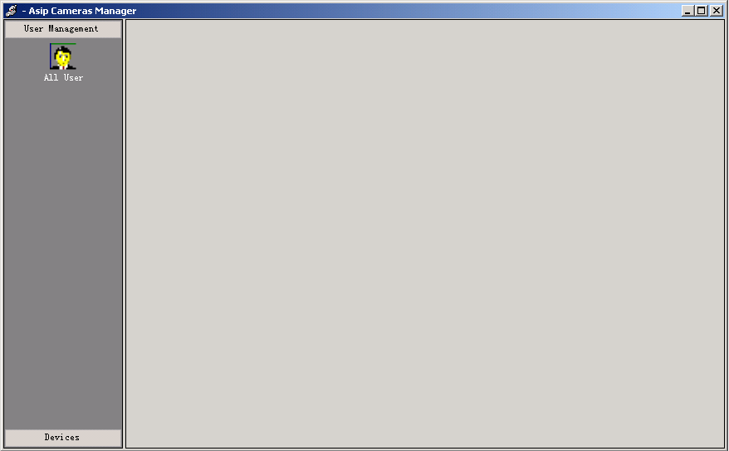

The figure of Viewer as below:
WebSurv 2.0 Viewer
  - View the video picked by devices in selected layout
  - PTZ protocols and movement control
  - Video parameters control
  - Snapshot
  - Bandwidth and framerate setting

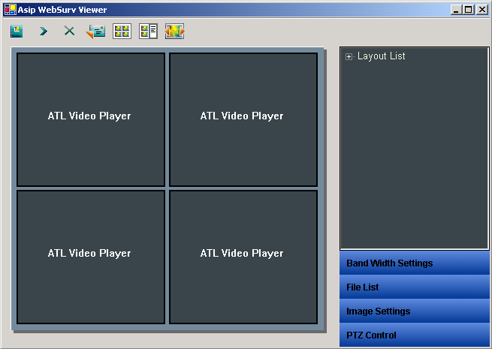

3.2 Operation procedures guide for WebSurv 2.0 Manager
After installation of WebSurv 2.0 software, system will create a Menu on your “Start” “Program” “WEBSURV APP”, click on the “Manager” will open the WebSurv 2.0 Manager program. You can login as an administrator by using the default administrator username “Admin” with password same as the username for the first time. After login successfully, you will see the figure as below:
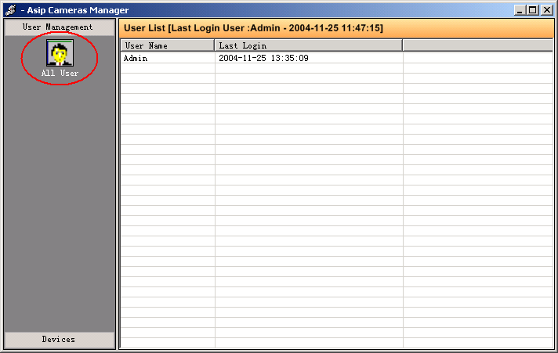

In this section ,you can set the USER and PASSWORD, Right click on the right district ,then a menu pop up, select “add new user”, a dialog box pop up ,then you can input the username password and privilege you want to set, click the “ok” button .
Right click the user name you want to delete, select the “del user” menu, then you can delete the user you selected.
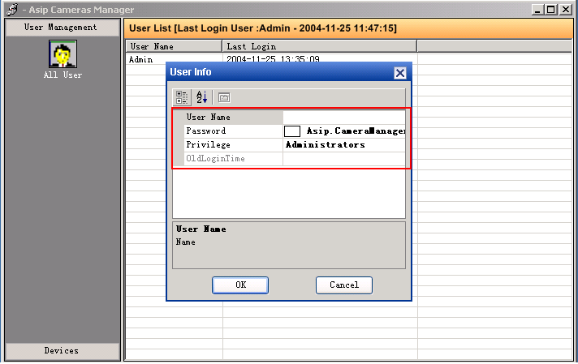

Click the left bottom button of the interface, you can set the device.
In the device setting section there are three buttons with the name “device setting”,”current cameras”,”layout manage”.

Device Setting: click the “Device Setting” button,then you will see the device setting interface.. double click the device ,then a dialog box pop up,you can set the“basic info”, “serial port ”, “mail”，ftp”,”event”.of the device.
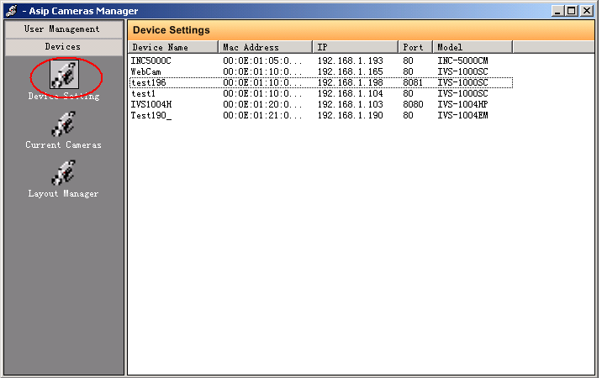

Basic info : record the basic information of the device, such as device name ,IP ,port, MAC,Model etc.
Serial port: record the serial port parameters of the device, such as baud rate, com, flow control ,com port model. data bits parity etc.
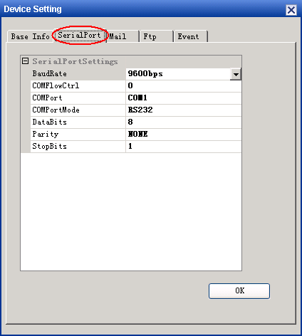
Mail: once the device detected the motion event in video, it will send the snapshot picture to a specified people by using standard Email
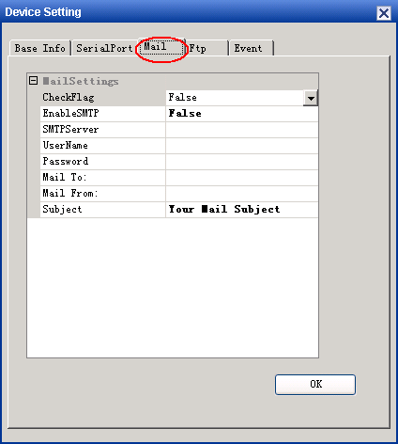

Ftp: once the device detected the motion event in video, it will upload the snapshot picture to a specified FTP Server.
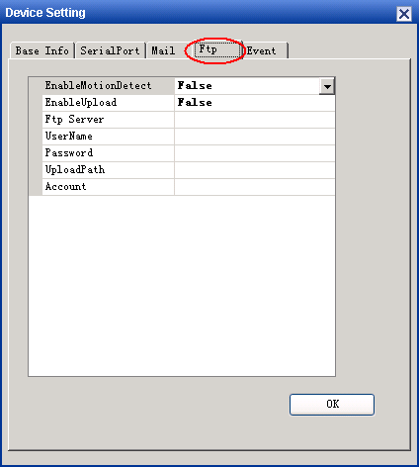
Event: this is set the event for a device. when the mail or the ftp function work,you must select one or multi channel for event.
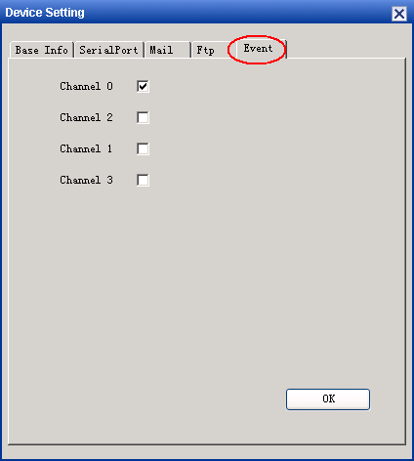
You may click the “ok” button every times as you complete every of above setting ,then click the right top “X” to close the dialog box.

Current cameras: click the “Current cameras” button,then you will see the current cameras interface .Right click the blank of the interface,you will see a menu with “add camera”,”delete cameras”,”property”,”record management”,”camera user”etc.

Add camera: there are tow methods to add a device , SCAN LAN and ADD BY HAND.you can select any of the tow methods to add a device.:
see figure below : This is add devices by “scan lan”,when you add by “scan lan”,All the cameras in the LAN will be located in a dialog box. Select a device in the box ,then click “select” button ,the device you select will be added to the cameras list, you may also add all the device to the camera list by selecting the “select all” then clicking the “select” button .
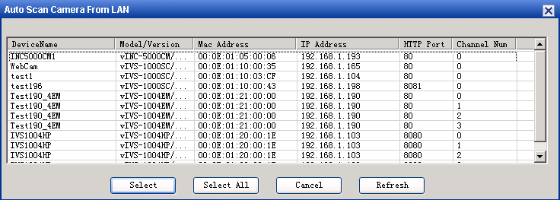

You can add devices to camera list by hand also. enter the IP ( If you view by Internet you may enter the Public IP and the PORT the IPshare assign to it of a camera you want to manage ) and PORT of the device you want to add to the cameras list.then click the “auto detection”button ,then the system detection the device automatically.
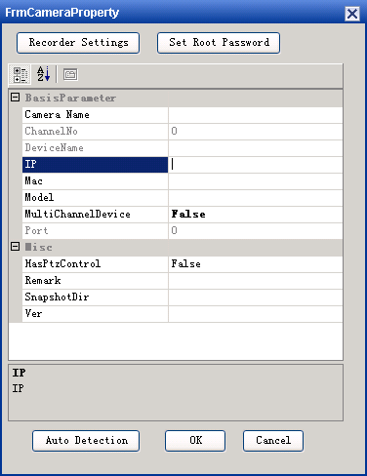

Delete camera: right click the device you want to delete, select the “delete camera”,the device will be deleted after a indicate pop up, click the “ok”,the device is deleted.

Property: the property show the basic parameters of the device and you can set the recording parameters snapshot parameters and the root password of device.(this dialog box is the same as the add device by hand ,please refer it )

Record setting: before you recording ,you must set the recording parameters, you may set the record path, schedule ,start time and end time etc.
The balance of the start time and the end time is the recording schedule, that is to say the device will record for the time of the balance.
Enable repeat is used to record repeatedly by the “hours”,”days”,”weeks”.
Schedule will end on show the recording over. So the time setting here is must bigger then the start time set before.
The “need alert” option is used to record when there is a alarm happened
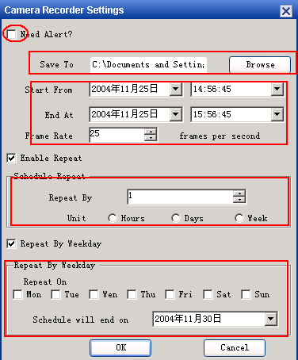

Snapshot parameters:here you may set the snapshot save path
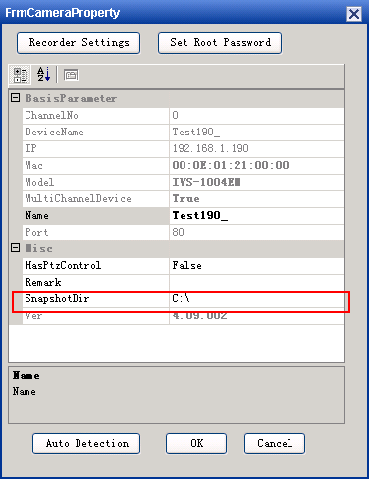

Root password: you can modify the device root password by click the “set root password” and in the dialog box ,you may enter a new root password for the device.
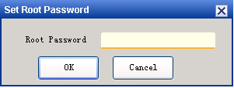

Cemara user: the user of the device, you can add/delete a user for a device by this dialog box.
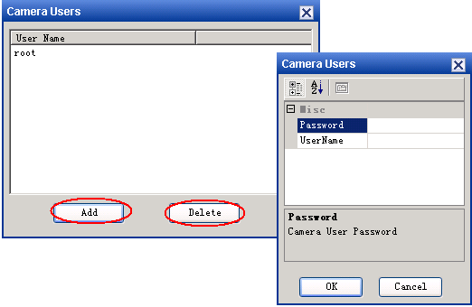

Layout manager: click the “layout manager” button,then you will see the layout manager interface.
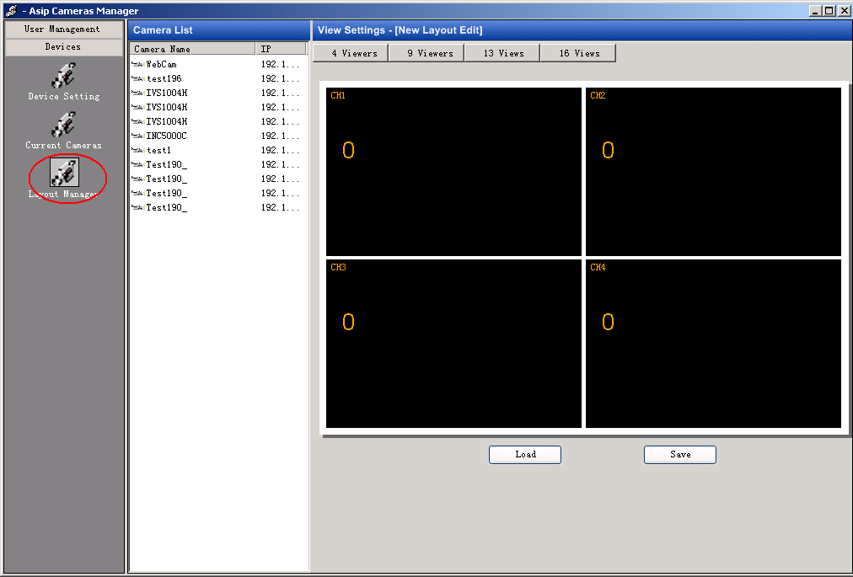

Websurv 2.0 software provide 4,9,13,16 channel view model .the layout setting of each model is same. the center column of the interface is the camera list .you can select a camera to be layout from here . the right column is the layout form. you may select a device from camera list and drag it to the right each form. once you dragged a camera to the form ,the form will show the number of the camera. See figure below:
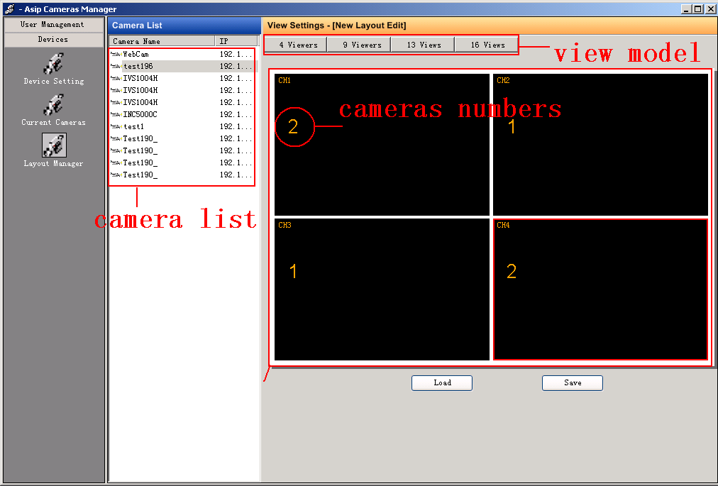
Websurv 2.0 software provide the rotating function, thus you may setting the rotating parameters here .first you must select more than one cameras to a little form , second right click the little form, three menu pop up, seclect the “rotation setting”,a dialog box pop up ,
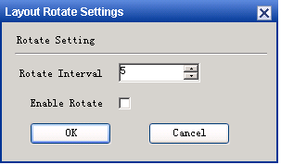
Check the “Enable Rotate” to enable the channel rotation to be used, increase/decrease the Rotate Interval as your need, then Click on “OK”.
The second menu of the three menu is “channel edit”, you can edit the cameras you want to rotate.such as move up/down or remove the cameras.
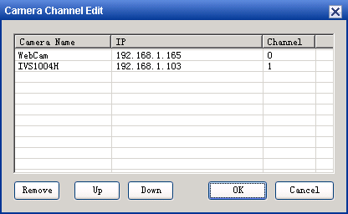
The last menu of the three menu is “clear cameras”,if you click the menu,the device you dragged to the little form will be delete thoroughlly.
When you complete the layout setting,you may save them, please click the right bottom“save”buttong ,there will be a dialog box pop up, give the layout file a name then click “ok” to save ,or click “delete” to remove a layout file.
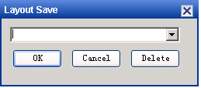
When you want to load or modify a layout file, you may click the center bottom “load “button.
Suggestion :The other view model layout setting is the same as above step. please refer it !

3.3 Operation procedures guide for WebSurv 2.0 Viewer
The WebSurv 2.0 Viewer is used to view video picked by devices, it can also make various control on devices.when you come in to WebSurv 2.0 Viewer from “START”.”PROGRAM”,”ASiP APP”,”VIEW”,there will appeare a dialog box for you to input your username and password. the username and password is the same as you set in the WebSurv 2.0 manager.(The default username and password is Admin)

To load a user defined layout
After you enter the view interface, you may load the layout file, double click right top “layout list ” of the window, select the layout file you want to load(these layout file are created in the manager and save to the database automatically), Once you load a layout file which number of channels equal to another profile you have originally loaded, the new setting will overwrite the old one.
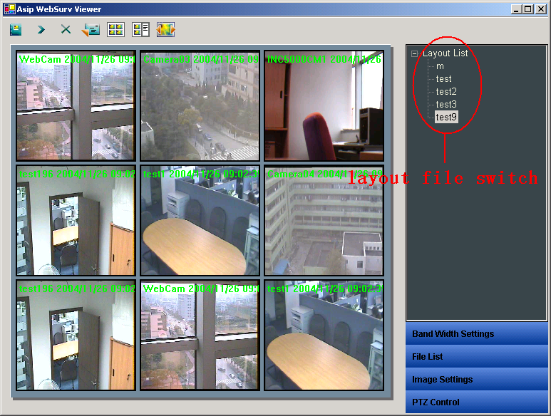
To switch view layout
In the earlier part, we mentioned the viewer can load different layout files at same time, to switch betseen multi layout is very simple, just double click on the different layout files located by the layout list at right top of the window. You may double click a single channel image to make it maximized for viewing reason.
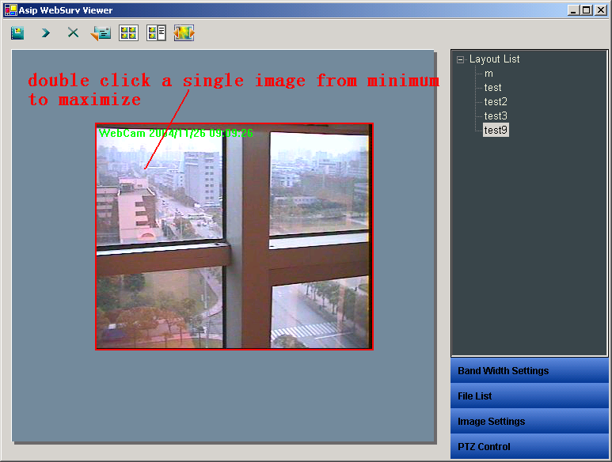
PS: the different view model layout files are defined and created in the manager, each file you may give a different particular name in order to you can differentiate them .when you want to switch the different files ,you only just double click these files located in the layout list on the right top of the window.

To configure Bandwidth Settings
On the window of view ,there is a slider bar for Bandwidth settings which is used to set per connection bandwidth ,Select the channel you want set, drag the bar marked “Bandwidth”, the bandwidth of the selected channel is changed when the bandwidth bar is dragged. When you drag the slider bar to the right direction , the selected channel bandwidth is become high and it’s frame rate is high too,but the CPU possess is high. On the contrary the selected channel bandwidth is become low and it’s frame rate is low too,but the CPU possess is low,when you drag the slider bar to the left direction.
There are three set button on the bandwidth setting ,set single for the one channel bandwidth setting ,set all for all the channel bandwidth setting ,and the cancel for cancel the setting.
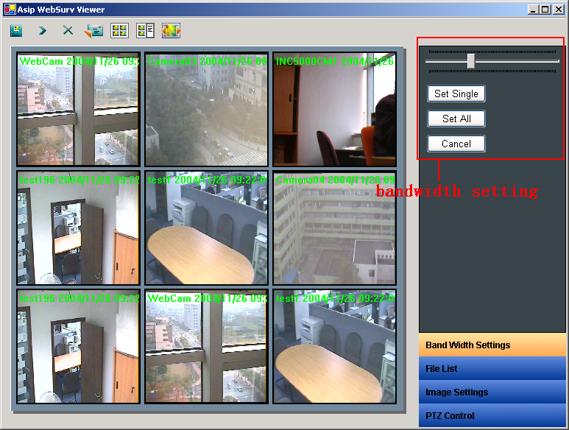
Suggestion: when you want to watch a smooth image only ,please drag the bandwidth bar to the right direction in order to add the frame rate of the selected channel but at the same time the CPU possess is high

File list
This section is the same as the To load a user defined layout ,please refer it.

Image setting
The image setting of this version contain image setting ,rotate and snapshot ,each of these functions has a shortcut button on the top of the window.
If you want to rotate a image, please select a channel image and double click the rotate, the image will be rotated 180⁰ ,you may click the rotate shortcut button on the top of the window also.
If you want to have a snapshot for a image, please select a channel image and double click the snapshot, the image will be save to the assign path you set in the manager before ,you may click the rotate snapshot shortcut button on the top of the window also.
If you want to set a image parameters, please select a channel image and click the image setting shortcut button on the top of the window also.there will a dialog box pop up,then you may set all the image parameters you want.

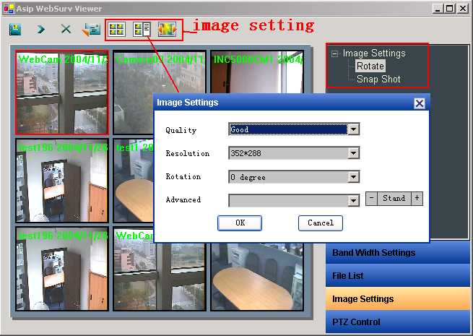
Control PTZ movement
Please note, before any action you want, you must active a channel by select it (click on the channel), the channel currently activated is marked in red.
In the picture above the PTZ movement related controls is masked by red color, once you selected a channel (support PTZ control) you can control the PTZ by using these direction controls & zoom in, zoom out & auto pan &stop etc functions. You may select the movement speed by using the combo box in PTZ Control section
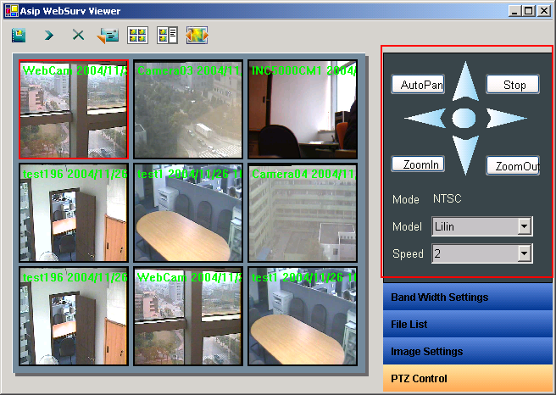

Recording
Websruv 2.0 provide the recording ,before any recording ,you must set the record parameters in the manager before. please refer 3.2 section about the record setting.
When you want to record ,just click the shortcut button of the record, there are tow shortcut button for record ,start and stop,click the start button the record beging and stop when you click the stop button.the record file will be saved to the path you assign before , please refer the below figure.
PS: when you click start button to begin record ,the record program will launched and hide for a salver in the right bottom automatically. and exit automatically when you stop the record, please refer the 3.5 record section.
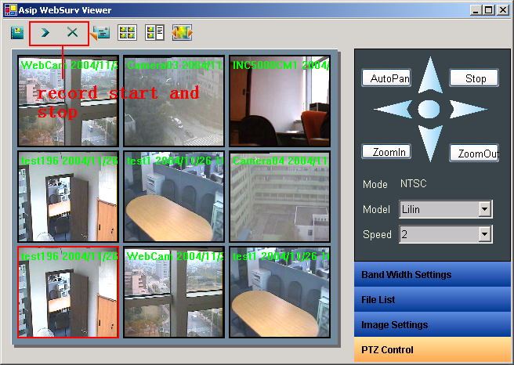
Open manager
When you want to enter the manager from the viewr model,you can click the shortcut button on the left top of the view window.the operation result is the same as entering the manager from the from “START”, “PROGRAM”, “WEBSURV APP”, “MANAGER”.
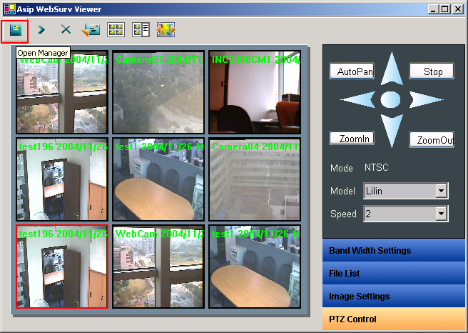

3.4 Operation procedures guide for WebSurv 2.0 Playback
WebSurv 2.0 Playback is one section of the WebSurv 2.0 ,you can click the WebSurv 2.0 Backplay menu from “START”, “PROGRAM” “WEBSURV APP”, “PLAYBACK”,then you will see the window below
Login:
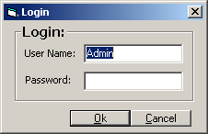
Please input your username and password ,which are set in the WebSurv 2.0 manager, then you will enter the initial playback window below
Note: Only Administrator and Power User can use the program
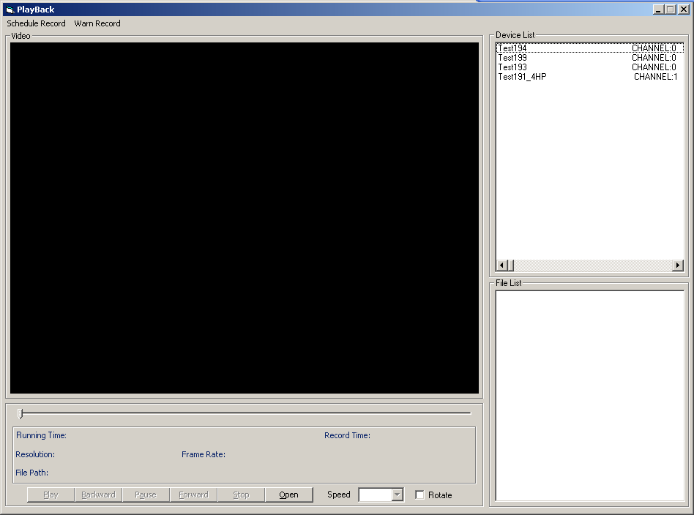
Black button is enabled, gray button is unable

Load file:

After you login ,you can see the playback window ,you can click the button and select a file you want to play ,then you can play the file you select
Note: This program provides multi-select, the interface like below
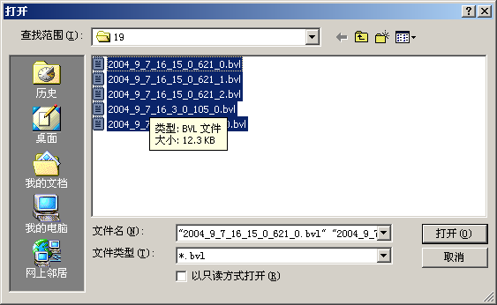
Of cause, you can also select the device name in the list box which on the top right corner. After you double click the device name which you selected, It will pop-up form like following picture
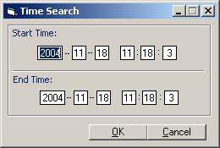
In this form you can see two labels on it.
First is “Start Time”,You can appoint the time when to begin.
The Second is “End Time”,You can appoint the time when to end.
After you click the OK button, the program will detect the time you have appointed whether include the files. If the files exists, the program will play it, otherwise you will get an error message.
Error Massage description:
1)．Set time Error：Start time should be smaller than End time!
2)．Start Time Not Currect; End Time Not Currect
3)．No history file found

Playing interface
The WebSurv 2.0 Backplay window is like below
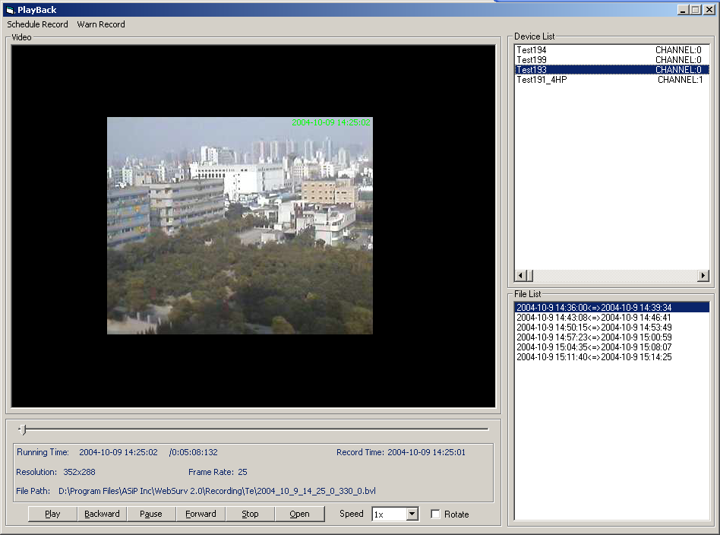

After you load the file you selected ,the playback is working, all button of the window is enable.
1． Resume button:
Function: Resume normal play
2． Reverse play button:
Function: Reverse play
3． Pause button：
Function: Pause play
If you want to resume normal play, please click Resume button again
4． Resume button:
Function: same as “play” button
5． Stop button
Function: Stop play
After you click the button, the interface will resume to initial interface but the device list box and file list box will not be clear.
6． Open button:
Function: Open the file which user selected
7． Speed set button:
Function: Speed down or speed up the playing speed.
When you want to resume normal play, please click resume button. again
8． Rotate Select Button:
Function: Rotate image 180 degree.
9. Scroll bar:
Function: You can click on the black scroll bar to appoint the position you want or you can drag the blue button to move anywhere.

Menu Illustration
1.Schedule Record: Load Devices and Files of the Schedule
2.Warn Record: Load Devices and Files of the Warning Recording
Of cause, you must set warning recording in the record application first and be sure the record application already recorded the warning recording.

Device List Box
The list box is on the top right corner. In it you can see all devices’ name which had recorded. You can select one of them, and double click to play.
When then device information is too long, there will appear a scroll bar, you can drag it to see over the device’s IP and Channel.

File List Box
The list box is under the device list box. In it you can see all files of the time you appointed. Of cause the files you load from disk will also add to it.
You can double click one file you selected to play.
When the file information is too long, there will appear a scroll bar, you can see over more information.
Note: You can press delete key to delete the record in list box.

File Information:
When you play the file, the file information will appear at right bottom corner.
File path：The path of the file
Resolution: The file of resolution
Record time: Time when the file recorded
Running Time: The playing time

3.5 Operation procedures guide for WebSurv 2.0 Record
WebSurv 2.0 Recording process is in background ,in order to realize your recording,you must load the WebSurv 2.0 Recording Schedule .
When you launch the Record function in the view interface or from ““START”, “PROGRAM” “WEBSURV APP” “RECORD”,the Record program will show for salver in the right bottom automatically.

click the salver ,you will see the window below:
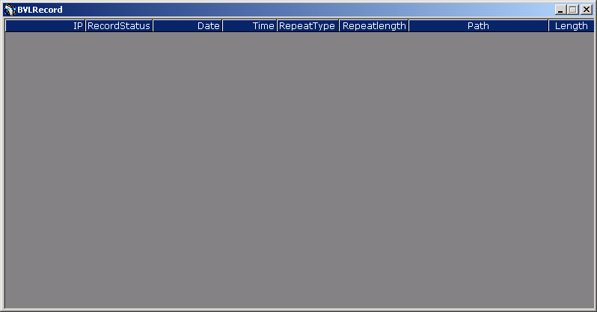
This window record the data which you set in the record management.

