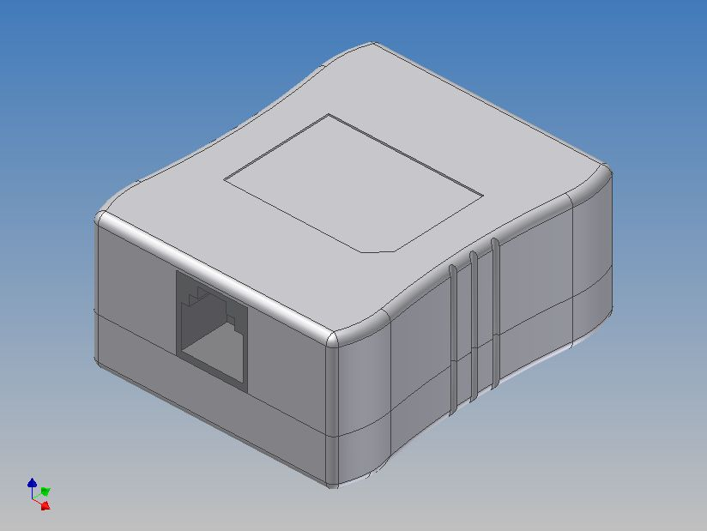 |  | - Compact package, includes connectors for ease of  installation  - Design for G.lite Application  - 100 mA DC Loop Current Capacity  ★ GOLD PLATING: 50u”

Specifications
POTS Port Impedance | 600Ω |  |  | DC Resistance each line | 12.5Ω Max
Insertion Loss @1004Hz | -0.3dB Max |  |  | Return Loss @SRL-L | 30 dB Min
200Hz~3.4KHz | +/-0.5 dB |  |  | @ERL | 20 dB Min
3.4KHz~4.0KHz | +/-0.75 dB |  |  | @SRL-H | 17 dB Min
Insertion Loss @1004Hz / 5 Filter | -0.5 dB Max |  |  | Attenuation @30 KHz | -26dB Min
200Hz~3.4KHz | +/-2.5 dB |  |  | @1MHz | -65dB Min
3.4KHz~4.0KHz | +/-4.0 dB
Isolation resistance tip/ring | 10M ohm Min
Dimension Schematic
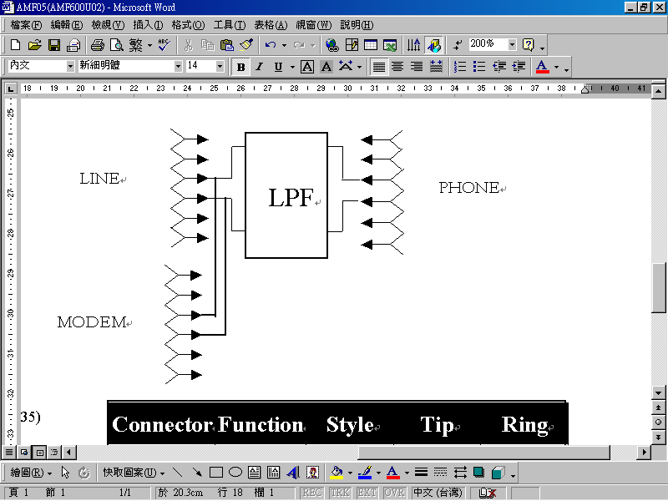

1
6
RJ11
Connector | Function | Style | Tip | Ring
J1 | Modem | RJ11 | Pin3 | Pin4
J2 | Line | RJ11 | Pin3 | Pin4
J3 | Phone | RJ11 | Pin3 | Pin4

Data sheet subject to change without notice

