S/W UPGRADING MANUAL
DATE: 2004-08-06

1. Upgrading Procedure with USB Flash Memory Stick
2. Upgrading Procedure through Network
3. Upgrading Procedure with CD-RW

The Kinds & Application of Updated Files
- logo_***.rui: to be used to change the logo appeared in booting DVR.
- kernel_***.rui: to be used to upgrade DVR’s operating system.
- ramdisk_***.rui: to be used to upgrade DVR’s application.
- image_***.rui: to be used to change DVR’s GUI and language.

1. Upgrading Procedure with USB Flash Memory Stick
1. Preparing for Updating
** Prepare for .rui file at ROOT of USB Flash memory storage equipment.
** Only one kind of .rui file should be in USB Flash memory storage equipment
2. Moving into “MAIN Mode”
After activating the window for changing Admin Pass word,
Input “12341234” instead of the current P/W, and press “Power” key, not “Select”
key.
And then it moves into “MAIN Mode” with being rebooted.
MAIN

BOOT
BUS
MISC
VIDEO
AUDIO
FILE
USB

3. USB Update
After inserting USB Flash into DVR, please go to the menu of “USB” on bottom of “MAIN Mode” menu, and then press Select.
Here
LOGO UPGRADE,
KERNEL UPGRADE,
IMAGE UPGRADE,
RAMDISK UPGRADE
are four kinds of sub-menu. Among them, please select what you want to upgrade.
After selection, upgrading begins. And the messages as follows are shown in a row during upgrading.
Ex: To upgrade LOGO
“LOGO” UPGRADING
COPYING

“LOGO” UPGRADING
ERASING

“LOGO” UPGRADING
(1 to 100) %

“LOGO” UPGRADE COMPLETED

5. When upgrading is completed, DVR is rebooted and go back to “MAIN Mode” again.
CAUTION
(Or depending on the kinds of USB Flash, “ “***** UPGRADINGE” 100%” may be shown, and DVR may not be rebooted, so it may not be get back to “MAIN Mode”. In this case, upgrading is completed, so please take out power code and put it in again, and then it goes back to “MAIN Mode” with being rebooted.

6. When you select “BOOT” in “MAIN Mode” and then “GO_DVR”, DVR is rebooted and upgrading is completed.
BOOT

MAC-ADDRESS
ENV-CLEAR
REBOOT
GO-DVR
POWER-OFF
SERVER-IP
SYSTEM

Compatible USB Flash Memory Sticks List with DVR (DATE: 2004-02-20)
- UNIDRIVE “KMF-UD” USB1.1, 128MB
- SANDISK – CRUZER mini (SDC22-128) 128MB
- IOMEGA "MINI DRIVE" USB2.0, 128MB
- Sony Macro Vault USB2.0, 128MB

2. Upgrading Procedure through Network
1. After connecting DVR to monitor and booting, please make sure to put DVR under LIVE DISPLAY.
2. Please connect DVR & PC to network (if you use CROSS CABLE, upgrading should be proceeded speedier and safer.)
3. Please install "Client S/W" into PC and run it.
4. Please input DVR’s IP address and P/W to connect into network.
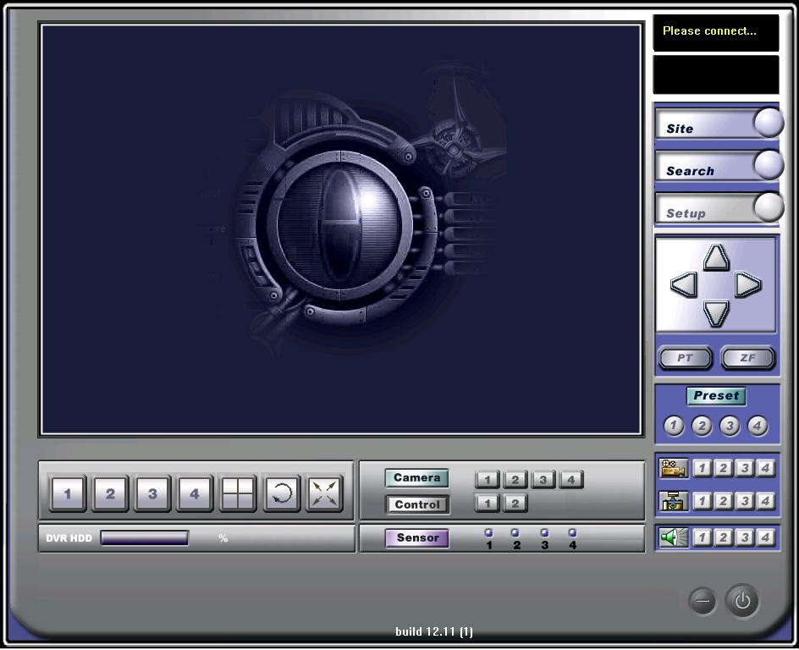
5. Click  of top right to move into setup, and then move onto “NETWORK.”
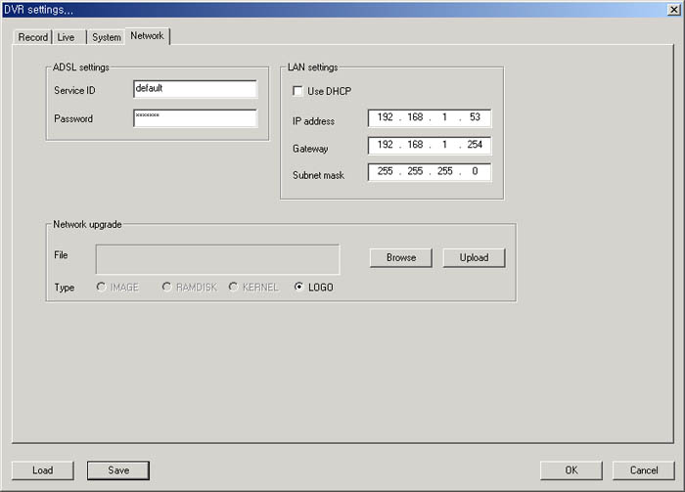
6. Please select what you want to upgrade on the type of "NETWORK UPGRADE.” (Ex. If you want to upgrade DVR’s Application, please mark "RAMDISK.”)
7. After selecting the file that you want to upgrade through “BROWSE”, please click “UPROAD.” In upgrading, DVR should be LIVE status.
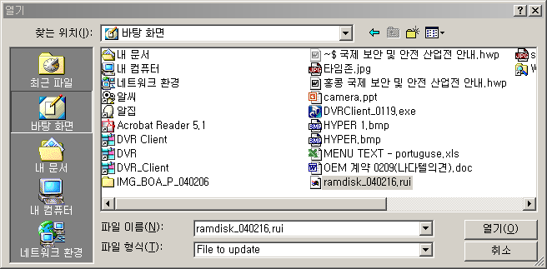
8. The status transferring upgraded file to DVR is shown as picture below. It may take several minutes depending on network status. (Please do not be confused. There is no indication during transferring.)
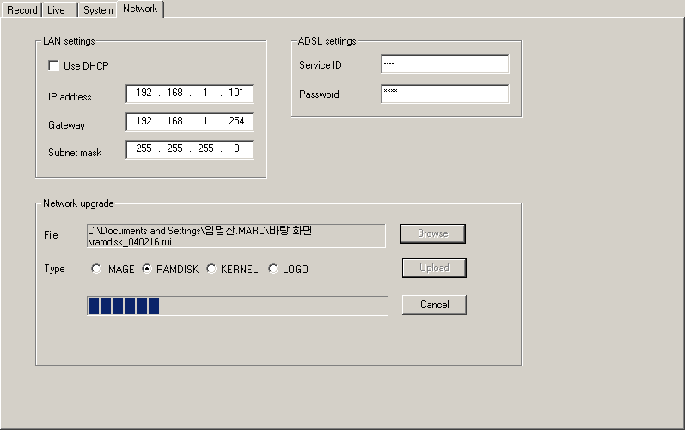
9. When file transferring is completed, window as follows is shown.
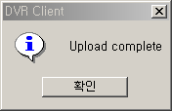
10. “UPDATING FLASH” on DVR screen is shown, and "UUUUUU" is flashing, and upgrading is proceeded.

UPDATING FLASH
UUUUU

11. When upgrading is completed, DVR is automatically re-booted.

3. Upgrading Procedure with CD-RW
1. Preparing for Updating
** Prepare for .rui file at CD-Media.
** Only one kind of .rui file should be in CD-media.
2. Put CD with .rui file in CD-RW
3. Enter into SETUP>STORAGE>S/W UPGRADE W/ CD-RW, then the window will appear.
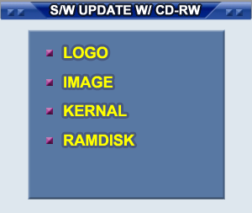
- Move the cursor and select one. Then the following window will appear. Selecet YES, then the upgrade will start.
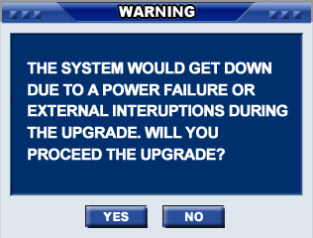
- When the upgrade is finished, the following window will appear. Then DVR will reboot.
