1.3Megapixel AHD Dome Camera
RL-9313H
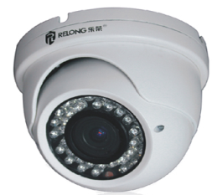
Product Features

- High Definition AHD 960P real-time video
- HD AHD video output,no delay,lossless,long distance transmission
- Progressive scan CMOS,capture moving object perfectly
- Reach 500 meters coaxial cable real-time transimission
- Support low illumination,auto color to black
- Support ICR switch, realize day&night monitore
- Support 3D noise reduction
- Metal shell,IP66
Model | RL-9313H
Image Sensor | 1/3" color CMOS
Resolution | 1280*960P
Image System | PAL/NTSC
Minimum Illomination | 0lux（LED ON）
Lens | Vari-focal 2.8~12mm
IR distance | 40m
Video Output | BNC×1
Frame rate | 30fps（60Hz）,25fps(50Hz)
D&N | Support ICR
SNR | >52dB（AGC off）
Electronic shutter | 1/60s~1/67500s
Auto-gain | Support
White Balance | Auto
Power | DC12V（±10%）
Operation Environment | ﹣20℃~ 55℃，10% ~ 90%（humidity）

