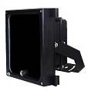
S-H301-IR-L
• Intelligent brightness control
• Deliver high power infrared light for CCTV & IP camera at night time and
improve performance of camera to get clear pictures.
• 50,000 hours lifetime of LED.
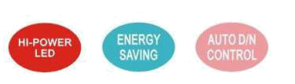
• 3/5 years warranty.

Professional Design
• Adopt WisdomEye intelligent infrared technology with sensitive photocell to disperses and focus the infrared light automatically. It provides global uniformity radiation to avoid less background light or over exposure of foreground at indoor or outdoor environment.
• Two stages of constant current circuit avoid LED away from instantly impulse impact when started.
• 50% design margin and accurate constant current circuit drive not only develop excellent performance of LED but maintain whole product a super long life of 10 years.
• Low failure rate of products is guaranteed by the professional in-house optimized independent circuit technology, which has been widely used in the illuminators for more than 5 years.
• Wide edge of silica gel circle and water stop line ensure IP66 waterproof and dustproof level.
• Twice direct cooling heat sink processing enable to increase the cooling coefficient and prolong the service life of the product.
• Patent design hexagonal spherical light sensor more accurately responses ambient brightness and improves accuracy of automatic light control.
• Flexible angle-adjustable bracket can extend the illuminance range widely.
• Robust cooling fin design is available the illuminator working at -40℃ to 50℃.
• Super energy saving circuit with low electrical power consumption.
Wide Range of Application
• Recommended for video surveillance at indoor or outdoor environment such as building, shopping mall, ports, railway, border, highway, etc.
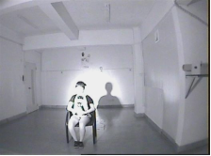
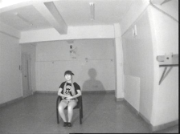
Intelligent Brightness Testing

The intelligent IR illuminator can detect the ambient infrared intensity. When the infrared light is too strong in the center of object, it will intelligently dim and disperse the light to become soft and uniform irradiation. When the infrared light is too weak in the center of object, the intelligent IR illuminator will enhance the light intensity automatically to improve the brightness to be stronger and brighter. It’s a smart infrared illuminator to provide global uniformity radiation for CCTV cameras, avoid lack of background light or over exposure of foreground at indoor or outdoor environment.
Without Intelligent IR With Intelligent IR

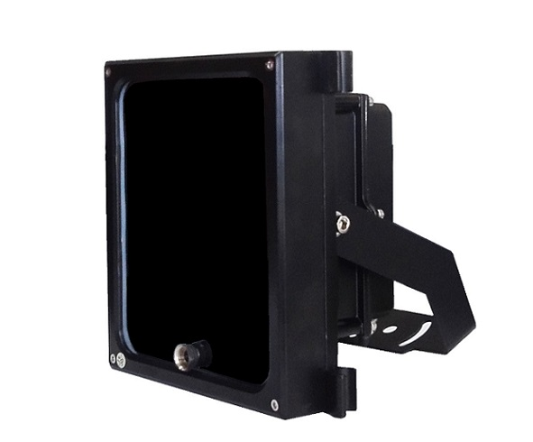
Picture Product Certificate




Technical Specification Drawing
LED type 30pcs 2W dot-matrix IR LED DC12V:
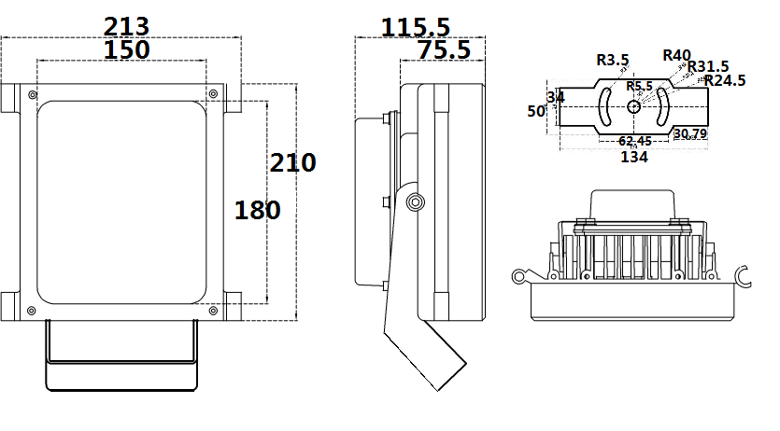
Wavelength 850nm
Voltage AC85-265V/DC12V/AC24V
Power consumption 50W (850nm)
Day and night switch Auto
Cable length 1.3meter
Mounting Wall mounting “U” bracket
Temperature -40℃ to 50℃
Grade of protection IP66
Color Black AC85-265V/AC24V:
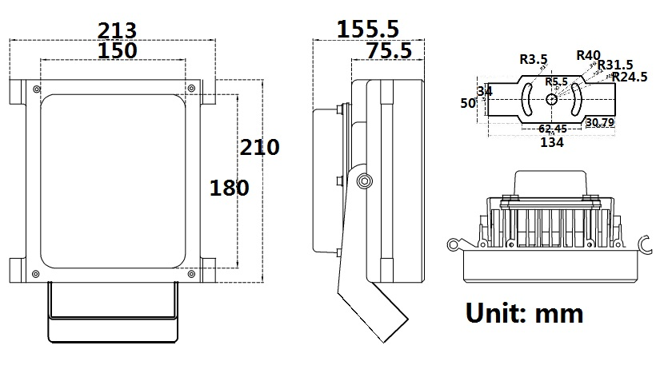
Housing Aluminium
Panel High light transmittance toughened glass
Net weight 3.3kg
Gross weight 3.75kg
Dimension 208*206*117mm
Packing dimension 300*260*200mm
Model for selection
Model Beam angle IR distance (850nm)
S-H301-30-IR-L 30° 150m*
S-H301-45-IR-L 45° 90m*
S-H301-60-IR-L 60° 70m*
S-H301-90-IR-L 90° 60m*
S-H301-120-IR-L 120° 50m*
*IR distance is tested by Sony 1/3 CCD Camera.
To achieve the distance needed, please pay attention to your camera specification and lens before purchase. It is normal phenomenon that distance may vary due to different cameras and lens.

