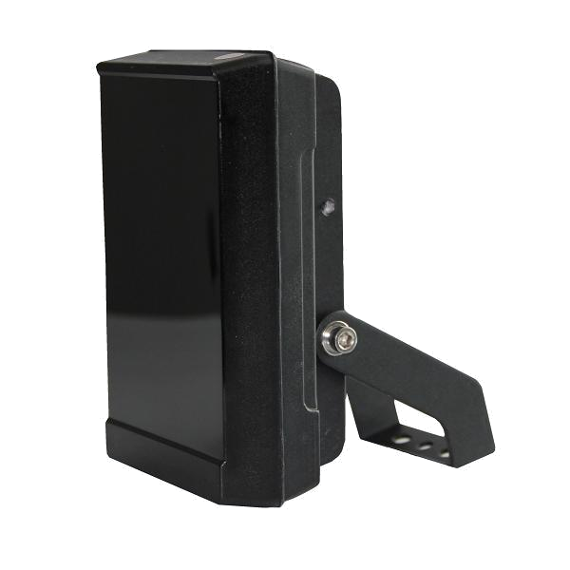

S-SG12-IR IR Illuminator
• Deliver high power infrared light for CCTV & IP camera at night time and
improve performance of camera to get clear pictures.
• Manual adjust power and sensitivity of light sensor.
• 2 years warranty.

• IK10 approved.
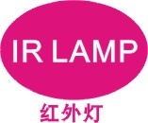
Product Features
• Precise secondary optical technology
The latest LED technology assures outstanding performance of LED with excellent luminous efficiency and more uniform illumination
• Independent innovation of high efficiency power drive schemes
Low failure rate of products is guaranteed because of professional in-house optimized independent circuit technology widely used in our LED illuminators for more than 5 years
• High thermal conductivity aluminum
Excellent thermal management not only reduces excess heat and brightness decay of LED but also ensures efficient, reliable and continuous operation of LED throughout its lifetime as 50,000 hours.
• Manual adjustable photocell and brightness
Easily set the time of Turn-on illuminator to meet any environmental brightness requirement and dim the brightness of illuminator to suitable light effect.
• Vandal resistant
Vandal resistant panel protects against hammer, stone and continuous thumping in a certain range.
• Energy saving technology
All illuminators has energy saving circuit with low electrical power consumption.
• Thinner and lighter design
Our patent owned housing is designed for simple installation and easy operation to reduce construction difficulty.
Basic Function
•To improve performance of the weak light camera, thereby enhancing the picture effects at night.
•Conventional night monitoring
•The function of video analysis at night
•Reduce signal noise and other image distortion
•Reduce the network bandwidth requirements
•Energy saving by power factor correction
•Lower cost of installing and wiring
•Indoor and outdoor use
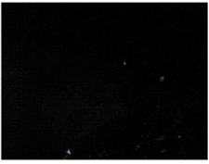
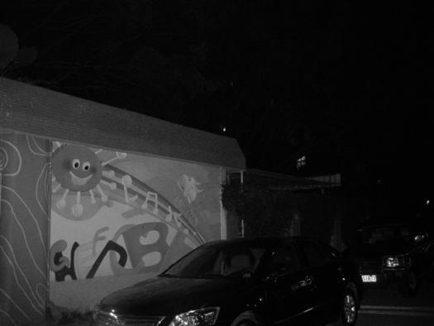
Viewing picture at night

With IR light Without IR light

Picture

Technical Specification
LED type: 12 pieces high power IR LED
Wavelength: 740nm/850nm/940nm
Beam angle: 15 to 120°
Beam distance: 150m to 30m (850nm)
Bracket: wall mount bracket
Working voltage: DC12V
Current: 1500mA adjustable (850nm)
Power: 18W
Day/night switch: automatic/adjustable
Working temperatures: -30°C to 50°C
Protection level: IP66
Color: black
Panel: vandal proof PC panel
Housing: aluminum die-casting housing
N.W.: 0.82KG
G.W.:1.1KG
Packing dimension: 185*155*110mm
Model for Selection
Model Beam Angle Distance (850nm)
S-SG12-15-C-IR 15° 150m
S-SG12-30-C-IR 30° 100m
S-SG12-45-C-IR 45° 70m
S-SG12-60-C-IR 60° 50m
S-SG12-90-C-IR 90° 40m
S-SG12-120-C-IR 120° 30m
*IR distance is tested by Sony 1/3 CCD Camera with 0.01LX.
To achieve the distance needed, please pay attention to your camera specification and lens before purchase. It is normal phenomenon that distance may vary due to different cameras and lens.
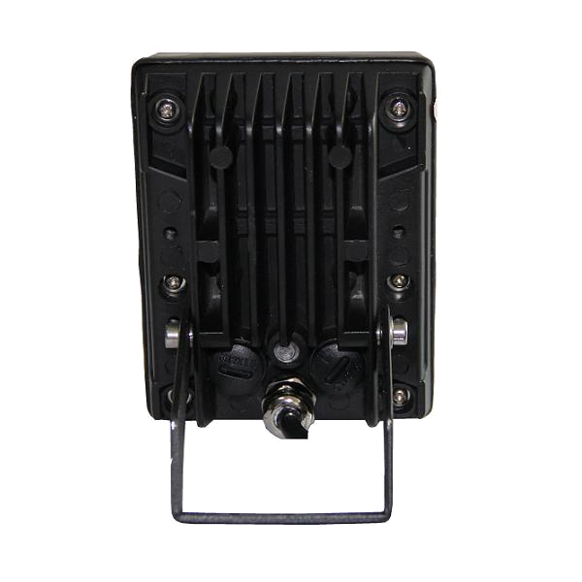
Adjustable Function

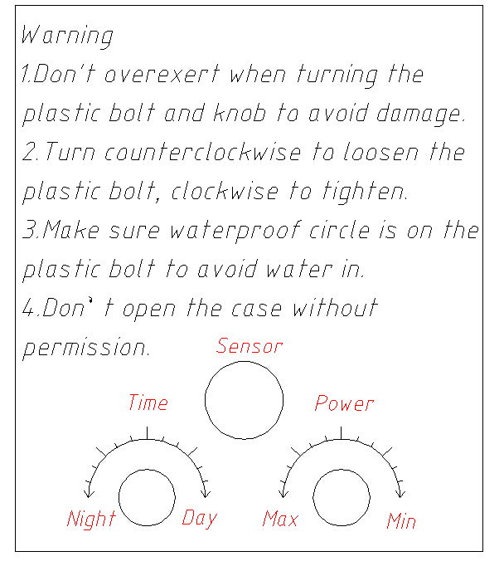

DC12V Version
This side must be downward!

- Both wires of power and led panel must be downward to avoid water in.
- Power wire must be grounded and lighting protection measure must be done.
- Adjust the bolt of brightness, sensor and time slightly, do not be so rude.
- Install and adjust by professional electrician or quality technician.
- Do not open the case and remove the power supply.


Product Certificate




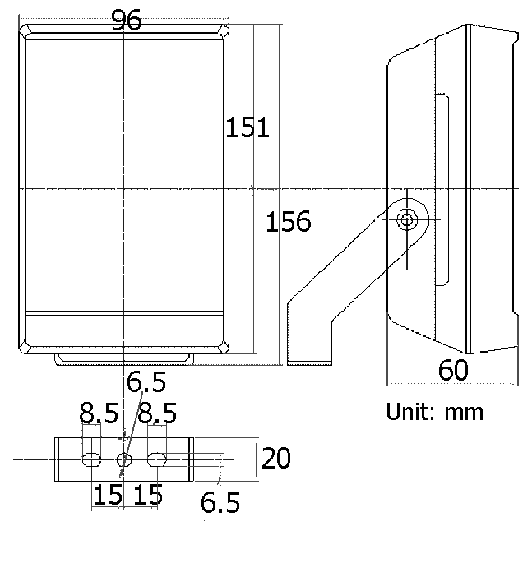
Drawing

