GOLDEN H SERIES WHITE LIGHT ILLUMINATOR S-H063-W
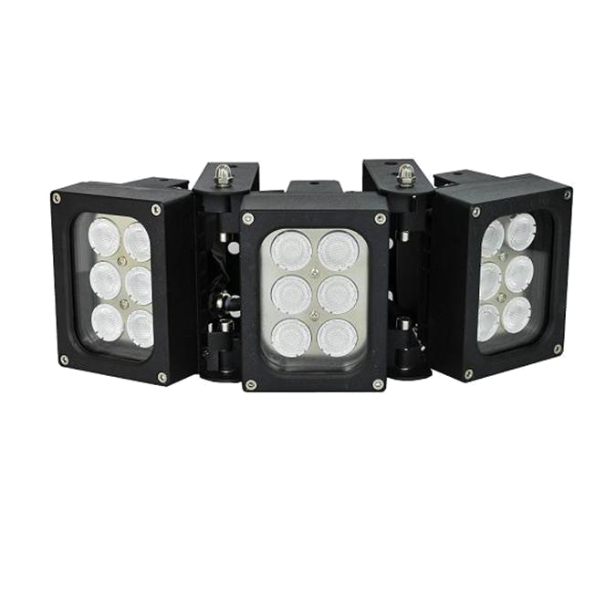
The H series of High Power White Light illumiantor is a top performance,
long service life LED light source of lighting . Accurate constant current
circuit drive not only develop excellent performance of LED but maintain
whole product a super long life of 10 years.

They're suitable for civil, industrial and commercial surveillance/lighting.
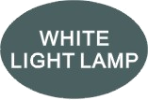
Professional Design
· Two stages of constant current circuit avoid LED away from instantly impulse impact when started.
· A wide edge of silica gel waterproof circle and water stop line ensure excellent waterproof performance.
· Twice direct cooling heat sink processing enable to increase the cooling coefficient and prolong the service life of the product.
· Patent design hexagonal spherical light sensor more accurately responses ambient brightness and
improves accuracy of automatic light control.
· Flexible angle adjustable bracket can extend the illuminance range widely.
· IP66 waterproof and dustproof housing available work at ambient temperature -40℃ to 50℃.

Qualified Material
· Super power dot-matrix white light LED with strong light effect, long service life and low light decline.
· High efficient twice optical lens processing achieves 90% of the luminous efficiency.
· The housing adopts high thermal conductivity aluminum to enhance heat dispersion property.
· Stainless steel bracket and screw ensure low maintenance.

Wide Range of Application
· Recommended for security at ports, railway systems, border, prisons, traffic LPR/ANPR, ITS as well as large public places lighting.
· 50,000 hours lifetime of LED
· 3/5 Years warranty

Basic Function Viewing Picture at night
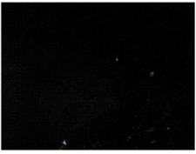
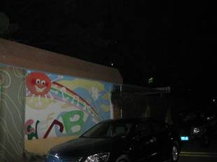
•To improve performance of the weak light camera,
thereby enhancing the picture effects at night.
•Conventional night monitoring
•The function of video analysis at night
•Reduce signal noise and other image distortion
•Reduce the network bandwidth requirements
With white light Without white light
•Energy saving by power factor correction
•Reduce the equipment cost
•Lower cost of installing and wiring
S-H063-W Product certificate




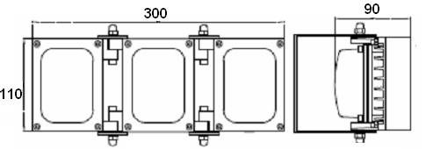
Technical Specification Drawing
LED type 18pcs dot-matrix white light LED
Color temperature 3000-3500K/5500-6000K
Luminous Flux 1980lm-2160lm
Voltage AC85-265V/DC12V/AC24V
Power consumption 36W
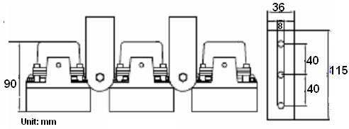
Day and night switch Auto (build in photocell)
Cable 1.3M waterproof Cable
Mounting Wall mounting “U” bracket
Temperature -40℃ to 50℃
Grade of protection IP66
Color Black
Housing Aluminium
Panel High light transmittance toughened glass
N.W 3.0KG
G.W 3.9KG
Dimension 300*110*90mm
Packing dimension 550*180*220mm

Model for selection
Model Beam angle Viewing distance
S-H063-15-W 15° - 45° 120m-70m
S-H063-30-W 30° - 90° 100m-50m
S-H063-45-W 45° - 135° 70m-35m
S-H063E-60-W 60° - 150° 60m-30m
S-H063D-75-W 75° - 165° 50m-25m
S-H063E-90-W 90° - 200° 25m-15m
S-H063E-120-W 120° - 230° 15m-10m
*Viewing distance is tested by Sony 1/3 CCD Camera.
To achieve the distance needed, please pay attention to your camera specification and lens before purchase. It is normal phenomenon that distance may vary due to different cameras and lens.

