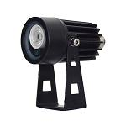
S-SA2-W White Light Illuminator
Delivers high power white light for night time illumination, improves performance of night vision camera to get colorful pictures.
Innovating high-efficiency design ensures long life span and zero maintenance

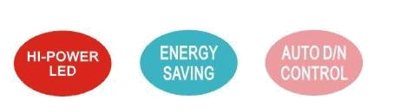
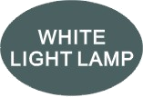
Product Features
• Precise secondary optical technology
The latest LED technology assures outstanding performance of LED with excellent luminous efficiency and more uniform illumination
• Independent innovation of high efficiency power drive schemes
Low failure rate of products is guaranteed because of professional in-house optimized independent circuit technology widely used in our LED illuminators for more than 5 years
• High thermal conductivity aluminum
Excellent thermal management not only reduces excess heat and brightness decay of LED but also ensures efficient, reliable and continuous operation of LED throughout its lifetime as 50,000 hours.
• Energy saving technology
All illuminators has energy saving circuit with low electrical power consumption.
• Thinner and lighter design
Our patent owned housing is designed for simple installation and easy operation to reduce construction difficulty.
• Warranty period
3 year warranty
Basic Function
•To improve performance of the weak light camera, thereby enhancing the picture effects at night.
•Conventional night monitoring
•The function of video analysis at night
•Reduce signal noise and other image distortion
•Reduce the network bandwidth requirements
•Energy saving by power factor correction
•Reduce the equipment cost
•Lower cost of installing and wiring
•Indoor and outdoor use
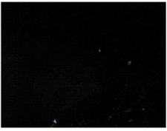
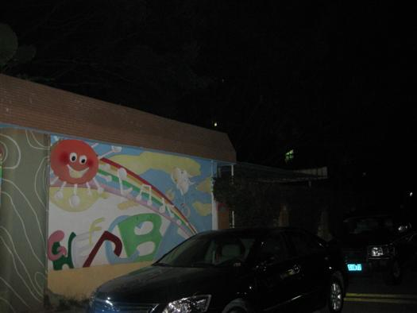
Viewing picture at night

With white light Without white light
S-SA2-W Product Certificate
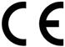



Technical Specification Drawing
LED type: 1pieces high power white light LED
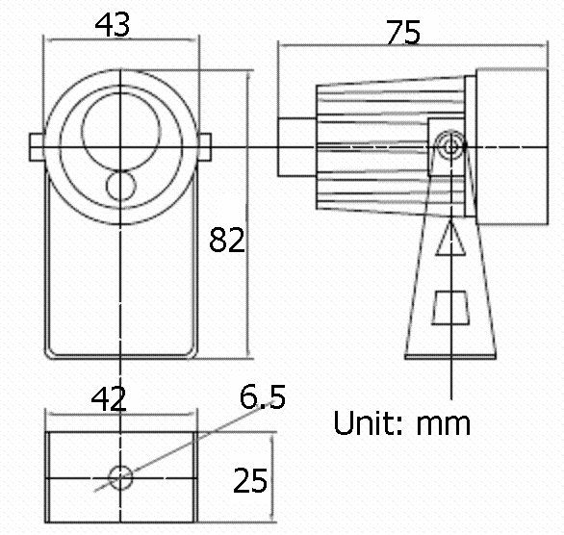
Luminous flux: 120lm
Color temperature: 5500-6000K/3000-3500K
Beam angle: 15 to 120°
Beam distance: 10 to 0.5m
Bracket: wall mount bracket
Working voltage: 12V DC 300mA
Power consumption: 3.6W
Day/night switch: With/without CDS sensor
Working temperatures: -30 to 50°C
Protection level: IP66
Color: black
Panel: tempered glass panel
Housing: aluminum die-casting housing
Net weight: 0.15kg
Gross weight: 0.17kg
Packing dimension: 50*50*105mm
Model for Selection
Model Beam angle Viewing distance
S-SA2-15-C-W 15° 10m
S-SA2-30-C-W 30° 7m
S-SA2-45-C-W 45° 5m
S-SA2-60-C-W 60° 2m
S-SA2-90-C-W 90° 1m
S-SA2-120-C-W 120° 0.5m
*Viewing distance is tested by Sony 1/3 CCD Camera with 0.01LUX.
To achieve the distance needed, please pay attention to your camera specification and lens before purchase. It is normal phenomenon that distance may vary due to different cameras and lens.

