Vandal Resistant PoE White Light Illuminator

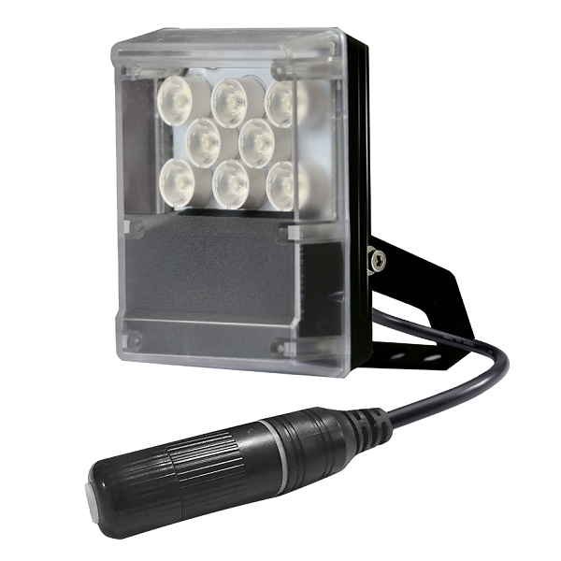
S-SG8P-W
• Powerful lighting products for dark place and night vision illumination
Improves performance of night vision camera to get colorful pictures
• High-efficiency, long life span and zero maintenance



Product Features
• Independent innovation of high efficiency power drive schemes
• High thermal conductivity aluminum + Vandal-resistant PC panel
• Long service life, 50,000hours in theory
• Energy saving technology
• IP66 waterproof and dustproof
• Manual power control
• Manual Light operated sensor control
• PoE (Power over Ethernet) powered
• Easy installation
• 2 years warranty

Basic Function
• Improves performance of the weak light camera and enhances the monitoring picture effect.
• Low equipment cost
• Reduce cost of installing and wiring
• Indoor and outdoor use

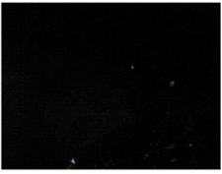

Viewing picture at night

With white light Without white light

Picture Product Certificate




Technical Specification Drawing
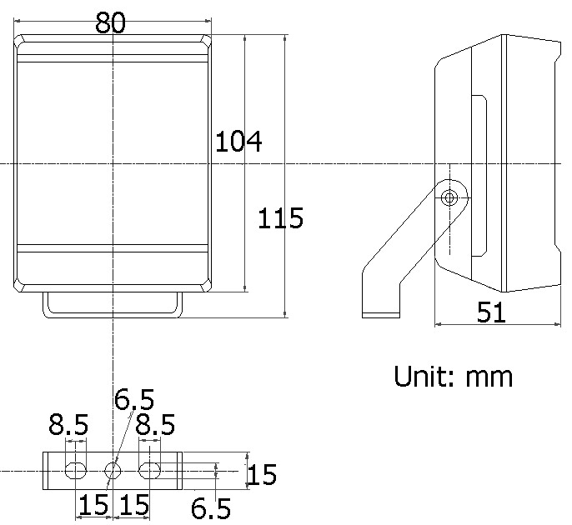
LED type: 8pieces high power white light LED
Color temperature: 5500-6000K/3000-3500K
Luminous flux: 700lm
Beam angle: 30° to 60°
Beam distance: 1m-30m
Bracket: wall mount bracket
Cable: IP66 RJ45 jack with Cat.5e 50cm
Working voltage: PoE IEEE 802.3af
Power consumption: 8W
Day/night switch: with CDS sensor
Working temperature: -40°C to 60°C
Protection level: IP66
Color: white color
Panel: vandal-resistant panel
Housing: aluminum die-casting housing
Net weight: 0.52kg
Gross weight: 0.6kg
Dimensions: 145*135*95mm

Model for Selection
Model Beam angle *Viewing distance (adjustable)
S-SG8P-30-W 30° 1m-30m
S-SG8P-45-W 45° 1m-25m
S-SG8P-60-W 60° 1m-15m
*Viewing distance is adjustable, tested by Sony 1/3” CCD Camera with 0.01LUX
To achieve the distance needed, please pay attention to your camera specification and lens before purchase. It is normal phenomenon that distance may vary due to different cameras and lens.

