PRODUCT SPECIFICATION
VISUS CITY Series Enclosure

Key Features
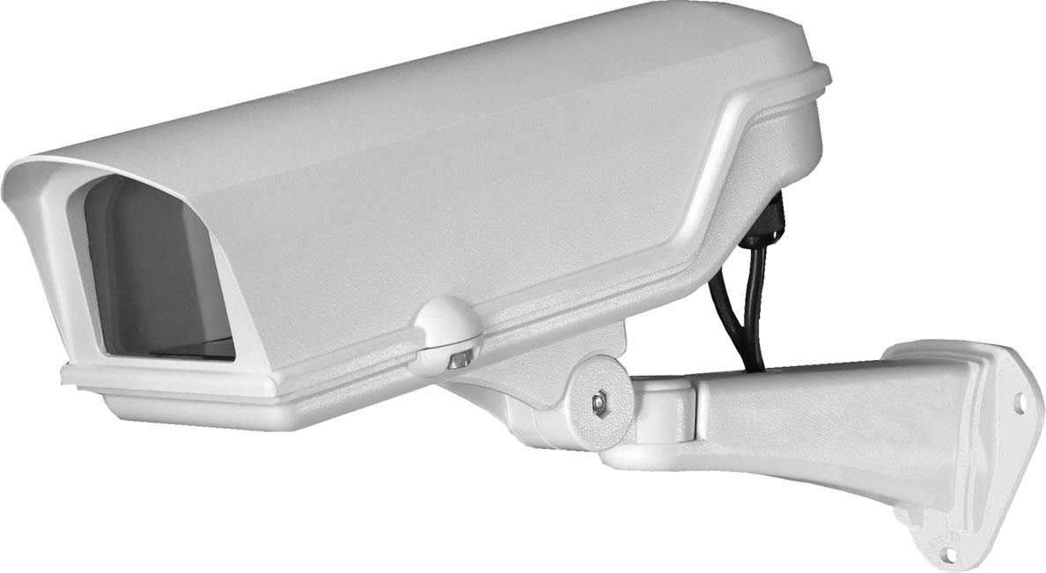
- Attractive styling Design
PATENTED H1B1 ENCLOSURE AND MOUNT

- High Reliability Die-Cast
Aluminum Alloy Construction
- Cable Entry with IP68 Glands
- High Wear / UV Resistant

Rubber Seal
- Stainless Allen-head Screws for
Tampering and Rust prevention
- 3 mm Temper glass window with
High Reliability Gel
- Weatherproof to highest level IP68
- Robust Cable management bracket assembly
- Designed for Indoor/Outdoor Applications
- Easy Access for Servicing and Installation
- Fused input terminal block
- Models Available with Factory-Installed
Heater and Blower with Multiple voltage option

The VISUS CITY Series comprises a stylish pressure die cast enclosure, sized to suit CCD cameras with fixed focus lenses, plus wall bracket with cable management system.

The equipment has a compact body length of 13.38 (base) and 14.76 (overall) inches (34.0 and 37.5 cm, respectively).
VISUS CITY Series is designed to provide the installer with a secure and reliable camera option.

The internal camera cavity is simply accessed by loosening 3 stainless Allen screws. Two adjustable glands (PG13.5) on the bottom of the enclosure allow for easy installation of the power and video cables.



VISUS CITY | 1/3

TECHNICAL DATA
H1B1 Series Enclosure

TECHNICAL DATA
VISUS CITY Series Enclosure

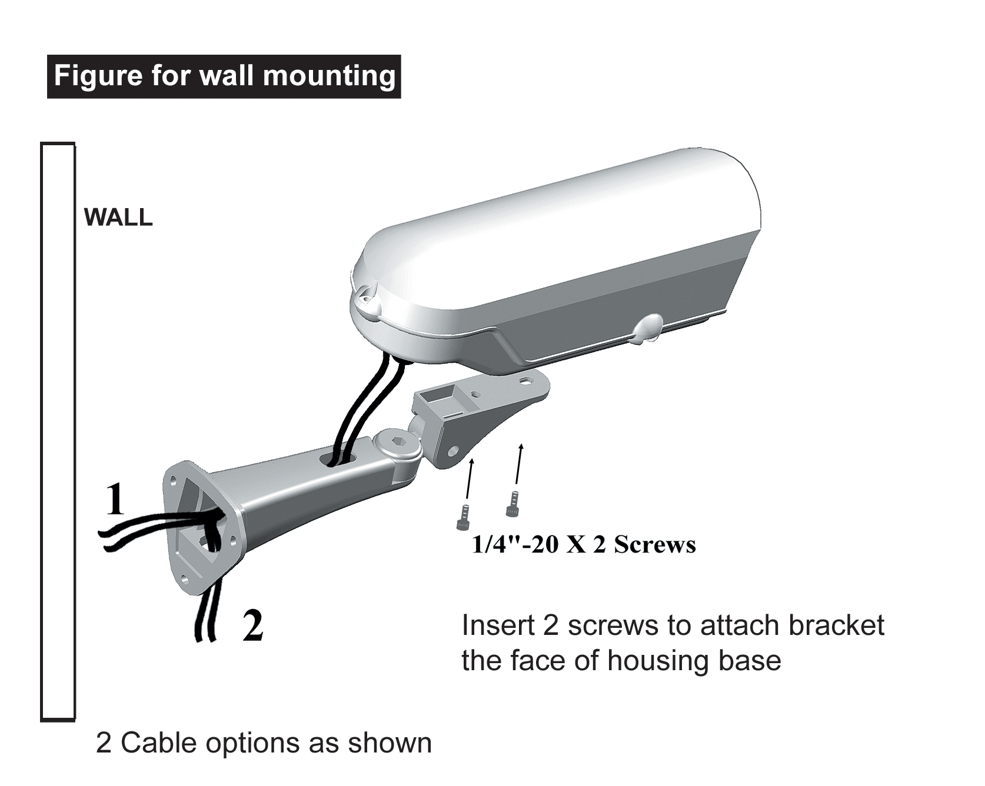
GENERAL
Construction | Entirely made of die-cast aluminum alloy
Finish | RAL 9010 color of UV rays resistant  powder coat
Environment | Totally protected against dust and  any water from all directions
Weight
 | VISUS CITY 124H 5.25 lb (2.38 kg)
 | VISUS CITY 230H 5.25 lb (2.38 kg)
 | VISUS CITY 12HB 5.68 lb (2.58 kg)
 | VISUS CITY 24HB 5.68 lb (2.58 kg)

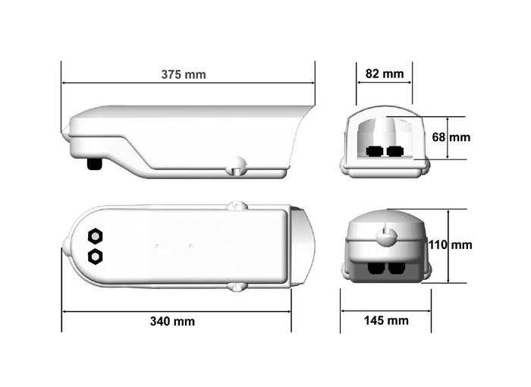
MECHANICAL
Window 4 mm thick tempered glass
82 x 68 mm ( W X H ) in viewing

Enclosure Length base 340 mm
overall 375 mm
Width 145 mm,
Height 110 mm

Internal usable area
250 mm length
110 mm Width
70 mm Height

Certification Meets international IP68 standard
Camera mount Slot plate for adjustable camera positioning
Certification Meets international IP68 standard
Cable Entry 2 X PG 13.5 IP68 rating cable glands

VISUS CITY | 2/3

TECHNICAL DATA
VISUS CITY Series Enclosure

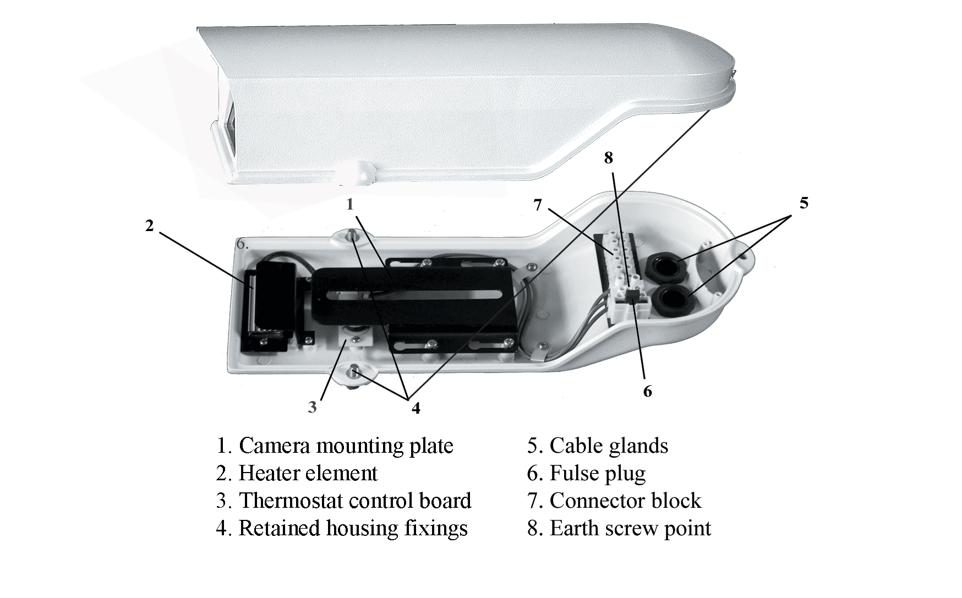
MECHANICAL
Bracket Robust wall mounting design ,
Length 330 mm
Fully adjustable swivel head by 2 stainless
steel allen-head screws
Very good resistance to swaying
Tilt angle of +40° to -150°;
Pan angle of +100° to -100°
Load rating: 76 lb (30kg)

ELECTRICAL
Heater control Below 15°±3°C automatic turning on
Above 25°±3°C automatic turning off
Blower control Above 35°±3°C automatic turning on
Below 25°±3°C automatic turning off

Terminal block Fuse input ( Max. 400V )

VISUS CITY | 3/3
VISUS CITY Series
MODEL | Basic Enclosure & Mount | Heater 12Vdc / 24Vac | Heater 100 ~ 240Vac | Blower 12Vdc | Blower 24Vac | Max. Consumption
VISUS CITY 124H | ◆ | ◆ |  |  |  | 30W
VISUS CITY 230H | ◆ |  | ◆ |  |  | 40W
VISUS CITY 12HB | ◆ | ◆ |  | ◆ |  | 34W
VISUS CITY 24HB | ◆ | ◆ |  |  | ◆ | 34W

