

**HSP500**

**Wireless HotSpot Gateway with Printer**

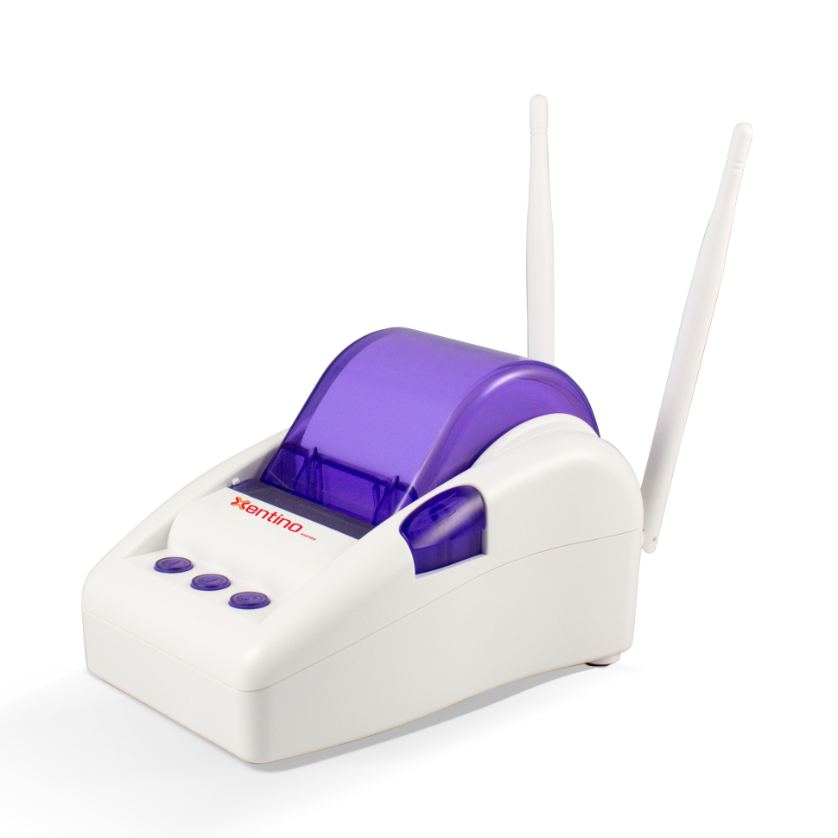

***Product Overview***

*With BYOD(**) trend today, people need Wi-Fi access for their works, searches and their social life. Therefore, the HSP500 offers a robust and secure hotspot solution for the mini size venues to provide Internet service such as café, pharmacy, small office-store or shop.*

*The HSP500 support time-base and volume-base billing selection, so venues can set up their own billing methods by either letting the customers pay for the volume of downloads or usage time without worrying about insufficient bandwidth because HSP500 has already done a good job on allocating it!*

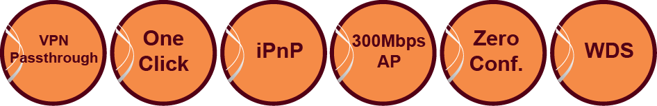

***Key Features***

* Support up to 50 simultaneous devices and up to 256 local accounts
* Support QR Code print out
* Make more convenient for portable devices to login
* Support WPA/WPA2 Encryption
* AAA Control and Billing Support
* All-In-One Instant Hotspot Gateway with built-in Thermal Printer
* Compatible with IEE802.11b/g/n, Wireless 2T2R 2.4GHz with 300Mbps high speed network
* Support network access control service including Authentication, Authorization and Accounting (AAA) for internet subscribers and 10 billing profiles
* Support Rich Functions
* Transparent HTTP proxy, Layer 2 Isolation, Administration access Control , SSL login page and various WAN connections
* VPN PASS Through
* Run your VPN or Secure tunnelling client software to connect to your company’s VPN server
* Support WDS function with repeater mode*
* Allow multiple devices to login one subscriber account*
* Micro-USB to Ethernet Connector design to support multiple LAN Device usage
* Multiple languages support
* For ticket printout format and login-page only, language support available in English/ German/ French/ Spanish/ Portuguese/ Italian languages
* IP Plug and Play Internet Access
* Zero configuration Internet access!
* Connect your office PC, laptop and handheld devices to the network without human intervention. It will automatically configure itself for the network

* Features will be available in future release.

** BYOD= Bring Your Own Device

**Xentino Technologies Corp.**

6F., No.93, Zhongcheng Rd., Tucheng Dist., New TaipeiCity 236, Taiwan (R.O.C)

**Tel** : +886-2-8076-3071 **Fax** : +886-2-8076-3061 **Email** : info@xentino.com

**www.xentino.com**



**HSP500**

**Wireless HotSpot Gateway with Printer**

**Product Specifications**

|  |  |
| --- | --- |
| **Network**  **Specification** | * IEEE802.3 10BaseT Ethernet * IEEE802.3u 100BaseTX Fast Ethernet * IEEE802.11b/g/n |
| **Wireless** | * IEEE802.11n * 8xESSID |
| **Frequency**  **Band** | * 2.4 GHz frequency band |
| **Wireless**  **Operation**  **Range** | * Up to 100 meters (outdoor) |
| **Concurrent**  **Devices** | * To extend wireless coverage, support USB to Ethernet for up to 50 devices |
| **Wireless Data**  **Rate** | * Up to 300Mbps with auto fall back with 802.11b/g/n |
| **Networking** | * IP Plug and Play (iPnP) * HTTP Proxy support * SMTP server redirection * DHCP server (RFC 2131) / DHCP relay (RFC 1542) * Static IP / DHCP / PPPoE / PPTP WAN client * NAT (RFC 1631), IP routing, NTP support * Local account: 256 * Max session number up to 16384 |
| **Authentication** | * Built in authentication * Radius authentication/ Accounting * Web-based authentication/ Account manager/ Authorization user agreement |
| **Encryption** | * WEP 64/128bit, WPA-PSK TKIP, WPA2-PSK (AES) * WPA/WPA2 Mix mode |
| **Billing** | * Accounting without PC operating * Credit card support * 10 Customizable billing profile * Prepaid billing mechanism * Time-base billing (by minute, hour, day and week) * Account log max. 1000 |
| **Security and**  **Firewall** | * Layer 2 Isolation * SSL Login Page/ SSL Administration * VPN pass through (IPSec/PPTP/L2TP) * Customize SSL certificate * Pass through destination IP/URL * Pass through source IP/MAC * Restricted destination filtering IP/URL * VPN PPTP client |

|  |  |
| --- | --- |
| **Management** | * Remote web-based configuration and management * Authorized remote management (Access Control List - ACL) * Firmware upgrade (RFC 1350) via HTTP/TFTP * Scheduled firmware upgrade * Dynamic DNS * Real-time current user list / DHCP clients list / Session list / Account list * Syslog * Bandwidth / Session control per user * Session trace * Secure remote * SNMP V1/V2c (Read Only and OID 500) * Ping command * SSL certificate upload * Internet access limit during the peak time(*) |
| **Marketing**  **Cooperation** | * Advertisement URL link * Walled garden * Customize login page, Logo, Information windows, Account print out, Credit card, User agreement * Portal page * QR code scan for login |
| **Power**  **Requirement** | * External power adaptor * Input : 100-240 VAC, 50/60 Hz * Output : 12V, 1.5A |
| **Dimension** | * (L): 109 mm / (W): 155 mm / (H): 90 mm * Weight : about 340g (net) |
| **Printer Tray** | * Push button: Push to open printer cover * Tear bar: Cuts receipt paper * Button A: Flashing when printer cover is opened * Paper roll housing: Put paper roll here |
| **Paper Roll**  **Specification** | * (W): 58(+1/-1) mm /(L): 50meters (max) / Thickness: 65um * Outside diameter: 63(+2/-2) mm * Inside diameter: 12(+0.5/-0.5) mm * Weight: 120 grams. |
| **Environmental**  **Conditions** | * Operating temperature: 0 °C to 50°C * Storage temperature: -10 °C to 60°C * Humidity: 10% ~ 90% non-condensing * Humidity: 10% ~ 80% condensing |
| **Certification** | * FCC/ CE/ C-Tick/ VCCI/ GOST-R/ Telec/ NCC/ NTC/ FAC/ BSMI*/ Anatel*/ COFETEL* |

(*) Features will be available in future release. 

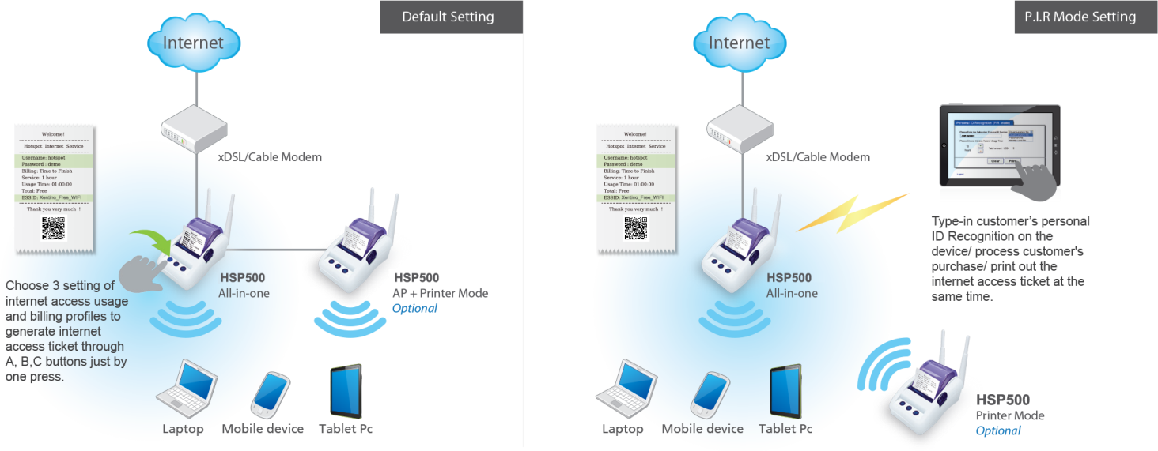–

**Xentino Technologies Corp.**

6F., No.93, Zhongcheng Rd., Tucheng Dist., New TaipeiCity 236, Taiwan (R.O.C)

**Tel** : +886-2-8076-3071 **Fax** : +886-2-8076-3061 **Email** : info@xentino.com

**www.xentino.com**

**Application**