YOKO SPACE-DOME IR-LED Camera

MODEL: RYK-2G49LVF3/1&RYK-2G85LVF/1 2007/8/14
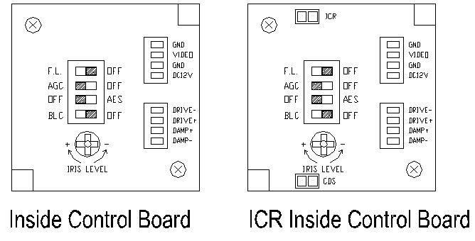
Top View
Side View
87.4mm

FEATURES
- Color camera with SONY 1/3“ Super HAD CCD sensor.
- Employs Digital Signal Processor (DSP) IC for image control.
- Pixel number: Normal Resolution : NTSC=270K / PAL=320K pixels
High Resolution : NTSC=380K / PAL=440K pixels.
❑ High sensitivity, low smear, high anti-blooming.
- Auto Electronic Shutter (AES), Auto Gain Control (AGC), Auto Iris (AI), Back Light Compensation (BLC), Auto White Balance (AWB), Flickerless mode (FL).
- Built-in Vari-focal type DC-drive auto iris lens.
❑ Furnished with power cable and video cable.
- Only DC Voltage, low power consumption.
- Easy to install, easy to use, aesthetic.

SPECIFICATIONS ( Note: Design and specifications are subject to change without prior notice. )
Model No. | RYK-2G49LVF3/1 | RYK-2G85LVF3/1
Image Device | SONY 1/3“ Super HAD CCD sensor. | SONY 1/3” Hi-Res. HAD CCD sensor
Picture Elements | NTSC: 510×492, PAL: 500×582 | NTSC:768*494 , PAL:752*582 (H*V)
Horizontal Resolution | 380 TVL | 470 TVL
Minimum Illumination | 0.2 Lux / F2.0(Day),  0 LUX (IR ON) | 0.3 Lux / F2.0(Day),  0 LUX (IR ON)
S/N Ratio | More than 48dB
Auto Electronic Shutter | NTSC: 1/60s~1/100,000s, PAL: 1/50s~1/110,000s ON/OFF switchable.
Flickerless Mode | NTSC: 1/100s, PAL: 1/120s ON/OFF switchable.
Gamma Characteristic | 0.45
Iris Control | DC Drive
Lens Furnished | Vari-Focal with DC Drive Iris Lens.  VR3：Vari-Focal Lens with ICR f3.3~12.0mm/F1.6~360,DC Drive
Focal Length & Aperture Ratio | f = 3.7~12mm / F1.6~3.0
Angle Field of View | Wide:71.6°×55.8°, Tele:23.8°×17.9° (H×V)
White Balance | Auto
Gain Control | Hi /Low
Back Light Compensation | ON/OFF
Synchronous System | Internal, Negative sync.
Video Output | 1 Vp-p / 75 Ohms.
Infrared Luminary | 24 pieces IR-LED,Life:600hrs
Wavelength | 850nm
Illuminate Distance | 20M
Power Supply | DC12V ±10％
Power Consumption | IR On : 425mA(max)  IR Off : 150mA(max) |  | IR On : 425mA(max)  IR Off : 200mA(max)
Operating Temp. | -10℃ to 50℃ (14℉ to 122℉)

