Hidden CCD Camera
Instruction Manual

VER.:1.0, NO.: R040025A/2

Thank you very much for purchasing our product. Before operating this product, please read this instruction manual carefully to ensure proper use.
1. Safety Precautious

 | Disposal of Old Electrical & Electronic Equipment (Applicable in the European Union and other European countries with separate collection systems).

- Please do not directly touch the sensor element. If necessary, use a soft cloth moistened with alcohol to wipe off any dust.
- Please be extra careful not to shake the camera.
- Please avoid places where there is direct sunlight or reflected sun light as PIR alarm features are affected by environmental changes.
2. Description
The camera uses SONY high sensitive super HAD interline transfer image sensor, and employs digital signal processor (DSP) chip-set for image control, and all integrated state circuitry which provide extremely long life and high reliability. This camera offers excellent image quality with low lag and high burn resistance, and is not subject to distortions from magnetic fields.
Highly resistance to shock and vibration, easy to install, this camera is a very good choice for your color CCTV system.

3. Feature
- Sony Super HAD CCD sensor.
- Employs Digital Signal Processor (DSP) chip-set for image control.
- Pixel number: NTSC=380K/ PAL=440K (EIA=440K/ CCIR=380K) for high resolution models, and NTSC=250K/ PAL=290K (EIA=290K/ CCIR=250K) for normal resolution models.
- High sensitivity, low smear, high anti-blooming and high S/N ratio.
- Powerful functions: Auto Electronic Shutter (AES), Auto Iris (AI), Auto Gain Control (AGC), Auto White Balance (AWB), and Back Light Compensation (BLC).
4. Contents

Item | Name of Part |  | Quantity
1 | Camera |  | 1
2 | Bracket |  | 1
3 | Instruction Manual |  | 1
4 | Appurtenance Bag |  | 1
 | A | Screws | 2
 | B | Anchor | 2
 | C | 4Pin or 6Pin Cable (optional) | 1

5. Installation
- Select a location from which the pattern of the detector is most likely to be crossed by a burglar, should there be a break in.

- Mount the wall bracket using the supplied screws.

- Attach the camera case to the bracket.

4. Adjust the vertical and horizontal angles by loosening screws (A&B) and by turning the bracket vertically and horizontally.

6. Wiring
  - Connect the video input connector on the video monitor to the video output connector of the camera with 75-ohm coaxial cable.

  - Insert the AC plug into the AC power socket and the DC plug to the DC Jack.

Note: AC adapter is sold separately.

7. Detector board
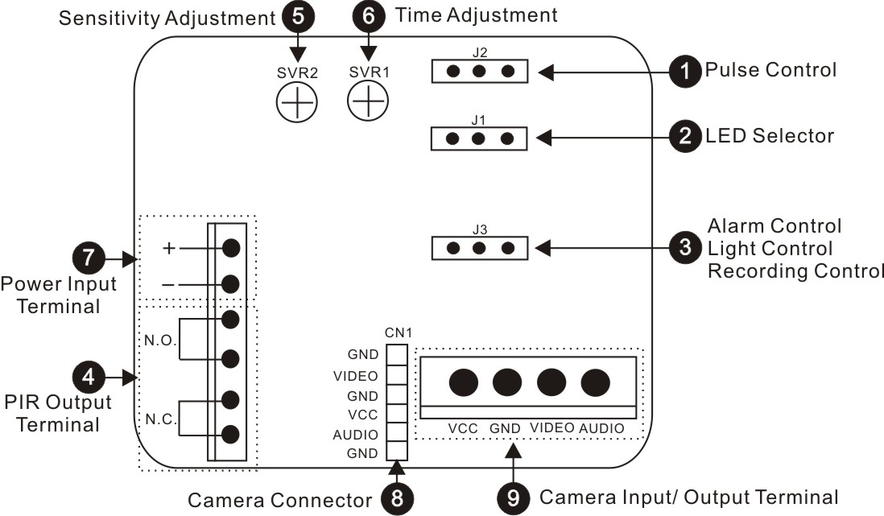

Options | Description
1. Pulse Control: 1 or 2  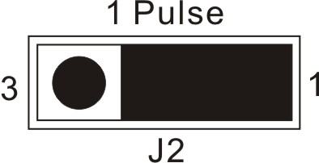  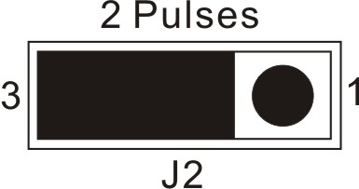  (3Pin: Left, Center, Right) | To setup the pulse count, please refer to the appropriate dip-switch configuration table shown below:  Position 1: For instant reaction when PIR detects someone.  Position 2: For 2 times detection within 15 sec.   The higher the pulse count the more movement will be necessary before the PIR detector will trigger the alarm.
  Switch | Position 1 | Position 2
  J2 | 1 Pulse | 2 Pulse
2. Setting the LED Indicator:  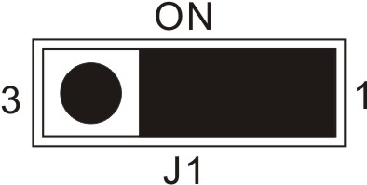  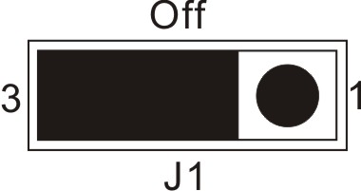  (3Pin: Left, Center, Right) | To enable/ disable the LED indicator, please refer to the appropriate dip-switch configuration shown below:  LED ON: Easy to be identified as a security system.  LED OFF: No light blinking while detection, less obvious.
  Switch | Position 1 | Position 2
  J1 | On | Off
- Alarm Control/ Light Control/ Recording Control (N.O or N.C)  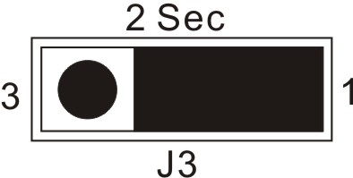  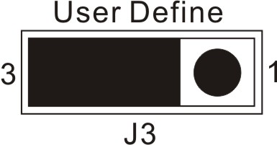  (3Pin: Left, Center, Right) | To setup dwell time of the Alarm Control/ Light Control/ Recording Control, please refer to the appropriate dip-switch configuration table shown below:  Dwell Time Adjustment:  *Set to “Position 1” to enable default time of the PIR sensor, fixed: 2 sec.  *Set to “Position 2” then turn “SVR1” clockwise to extend dwell time of sensor mechanically and counter clockwise to shorten dwell time of PIR sensor.
  Switch | Position 1 | Position 2
  J3 | 2 Sec. | User Define

4. PIR Output Terminals:  1  2  24 Hour/Anti-Tamper | 1. Power Input: 12V DC  2. N.C.: Normal Close  N.O.: Normal Open   Relay Output: 3A 120V AC, 3A 24V DC
5. Sensitivity Adjustment:  MAX  MINow  “SVR2” | Raise Sensitivity: Turn clockwise to detect longer distance and wider pattern.  Lower Sensitivity: Turn counter clockwise for detection in narrow areas.
6. Dwell Time Adjustment:  MAX  MIN  “SVR1”  Adjustable from 2 to 40 sec. | The Dwell Time Adjustment setting controls how long the alarm remains triggered after activation.  Max. Dwell Time: Turn clockwise.  Min. Dwell Time: Turn counter clockwise.   Set to "1 Pulse" from J3, and then turn “SVR1” clockwise to extend dwell time of sensor mechanically, counter clockwise to shorten dwell time of PIR sensor.
7. Power Input: DC 12V | Standby Current: 3mA  Working Current: 17mA
8. Camera Connector: | Camera connection using cables (4Pin / 6Pin) supplied.  4 Pin Cable: Non-audio type connection method  6 Pin Cable: Audio type connection method  Tip: User preference for an alternative connection solution, connect CN1 with Camera Input / Output Terminal.
9. Camera Input/ Output Terminal: | Camera power input, video and audio output connection.  Tip: User preference for an alternative connection solution, connect Camera Input / Output Terminal with CN1.

8. Detection patterns
Feet
Feet

- Wide angle lens up to 100°, coverage areas to 30x30 feet.
- Provide 64 beans in 3 layers.

9. Specification
According to the camera purchased, select and refer to the appropriate specification below:
Color Camera
Image Device | 1/3” SONY Super HAD |  |  | 1/3” SONY  Hi-Res. Super H AD | 1/3” SONY Ultra  Hi-Res. Super HAD |  | 1/3” Hi-Res.  CCD |  | 1/4” SONY  Super HAD
Picture Elements | NTSC: 510x492  PAL: 500x582 |  |  | NTSC: 768x494  PAL: 752x582 |  |  |  |  | NTSC: 510x492  PAL: 500x582
Resolution | 380 TVL |  |  | 470 TVL | 550 TVL |  | 540TVL |  | 330 TVL
Min. Illumination | 0.2Lux/ F2.0 | 0.3Lux/ F2.0 |  | 0.3Lux/ F2.0 |  |  |  |  | 0.4Lux/ F2.0
S/N Ratio | More than 48 dB
Electronic Shutter | EIA:1/60~1/100,000, CCIR:1/50~1/110,000
Gamma | 0.45
Lens Furnished | Corn Lens
White Balance | Auto
Gain Control | Auto
Sync System | Internal
Video Output | 1 Vp-p/ 75 Ohms
Audio Output | 2 Vp-p / 50 Ohms (optional)
Power Supply | DC 12V ±10％
Power Consumption | 140mA max. |  | 75mA max. | 140mA max. |  | 145mA max. | 75mA max. | 140mA max.
Operating Temp. | -10 to 50℃
Model Series
PIR N.C/N.O Relay Output | AC 120V/ 3A , DC 24V/ 3A
PIR N.C/N.O Relay  Alarm Time | 2 to 40 sec. (adjustable)
PIR Detection Angle | Hor.=100˚ / Ver.=45˚
PIR Max. Detection Range | Up to 15M.

BW Camera
Image Device | 1/3” SONY Super HAD | 1/3” SONY  Hi-Res. Super HAD | 1/3” Camera
Picture Elements | EIA: 510X492  CCIR: 500x582 | EIA: 768x494  CCIR: 752x582 | EIA: 510X492  CCIR: 500x582
Resolution | 420 TVL | 600 TVL | 400 TVL
Min. Illumination | 0.1Lux/ F2.0 | 0.2Lux/ F2.0 | 0.3Lux/ F2.0
S/N Ratio | More than 48 dB
Electronic Shutter | EIA:1/60~1/100,000, CCIR:1/50~1/110,000
Gamma | 0.45
Lens Furnished | Corn Lens
Gain Control | Auto
Sync System | Internal
Video Output | 1 Vp-p/ 75 Ohms
Audio Output | 2 Vp-p / 50 Ohms (optional)
Power Supply | DC 12V ±10％
Power Supply | DC12V±10%
Power  Consumption | 140mA max. | 150mA max. | 150mA max.
Operating Temp. | -10℃ to 50℃
Model Series
PIR N.C/N.O Relay Output | AC 120V/ 3A , DC 24V/ 3A
PIR N.C/N.O Relay  Alarm Time | 2 to 40 sec. (adjustable)
PIR Detection Angle | Hor.=100˚ / Ver.=45˚
PIR Max. Detection Range | Up to 15M
Note: Design and specifications are subject to change without prior notice.

