Upgrade Vigor2000 isdnRouter Firmware
1999/12/01
DrayTek Corp.
Ver. 1.01
Introduction:

For the expandability of features, Vigor2000 isdnRouter has a built-in Flash ROM memory to keep firmware and router's configurations or profiles even power-down. This chapter you will learn the following items:

- How to upgrade new firmware for enhancing your Vigor2000 isdnRouter .

Upgrade Notes:

- The following description of IP network configurations is assumed as factory default settings. Your network environment will be not the same as here.
- Before upgrading new firmware, please check your current firmware version. You can click 'F/W Upgrade' menu on DrayWeb web configurator or use 'sys ver' commands on Telnet command session to find out the current firmware version.
- If your last running firmware version is old than ver. 1.00, please select file V2Kxxxxx.RST to upgrade Vigor2000 isdnRouter. If not, you should upload V2Kxxxxx.ALL file.
- The definition of firmware filename:
V2Kxxxxx.BIN: router firmware only, means TCP/IP, routing, NAT and PPP/MP etc.
V2Kxxxxx.WEB: The ROM file of compressed webpages of DrayWeb Web Configurator.
V2Kxxxxx.CFG: The ROM file of factory default settings.
V2Kxxxxx.ALL: V2Kxxxxx.BIN + V2Kxxxxx.WEB.
V2Kxxxxx.RST: V2Kxxxxx.CFG + V2Kxxxxx.BIN + V2Kxxxxx.WEB.

Where xxxxx: The revision number of firmware.

Before you upgrade new firmware:

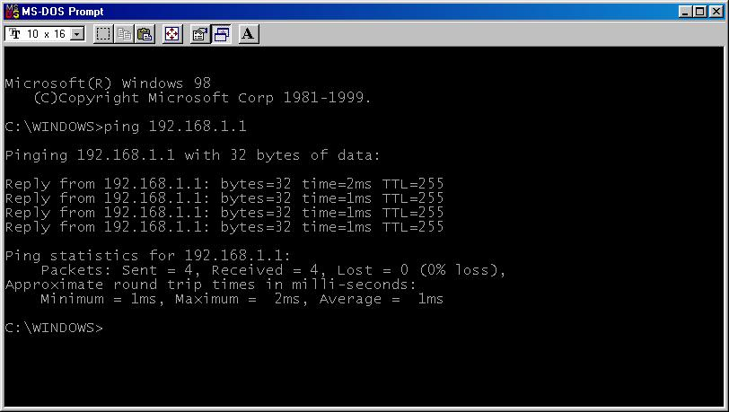
- Using PING utility on your local PC makes sure the network connectivity as following snapshot.

- Install DrayTek Firmware Upgrade Utility software on local PC. Double-clicking the file FUSetup.exe install the utility on your Windows platform. You will see a new folder on the program menu shown as below.
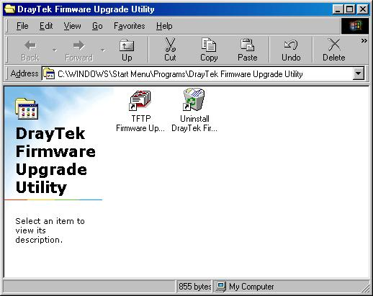

- If you had installed, you could launch the utility shown as below.
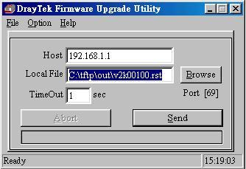

4. At last, launching HyperTerminal software to connect to console port of Vigor2000 isdnRouter for monitoring firmware upgrade status.

Upgrade Firmware under Boot Loader Mode

- Force Vigor2000 to enter Boot Loader mode: After power on Vigor2000 and press any key or Enter key to enter Boot Load mode as below.
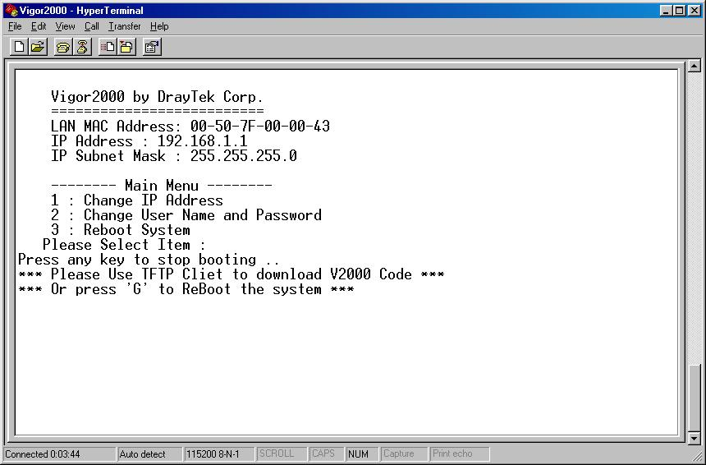

2. Open 'DrayTek Firmware Upgrade Utility' for upgrading new firmware. The 'Host' blank should be filled Vigor2000's IP address, here is 192.168.1.1 for example. Then clicking 'Browse' button selects wanted firmware, and then push 'Send' button to upload the firmware to Vigor2000. The next window will show a snapshot during upgrading new firmware. If finished, the status bar on the bottom will display 100% means upgrade successfully.
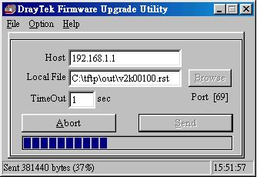

Note:
- When you upgraded firmware with RST file extension, the last configurations will be replaced by factory default configurations.
- Under the Boot Loader mode, Vigor2000 can accept the firmware type with file extension name as .BIN, .ALL and .RST.
- If you use DrayWeb to turn firmware upgrade server, Vigor2000 can accept V2Kxxxxx.CFG, V2Kxxxxx.WEB and V2Kxxxxx.BIN.

3. Finishing the upload procedure, you will see some messages from console port connecting with HyperTerminal software.
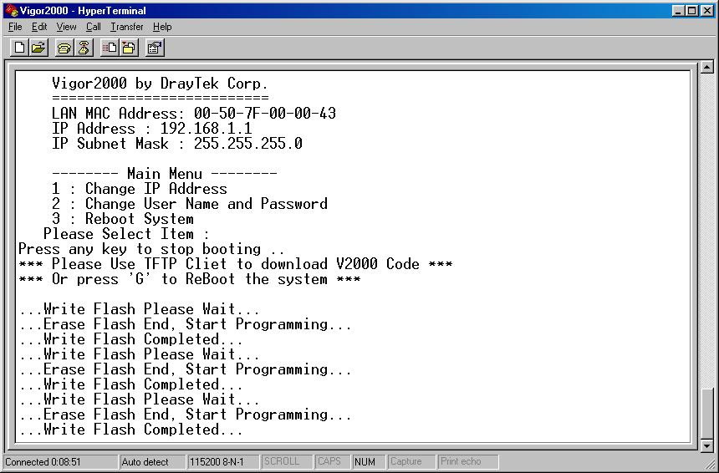

4. When the router reboot again, you could use DrayWeb to click System Utilities > F/W Upgrade to make sure the firmware version whether it's upgraded successfully or not.

