Virtual TA Client
Welcome to use the Virtual TA Client program which provide a powerful function that allow any PC in LAN to access a Remote Server ( ex. Vigor2000 ). It can make a point-to-point file transfer and send/receive fax, like it has a local ISDN TA.

- Installation:
Run VSetup98.EXE ( for Win98 ) or VSetup95.EXE ( for Win95, above OSR2.0 ) to install the simple program Virtual TA Client. Please follow the setup procedure and restart the PC.

- Operation:

After Installation, you will find a status icon ( one of the following two )
appears in the notification area of the task bar as follows:

The icon toggles between the two states:
Idle: Client does not find any server as follows:
Found: Client found a server:

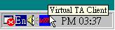
You can also see the ToolTip of each icon state, which is displayed if the mouse cursor hovers over the icon. If the icon is in the Found state, you also find the Remote Server IP address in the ToolTip.
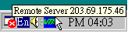
And

While icon is in the Found state, that mean found a remote server. You can run any CAPI-based application ( ex. RVS-COM ) like you have a local ISDN TA to make file transfer, send/receive fax and point-to-point connection.

- Functional Description of Items:
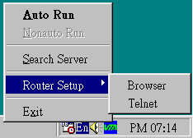
Click the right mouse button over the icon in the taskbar notification area may display a popup box, which contain several functional items:

- Auto Run:
Auto run the program after PC start up.
- Nonauto Run:
Don’t auto run the program after PC start up. You can run it from “Start ->Programs->Virtual TA Client->Virtual TA Client”
- Search Server:
Manually search if any remote server.
- Router Setup -> Browser:
For Vigor2000 only, call default internet browser with remote server’s IP address to enter the Web Configurator of Vigor2000.
- Router Setup -> Telnet:
For Vigor2000 only, call Telnet execution file with remote server’s IP address to enter the Telnet Configurator of Vigor2000.
- Exit:
Exit the application.

