Change the Title and LOGO of WebMnoitor
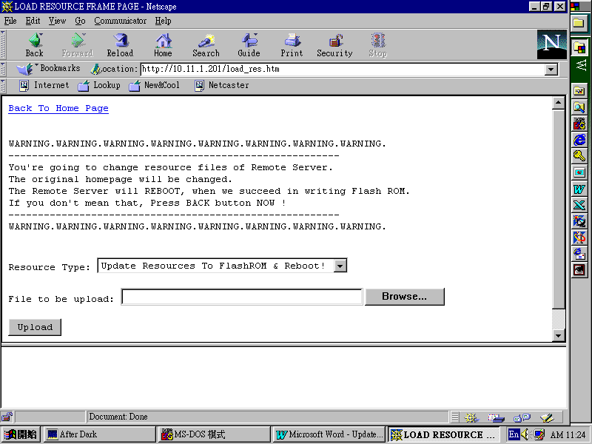
- Access “load_res.htm” in WebMonitor. You need to enter the user name and password to access this page.

- There are 3 options in Resource Type field: 1. Update Resources To FlashROM & Reboot! 2.Title Bitmap (.GIF) 3.LOGO Bitmap (.GIF). You can upload your own title bitmap ( must be GIF format ) by selecting the Resource Type to Title Bitmap (.GIF) and use Browse button to choose the title GIF file to be upload, and then click Upload button to actually update the bitmap. Now you can access the web pages of WebMonitor to see the change. You may need to reload the page to see the updated page. If you web browser is using a cache, maybe you won’t see the updated page but rather the old pages in cache. Turn off the cache of your browser is a solution.
- If you want to delete the bitmap uploaded, select the Resource Type to the type you want to delete and do not select any file, just click Upload button to delete the bitmap of this Resource Type. If there is no uploaded bitmap, the default bitmap ( factory settings ) will appears.

- Also you can update your own logo bitmap ( must be GIF format ) by selecting the Resource Type to LOGO Bitmap (.GIF) and use Browse button to choose the title GIF file to be upload, and then click Upload button to actually update the bitmap.
- Now repeat step 2, 3 and 4 until you are satisfied with your own style of design. Now it’s time to actually update these changes into FlashROM to make it non-volatile. Select the Resource Type to Update Resources To FlashROM & Reboot! and click Upload button to actually write the bitmaps into FlashROM. WebMonitor then will restart.
Now you have done with the job of updating the TITLE and LOGO GIF of

