Guide to Create Non-English Overlay Text

This document is applied to FW 1.11b2 or later for VP-400 series or FW 5.802B1 or later for VP-580 series.

Since the newer firmware specified above, VPON can overlay text in bitmap form for each video. What you need to do is to start Overlay Text Generator from a PC, type the words and upload the bitmap files to VPON. Follow the steps below:
- Start OverlayTextGenerator.exe on a PC running MS-Windows.

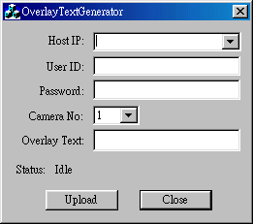

- Select camera number and type the words for each camera.

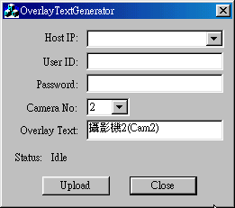

- Enter the IP address, administrator’s id and password to upload the images.
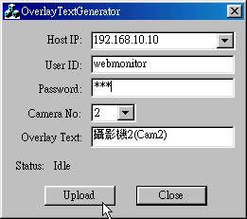

- After successfully uploading the images, reboot VPON.
- Go to “Set Names & On-Screen-Display” in advanced setting, set position and click enable option for the cameras. The text field can be left empty.
- Click Update button and check if the text is displayed on the video.

