Guide to Revise Firmware of VP-200

NOTICE

Care should be taken for updating FW2.16 or later to VP-200 FlashMemory version. FW2.16 is not compatible with loader prior to etsmon.bin.19, this incompatibility will cause VP-200 fail to boot. Loader should first be upgraded to etsmon.bin.19(or later).

1. See Section 1 & Section 2 for checking the version of loader and the version of VP-200.
2. See Section 1 & Section 2 for updating loader to VP-200.
3. See Section 1 & Section 3 for updating firmware to VP-200

For FW2.16 and prior version, we strongly recommend users to use WCOMW as the
only way to revise the firmware. And after revision, remember to restore default factory settings.

Step-by-step instructions for revising firmware of VP-200

1. See Section 1 to use WCOMW connecting to VP-200
2. See Section 2 to check the version of loader and revise it if necessary.
3. See Section 3 to revise firmware

Section 1 To Use WCOMW

A. Use WCOMW connect to VP-200
- Connect COM2 port (or one empty serial port) of PC and COM1 port of VP-200 using an RS-232 cable (comes with VP-200).
- Insert the Setup Disk come with VP-200 into your floppy driver and copy all of those files to a directory of the PC and unzip the file: TeleWriter.zip
- Launch WCOMW.EXE on PC (double click on the icon of that file while you are in Windows File Explorer)
- If you are using other COM port of your PC, please select it from File Menu.
- Power on VP-200
- When you see "Starting Loader.…" in WCOMW, press ESC key in 2 seconds and a loader information and menu will be displayed. If you failed to press ESC key in 2 seconds, just restart VP-200 to do it again and if you don't see "Starting Loader..." in WCOMW and the menu is displayed directly, just go ahead.
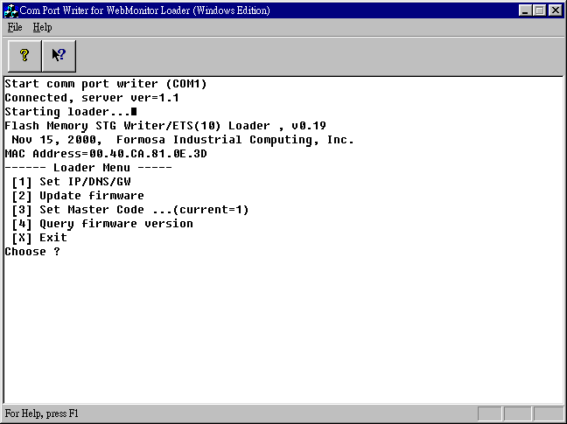
(WCOMW Menu Displayed)
←loader information
←loader menu
Flash Memory STG Writer/ETS(10) Loader, v0.19
[1] Set IP/DMS/GW
[2] Update firmware
[3] Set Master Code ...
[4] Query firmware version
[X] Exit
Choose ?

Section 2 To Check the Version of Loader And Upgrade Loader

- If your VP-200 is FlashMemory version, you will find "Flash Memory..." in loader information. And you can check the version of loader.
When you see “Flash Memory…” in loader information, it means that your VP-200 is FlashMemory version.

Loader versions and files for VP-200 FlashMemory version:
-------------------------------------------------------------------------------
loader version 1.52 file: etsmon.bin.152
loader version 0.17 file: etsmon.bin.17
loader version 0.18 file: etsmon.bin.18
loader version 0.19 file: etsmon.bin.19

Notice:
Before revising firmware, make sure the loader version of your VP-200 is v0.19(or later) for FlashMemory.

- If your VP-200 is DOM version, the loader information would be displayed as following, you can also check the version of loader.

"ETS Loader for VP200-D, v0.21"

Loader versions and files for VP-200 DOM version:
--------------------------------------------------------------------------------
loader version 0.21 file: ldr200.exe.021

Before revising firmware, make sure the loader version of your VP-200 is v0.21(or later) for DOM.

- Press 'W', 'E', 'B', 'M', 'O', 'N' will pop up additional menu items as:

[5] Dump flash memory
[6] Revise BOOT ROM
[7] Revise ETS LOADER
[8] Reboot
[X] Exit
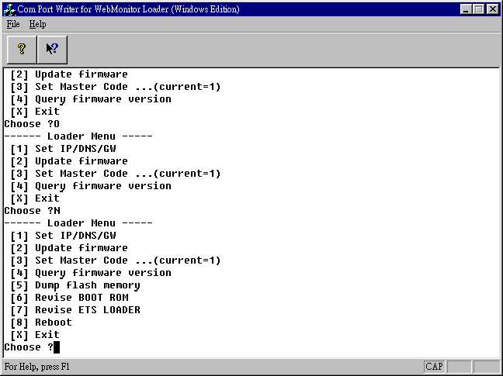
(Additional Menu Popped up)

- Press 7 to revise loader, enter the full path and filename of the new loader.
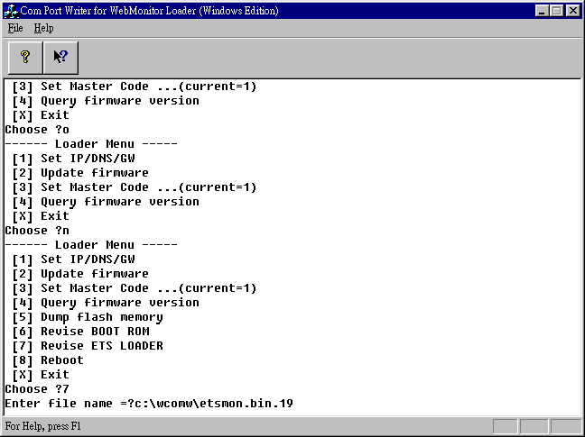
(Full Path and Filename of the New Version of Loader Entered)

- WCOMW is now uploading loader file to VP-200 for revision.
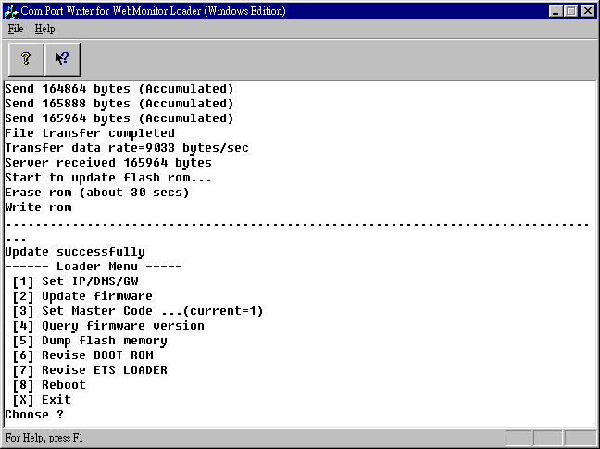
(ETS Loader Updated Successfully)

- After revision, you have to restart VP-200. Just switch the power of VP-200,

Section 3 To Revise Firmware

- Press 2 to revise firmware.
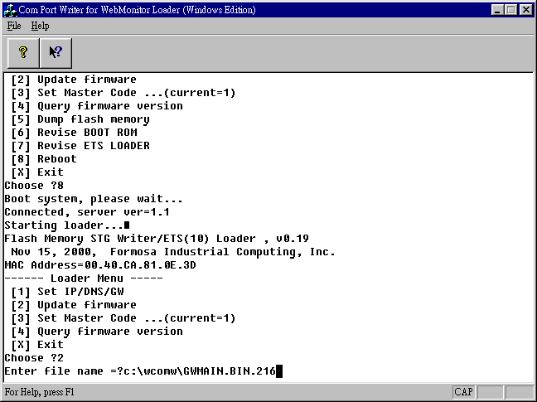
- Enter the full path and filename of the new firmware.
(Full Path and Filename of the New Version of Firmware Entered)

- WCOMW is now uploading firmware file to VP-200 for revision.
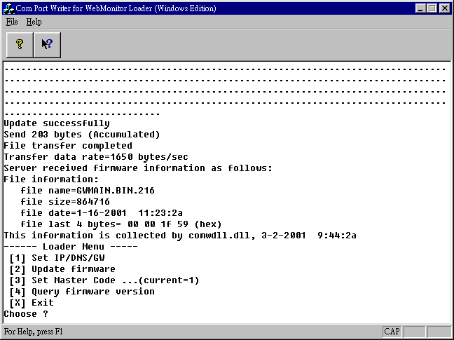
(Firmware Updated Successfully)

- After revision, press X to continue booting from the new firmware.
- After VP-200 is ready, push and hold default settings button until VP-200 stops beeping.
- VP-200 will restore default setting and reboot.
- You have completed updating firmware of VP-200, you can now continue to configure it and use the new firmware.

