Guide to Use FTP to Download DVR Files

- Go to Playback page from the web browser.

- Move the mouse pointer on the file, which you want, to backup, and you will see the file name displayed on the status bar of the browser.

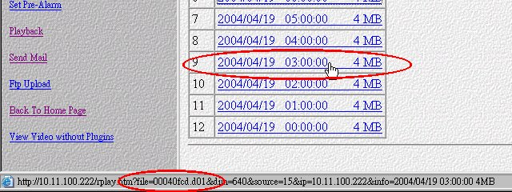

In this example, the file name is 00040fcd.d01.

- Use ftp program to connect VPON. The username is dvr_file and the password is the one used by the administrator.
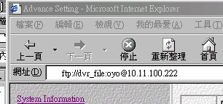

4. Find and download the file.
