A. Update firmware using web browser.
- Connect and configure VPON to run under LAN mode, so that you can use web browser to watch the video and change its configuration. Please reference VPON User’s Manual for the installation and configuration.

- Access the home page, “rframe.htm”, in your VPON. For example, assume the IP address of your VPON is “192.168.10.10”, access the page by typing “http://192.168.10.10/rframe.htm”. Reference VPON User’s Manual to see how to set the IP address.

- VPON now requires you to type the user name and password to upgrade firmware. If you haven’t change the name and password, you can use default name and password of VPON, please reference VPON User’s Manual.
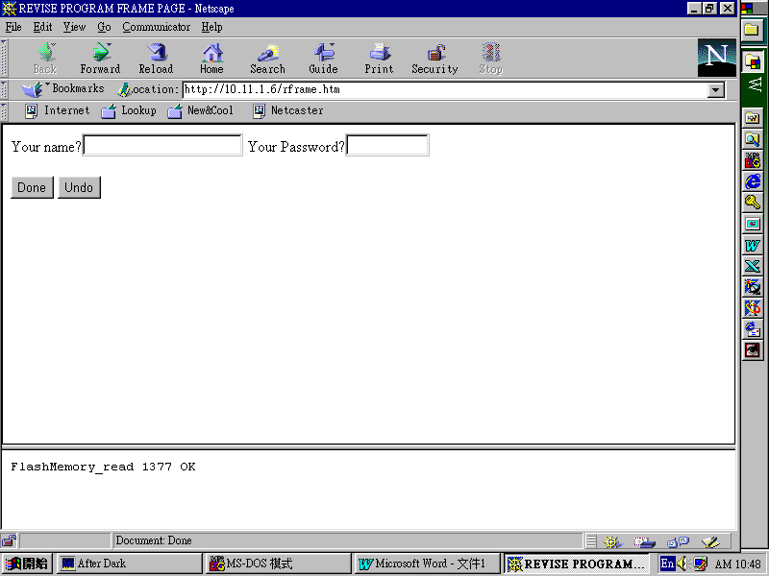

- If the user name and password is correct, at this time, you can see the page for updating firmware. Type the filename of the firmware directly or you can use Browse… button to choose the file. If a file is selected, click Revise Program button to upgrade the firmware.
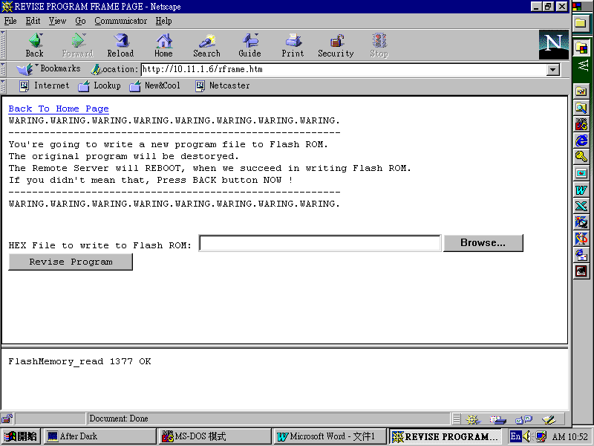
- Then the firmware will be uploaded to VPON and updated into FlashROM. This procedure needs a little time, wait for a moment. After updating firmware successfully, VPON will restart.

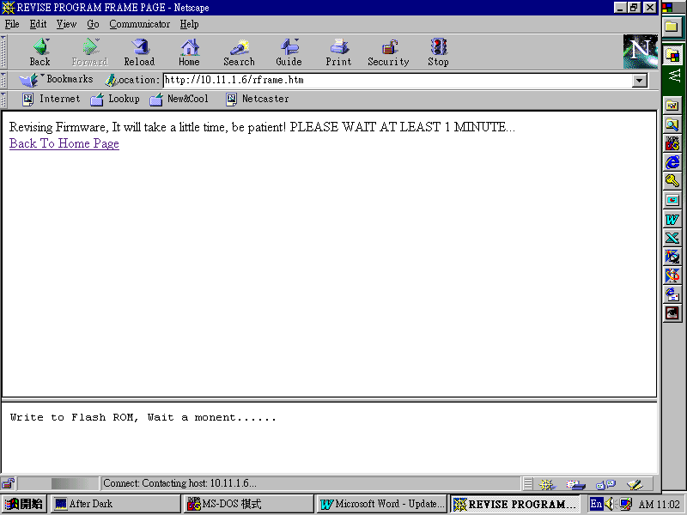

- After restart successfully, press and hold the default button at the back panel of VPON until the beep sound stops, then it will restart again. After this second restart successfully, the updating firmware procedure is now complete and you can run the machine normally. It should be noticed that after the procedure described above, the settings of VPON will return to factory default, and the running mode will return to Modem/RS232 Mode.

B. Change the Title and LOGO of VPON
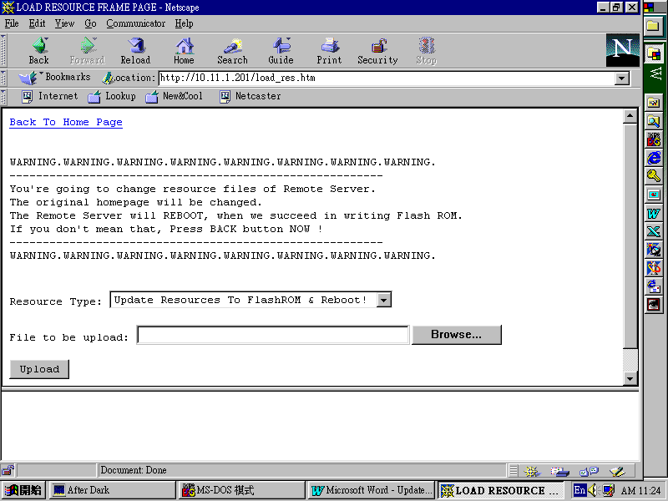
- Access “load_res.htm” in VPON. You need to enter the user name and password to access this page.

- There are 3 options in Resource Type field: 1. Update Resources To FlashROM & Reboot! 2.Title Bitmap (.GIF) 3.LOGO Bitmap (.GIF). You can upload your own title bitmap ( must be GIF format ) by selecting the Resource Type to Title Bitmap (.GIF) and use Browse button to choose the title GIF file to be upload, and then click Upload button to actually update the bitmap. Now you can access the web pages of VPON to see the change. You may need to reload the page to see the updated page. If you web browser is using a cache, maybe you won’t see the updated page but rather the old pages in cache. Turn off the cache of your browser is a solution.
- If you want to delete the bitmap uploaded, select the Resource Type to the type you want to delete and do not select any file, just click Upload button to delete the bitmap of this Resource Type. If there is no uploaded bitmap, the default bitmap ( factory settings ) will appears.

- Also you can update your own logo bitmap ( must be GIF format ) by selecting the Resource Type to LOGO Bitmap (.GIF) and use Browse button to choose the title GIF file to be upload, and then click Upload button to actually update the bitmap.
- Now repeat step 2, 3 and 4 until you are satisfied with your own style of design. Now it’s time to actually update these changes into FlashROM to make it non-volatile. Select the Resource Type to Update Resources To FlashROM & Reboot! and click Upload button to actually write the bitmaps into FlashROM. VPON then will restart.
- Now you have done with the job of updating the TITLE and LOGO GIF of VPON.

